**VIRTUALSHRINE: AN INTERACTIVE MUSEUM WEBSITE FOR CASA REAL SHRINE**

A Capstone Project Paper Presented to the Faculty of the

College of Information and Communications Technology

Bulacan State University

In Partial Fulfilment of the Requirements for the Degree of

Bachelor of Science in Information Technology

By:

**Claro, Sharvien Paul M.**

**Gabutina, Carlo Elijah R.**

**Mergal, Jhan Mar D.**

**Mauricio, Angelo D.**

**Nacional, Kristine Joy S.**

**Navarro, Rovi Keith Y.**

**Tapang, Jhel Ansel D.**

*(BSIT – 3M)*

JUNE 2022

**CHAPTER I**

**INTRODUCTION**

**Project Context**

The internet's global expansion over the years has impacted human activities through digital media, museums are evolving to adapt to the change and encourage young netizens to access and use museum materials Chen, T. L., Lai, W. C., & Yu, T. K. (2021). However, capturing and maintaining the attention of visitors is an absolute challenge in today's world, where information can be found online. Along with the digital revolution, visitor expectations have shifted somewhere along the way, and museums are striving to meet the difficulties posed by this new wave of digital expectations from their visitors Balanchine S., (2018).

In order to adapt with the changes in technology, museums need a visually appealing, informative, and entertaining website to attract visitors. According to Butler J. (2017), digital communications has created an opportunity for many museums around the world to create connections, communities, and relationships. It gives museums new avenues to share information about their exhibits and collections with a vast number of audiences and at the same time, allows them to understand visitor experience. To create a website that accurately depicts what makes a museum unique is to implement an engaging and interactive feature into the website Charr M., (2020)*.* An interactive website is one that allows users to engage with and communicate with the website's content. It takes a unique and entertaining approach that is sure to catch the interest of its users.

 It is apparent that museum websites play a significant role in information dissemination. According to a growing body of literature: Increased online and off-line museum visits is an effective strategy to boost visitors' interest and satisfaction and encourages online website visitors to visit the actual museum Allen L. B, Crowley K. J (2014). According to Madriaga, Virto, & Blaso (2017), the websites of museums were originally intended to provide basic information such as hours of operation, location, and costs. But because of the evolution of digital media, websites now provide a variety of interactive capabilities, like virtual galleries as well as a variety of materials to help visitors navigate better.

  Most museums around the world offer the opportunity to purchase or book tickets online because of the threat of Covid-19 virus, museums and galleries are required to have a booking system to limit the visitors visiting the museum at the same time. This way, the spread of virus within the museum could be prevented. Billock J. (2020)

 The Casa Real Shrine is one of Malolos oldest structures that was built in 1580 and has witnessed most of the Philippines political history, which is why today, it functions as a museum of Philippine political history. The museum displays the exhibits, printing press of Malolos, display of 21 Women of Malolos memorabilia, Miniature dioramas, theatrical backdrops, interactive terminals, and original artifacts recreate these periods, from the earliest communities to the Spanish and American colonial periods through the Second World War until the present. It is recognized as one of the country’s most notable museums and is one of Bulacan’s pride. National Historical Commission of the Philippines (2022)

The Casa Real Shrine plays an important role in the preservation of the local culture and history. Its existence also shapes knowledge by putting together visual cultural narratives that build views of the past and consequently of the present. Which is why it is important that they be able to clearly convey knowledge and information to their visitors all the while accommodating all visitors' needs during their visit. The Casa Real Shrine is popular amongst local and foreign visitors that want to learn about the Political History of the Philippines. The museum also caters educational tours for students and researchers.

 Over the years, the Casa Real shrine has used conventional techniques to spread information, generally through live exhibitions of artifacts where people must first visit the physical museum, but in this modern day and age, new trends have emerged, overshadowing the traditional way of attracting visitors. The proponents proposed the development of an Interactive website for casa real which is suitable for adapting digital advancement in the museum and be able to satisfy the needs of the visitors.

 The proponents believe that the implementation of the Casa Real Interactive Website will benefit both the Casa Real management and the visitors. Through the Casa Real interactive website, Visitors who want to visit the museum could inquire and book for admission online, the website could serve as the visitors’ digital itinerary and virtual tour guide as they venture into the museum making their visit hassle free. During the testing phase, feedback from end users will be gathered and used to identify recurring issues while also further improving the development of the website. Following the observation of these issues at Casa Real Shrine, the proponents would like to design and develop an Interactive Website for Casa Real Shrine.

**Purpose and Description**

The study aims to propose a web base system and bring the Casa Real Shrine to the virtual world as a virtual museum. The study also aims to utilize technology to freely walk and virtually visit the museum of Casa Real Shrine.

Proposing a virtual museum is the main concern of the proponents to develop an interactive museum that is user friendly, interactive and provides additional information through the web for Casa Real Shrine is the main concern of this study.

VirtualShrine is expected to provide significantly detailed information about the shrine. Besides providing information, the proposed system aims to create an interactive environment for the visitors where they can interact with virtualized versions of the shrine's artifacts to maximize their experiential learning. Additionally, the system is expected to feature other features like audio guides, 360 visualizations of the museum and museum galleries, and digital archiving of records and documents.

It is the goal of the study to create a user-friendly system that is easily maintainable, easy to use and as cyber secure as possible. The system is also mobile friendly so people can use it no matter where they are.

Finally, the study focuses on providing an overall better experience for anyone who wants to interact with the Casa Real Shrine virtually. By enabling easy access to its artifacts, scripts, works and other historical documents, the VirtualShrine aims to bring the shrine closer to the people it serves.

**General Objective**

The main purpose of this study is to design and develop a “VirtualShrine: An Interactive Museum Website for Casa Real Shrine” that will be utilized to virtualize Casa Real Shrine. The purpose is to deliver more knowledge to the online museum user by improving users' experience, interactivity, and comprehensive knowledge.

**Specific Objectives**

In order to develop the Interactive Website, specific objectives will be considered:

1. To develop a website that can perform functionalities such as:
   1. Online Booking reservation;
   2. Virtual Museum tour;
   3. Gallery Collections;
   4. User assisting features.
      1. Plan Your Visit
      2. Audio Guide
2. To design and develop a Management System that can perform functionalities such as:

2.1 Manage User Admins

2.2 Accept and Reject Visitor booking;

2.3 Upload Website Content

2.3.1 Collections

2.3.2 Exhibits

2.3.3 Blog

2.4 Generate and Print Admin Activity Report

2.5 Booking confirmation through email after reservation

1. To evaluate the level of acceptability of the proposed system using the software quality standard ISO 25010 instrument in terms of the following criterions:

3.1 Functionality Suitability;

3.2 Performance Efficiency;

3.3 Compatibility;

3.4 Usability;

3.5 Reliability;

3.6 Security;

3.7 Maintainability; and

3.8 Portability

**Scope and Limitations**

The main concern of this study is to design and develop “VirtualShrine: An Interactive Museum Website for Casa Real Shrine”. This study will help to improve the current situation and will promote the benefits of using an Interactive Website to improve museum operations. The main advantage is its accessibility at any time since it is web-based.

 The proponents will consider several system functionalities which will be incorporated into the proposed system as follows: (a) Online Booking Admission; (b) Virtual Museum Tour; (c) Email confirmation after reservation; (d) Create Educational and Informative Contents; (e) User assisting features; and (f) Report Generation.

 In addition, the proposed system will offer features like a virtual gallery, number code to access the audio guide.

In designing and developing the proposed system, website requirements will also be considered. The website will be developed using Visual Studio Code. The Visual Studio Code is a software under the Visual Studio .NET. This application will be used in developing both the website and admin panel. PHP and JavaScript will be used as the main programming language in developing the system.

 For the analysis of the system Agile Software Development will be used it is an iterative approach to project management and software development that helps teams deliver value to their customers faster and with fewer headaches.

 While for the level of acceptability of the proposed system, it will be measured using the following criterions: (1) Functionality Suitability; (2) Performance Efficiency; (3) Compatibility; (4) Usability; 5) Reliability; (6) Security; (7) Maintainability; and (8) Portability.

 Lastly, as a part of the limitation of the study, the study will only address the improvement of Casa Real Shrine in integrating a web based interactive museum website. Other areas or matters affecting the structure and maintenance of the museum are not part of our research study.

 The study will be utilized using a beta test to observe its purpose, potential changes, and any hazards towards the user. By this method the proponents will be able to come up with information that is vital to the research that could help improve the development of the system and will have great results once the final output is done.

**CHAPTER II**

**REVIEW OF RELATED LITERATURE/SYSTEM**

This chapter will present the review of related literature and systems that will help the proponents develop a thorough understanding and insight into previous work and even make comparisons between the findings of other similar studies. It will assist the proponents in searching for a guide in the formulation of the conceptual framework and in the preparation of the research design, methodology, sampling techniques, instrumentation, and statistical analysis.

**Related Literature**

To improve this project, related literature that is relevant to this study will be studied and assessed. These texts will also aid in the organization, interpretation, and interpretation of the various concepts that may emerge during this project.

**The utilization of Interactive Website to Museums**

New technologies are changing the way businesses communicate and interact with customers, and the tourist sector, and museums are no exception. As a result, the usage of digital communication tools has become widespread, considerably broadening the horizons of communication Fernandez, Crespo, & Fernández, (2022) and at the same time, it has provided alternative visitor interactions and many advantages Kabassi, (2017).  The main focus of this study is to design and develop a website that could improve the visitor experience. The proponents discovered that there is no existing website for Casa Real Shrine that could efficiently highlight the museum's uniqueness and services to its target audience.

Over the years, the website operations have changed, based on modern web technologies, responsive web pages have been designed to be interactive and dynamic. Museums, which are present in the global network, seek to present to their visitor’s information about their collections and cultural activities in an increasingly interactive and innovative manner, as does any institution tuned into the dynamics that have changed since the emergence of technology in our daily lives. The goal of this study is to develop an interactive museum website for Casa Real Shrine. Presently, the museum has a Facebook page that only displays basic information about the museum. Being able to attract visitors at the first glance of the website is important in order to effectively encourage them to visit the physical museum, thus why, the proponents will prioritize the interactivity of the website.

Cultural Heritage Professionals (CHP) is becoming more involved in the development of interactive technology. The growing access and affordability of digital technology enables CHPs with less experience in interactive technologies to develop content for and incorporate these technologies into their museums Maye, Bouchard, Avram, & Ciolfi (2017)*.* The Casa Real Shrine has already begun to adapt interactive elements and services within physical museums, and the museum's interactive website would be able to assist the museum to further adapt to technological advances and at the same time, attract bigger numbers of visitors. According to the findings of Raimo, De Turi, Ricciardelli, & Vitolla (2021),the adoption of digital technology stems from a desire to attract more visitors, decrease expenses, improve the visitor experience, and adapt to competition

The internet is critical in advertising and attracting museum visitors Cristóbal, Ramón, Daries, & Serra (2021) for this reason, the Casa Real Shrine also try to boost visitor loyalty by redesigning their services through the implementation of the museum website in order to delight visitors with pleasant experiences that would help distinguish them from other competions*.* According to Madriaga, Virto, & Blaso (2017) The museum websites were originally intended to provide basic information such as hours of operation, location, and costs. But because of the evolution of digital media, websites now provide a variety of interactive capabilities, like virtual galleries as well as a variety of materials to help visitors navigate better. In order to adapt to these new trends, the proponents will design the website according to the preferences of website users and the new trends in the industry. The availability of web-based materials has opened museums to a broader and more diversified user base, resulting in a huge increase in the number of visits to museum websites Walsh, Hall, Clough, & Foster (2020).

Researchers have attempted to understand and improve several aspects of audience online and offline experiences over the last two decades, including identifying factors that motivate individuals to visit museums, elements of the visit that influence their overall satisfaction, what is retained following their visit, ways to improve online visitors' website experiences, and understanding how all these combines to encourage visits to museum websites Chen, Lai, & Yu (2021). Through web-based interfaces, museums are improving access to their collections and enabling enhanced user experiences Walsh et al. (2020)*.* However, Kabassi (2017) stated that for a website to attract more people to the museum, it must be useful and functional. It is indeed important to make sure that the website would appeal to the visitors therefore, the proponents will design the website according to the rules of web design, at the same time, the proponents will consider the importance of the functionality of the applied design

**Online Booking Admission**

One of the proposed website features is the online booking admission. According to (2019: The recent state of online booking), when the first Electronic Online Booking was created in 1995 by SAS for their airline (https://scandinaviantraveler.com) the way of selling tickets was much faster and avoided the problem that the ticket was being sold out. In the year 2019, the Online Booking had some minor enhancement like having an online payment, fast processing, and even paying online with cryptocurrencies that you can also book online with just a few taps using your mobile phone. The Online booking system is one of the features that will help Casa Real Virtual Museum visitors when they visit Casa Real Shrine.

Providing a hassle-free museum visit experience to the museum visitors is one of the goals of the Casa Real Shrine and scheduling a visit ahead of time will help lessen the need to process a visiting pass through a walk-in process. Online Booking is a system that allows the customer or people to self-book and pay through a website to secure their spot on the place that they want to go K Steeve (2020). That’s why other businesses are using online booking because this will help them to save people time that are coming to their place.

There are many features to consider in creating an online booking system. Some examples of this are: (a) Online booking in real time may help the customer to see the available dates or if that date is fully booked. (b) Various Currencies and Language features might be considered one of the needs in an online booking system because if a customer is from another country, they can still use the system as it supports different languages and accepts other currencies in payment. (c) Intelligent Calendar/Diary, this feature provides the user a summary of all bookings. This will help avoid unnecessary work. (d) Booking management via Smartphones and Tablets is much more convenient instead of using PCs. These features can help customers access the system easily using their smartphones. Ruiz (2020)

The proponents believe that incorporating an online booking admission system into the proposed website will help both visitors and the client. The online booking system will allow a systemized visitor admission as opposed to the current manual booking system in the Casa Real Shrine, where visitors will only be able to schedule or book for a visit once they arrived at the onsite museum.

**Virtual Gallery**

A virtual gallery is one of the features of the proposed website, this feature will allow the Casa Real Shrine to display their collections online for the viewing of the website visitors. The researcher Tambahani, G. S., Wenas, M. B., & Somya, R. (2016) created an Online Virtual Gallery using the most recent technology, HTML5, to store files such as drawings, paintings, sketches, films, games, etc. As a result of this research, a virtual container was produced that could allow the program to hold exhibition files effectively online. It is relevant to the study since it has the same features as the proposed website, such as storing files like museum collections, relics, and more.

A virtual gallery is meaningless without its online visitors. The author Stefano, C. D., and Battisti F. (2017) designed a framework that allows the user to visit a virtual museum in which all canvases painted by Caravaggio and conserved in Rome are displayed. The synergistic collaboration between Art History and ICT provided this project a unique goal, combining the interests and demands of both disciplines to create a Digital Humanities project. One of the goals of proposing the Casa Real Shrine website is to engage people online using the proposed website, to showcase museum displays in a virtual gallery, and to encourage museum website visitors to visit the physical museum.

**Virtual Tour Guide**

  Recent events that took the world to a new norm of virtual interactions, including all business. Using web-based Virtual Tours and the resource of the museum has the academic and educational approach the students need for research Wang, Y., Stash, N., Sambeek, R., Schuurmans, Y., Aroyo, L., Schreiber, G., & Gorgels, P. (2009). Famous museums are now providing these services online with the prediction that more people will visit with more personalized and engaging new or old visitors. The focus of the study is to create a virtual Casa Real Shrine with virtual tours to completely immerse the visitors in a whole new virtual world of Casa Real Shrine.

According to the article about a common fear that apparently “remains the biggest fear” for people, Mortality Threat, and technology effects on tourism Nanni, A., & Ulqinaku, A. (2020). A troubling thought through people wanting to visit museums in the middle of a pandemic and are afraid to catch something, affecting the mental and actual well-being of the person. The ideal solution is the virtual museum with a more in-depth virtual tour for the visitors to resolve the conflict of the visitor. The main study is to tackle the common threat and issues of the visitors and give a proper solution with no compromises to the visitors' well-being by creating the virtual tour.

**Digital Learning**

Learning via digital resources such as desktop computers, laptops, tablets, and smartphones is known as digital learning. The proposed website is designed to be responsive, thus, it can be accessed with the use of either desktop or mobile. The interactive opportunities provided by the devices, rather than the equipment themselves, are what make digital learning engaging. By allowing the learner to choose and control the flow of information through mouse-clicking or screen-tapping, certain digital tools engage the learner. In multimedia learning, these characteristics are referred to as interactivity Chong, C., & Smith, D. (2017).

Digital technology has played a large role in shaping the new learning opportunities because digital content is far more engaging, easier to update, and it is portable and cheaper. Digital learning has the ability to maximize information absorption and excel at building higher order critical thinking abilities Aldrich, E., Bessette, K., Mueller, P., & Prakash, M. (2016). One of the objectives of the proposed website is to be able to provide learning through the use of digital media.

**Related System**

These Related Systems are research form books, articles, research journals, electronic source and other work that will help this research to make it more meaningful and easier to understand the purpose of the research.

Li J., Nie J-W, Ye J. (2022) conducted a study entitled,” Evaluation of virtual tour in an online museum: Exhibition of Architecture of the Forbidden City” which evaluates the purpose of how to try to construct a set of user experience evaluation methods for online museum virtual tours; and to evaluate, as a case study, the Exhibition of Architecture of the Forbidden City (EAFC), to further demonstrate and develop the proposed method.

There have been notable research evaluations of virtual museum tours, in which it describes user preference in order to enhance users' experience, navigation functions, control options, and information acquired during the virtual museum tour. These are also being evaluated as three critical qualities which are usability, entertainment, and learning. These critical qualities are simple, and the scope is limited, Kabassi (2017). made a study in a museum in Italy and concluded that the three most important parts in a three-dimensional museum are coordination of movements and performance, support of navigation, direction, and support of learning.

  To meet the purpose of this study, Li J., et’al (2022) applied a quantitative approach to this work consisting of a pre-test and an official test, and SPSS was used for reliability analysis of the data.  The pretest was gathered from January 4 to January 13, 2020, with 22 subjects; 18 valid questionnaires were collected, and the reliability test results showed that the Cronbach’s α coefficient was 0.815 (> 0.7). The official test ran from January 15 to February 20, 2020, and Cronbach's α coefficient of all valid questionnaires was 0.932 (> 0.7). The above results prove that the scale had high reliability. This result confirmed that the virtual tour provided a poor navigation experience, but a good experience in terms of reality and other aspects.

The study supports the current proposed system in which it helps the proponents on how to make the proposed system effective by enhancing users' experience, navigation functions, control options, and information acquired during the virtual museum tour. Implementing the most important part which are the coordination of movements and performance, support of navigation direction, and enhancing mode of learning.

Werner Schweibenz (2019) “The “Virtual Museum”: New Perspectives for Museums to Present Objects and Information Using the Internet as a Knowledge Base and Communication System” The relationship between museums and mass media as well as the possible impact of information technology on museums are described. The “virtual museum” is defined as a means to establish access, context, and outreach by using information technology. The Internet opens the “virtual museum” to an interactive dialog with virtual visitors and invites them to make a virtual museum experience that is related to a real museum experience. Some research is described on how the Internet can be used as a knowledge base and trends from surveys how museums and virtual visitors use the Internet as a communication tool.

The use of telecommunication technologies offers interesting perspectives for museums and the opportunity to add a new, digital dimension to the traditional museum, thereby creating a “virtual museum”. The foundations for the “virtual museum” are already laid. Bearman (1995b, pp. 15f) estimates that by the end of this decade over 20 million original objects will have been digitized. In this way, museums, and the digital information they offer will become loadstones of content for the growing multimedia industry and for museum initiatives for outreach to the public (Bearman 1995a, p. 12). As some statistics and research suggest, the public looks for and appreciates museum information on the Internet but has high standards that the museums have to meet. The Internet is a great opportunity which the museums should use to broaden its audience. So, there is a piece of advice for museums concerning the Web: “Be there or be square!”

Technology offers an opportunity to museums. The technology is established to access context, with the use of the internet, out of reach information can be exposed by utilizing virtual museums. Since almost everything is being digitalized, virtual museums can offer digital information. This can be an opportunity to invite virtual visitors to traditional museums.

 According to Liu Z., Wang M., Qi S. & Yang C., (2019) study on the Anti-Theft Technology of Museum Cultural Relics Based on Internet of Things, With the development of society, the museum has exhibited rapidly and more cultural relics, the number of visitors has also increased rapidly, and more criminals have stolen cultural relics due to its vulnerability. The traditional anti-theft methods cannot completely block their pace. This paper proposes a museum anti-theft scheme based on the Internet of Things (IoT) technology, which identifies whether the cultural relics are within the safe range through the passive RFID readers/writers. Once stolen, the cultural relics will leave the effective RFID identification range, which results in immediately alarming, then the system starts the anti-theft plan. The method is free from the drawbacks of the traditional infrared anti-theft, door magnetic detection and the like, the proposed anti-theft method monitoring has the immediacy, and the safety factor is higher.

The traditional museum is vulnerable to thieves, this study helps the clients from drawback of the traditional infrared anti-theft. In which case of the modernized museum in the virtual world the safety factors are higher.

In accordance with the study conducted by Albadawi, Bushra Izzat (2021) with the title “The Virtual Museum VM as a Tool for Learning Science in Informal Environment” where the study aims to verify whether a virtual museum (VM) is a tool for learning science in an informal environment for the lower grades of elementary school from a parent and child perspective. The study is a quantitative and qualitative mix of methods obtained from the main field test phase from the user's (children's and parents' perspective) in Educational Research and Development (R & R & D) methodologies, evaluation tools used as tools for parents. Using the data according to the data, they collected one of the parents for children who conducted a focused interview. The parent evaluation test gave positive feedback and the parent determined that the VM was appropriate. His parents were members of the VM with the same opinion as his degree. The child placement test was positive. The kids felt that the VM was appropriate. Children's comments show a growing interest in learning science using technology through games and multimedia. They were very enthusiastic about using VMs. This allowed him to understand the subject and navigate when searching for scientific information.

Implementing website museums can be beneficial to any age, either children or adults. This study shows a growing interest in learning using multimedia or virtual tours.

Chen, Lai, & Yu (2021) “Participating in Online Museum Communities: An Empirical Study of Taiwan’s Undergraduate Students” In 2019, the Ministry of Culture of the Taiwanese government said that the museum will adopt technology for digital applications, promote cultural participation and utilize friendly access to promote the country's cultural civil society, the digital age. Large museum-related exhibitions and events are dedicated to communication and interaction within the online community. The online museum community is unique and important. Internet-based communication allows you to discuss extended experiences and goals compared to traditional museums. The results show that perceived uniqueness not only slightly increases emotional response, but also slightly improves user engagement. The playfulness perceived by the viewer is a powerful way to increase user engagement, and emotional resonance has a weak but significant impact on user engagement. The interactivity between members and the reaction of the exhibition will encourage the audience to participate in the online community. Such a community is important for museums. Perceived relevance and respect slightly increase emotional resonance and increase user engagement. These results provide researchers and professionals with important insights into the important role that museum managers play in attracting audiences by providing an interactive experience in an online environment.

Traditional museums play a vital role in our society, however as time goes by the number of exabits decreases and the number of visitors decreases as well. Adopting technology to advertise the museum to utilize and promote cultural appreciation and help visitors to engage in museum communities.

**CHAPTER III**

**TECHNICAL BACKGROUND**

This chapter presents the technical considerations in developing the VirtualShrine: An Interactive Museum Website for Casa Real Shrine. The project approach, conceptual framework, Visual Table of Contents (VTOC) of Casa Real Shrine, conceptual system design, security matrix, and deployment diagrams will be discussed.

**Project Methodology**

The quantitative technique was used in the study to collect data from visitors of the Casa Real Shrine of Malolos. The proponents gathered statistics on visitor satisfaction comparing the present museum operations without the website and the museum operations after the website is implemented.

The research and development element of the design involves (1) analyzing the existing museum operations, (2) innovating and developing a system based on the findings, and (3) testing the efficacy of the innovation.

The approach includes a quantitative examination of the program/system, its components, as well as implementation and outcome data. Essentially, the procedure includes conducting comprehensive documentation analysis.

The study was used an agile method for research, it is based on based on iterative development, where requirements and solutions evolve through collaboration between self-organizing cross-functional teams. can help develop the features of the Casa Real Virtual Museum.

**Conceptual Framework**

**Conceptual Model of the System Development**

The first frame is the input stage wherein it involves the primary data and information of the Casa Real Shrine to develop the system. System Requirements is necessary to have the hardware and software requirements needed to develop the system. Related Systems in books, internet articles, related studies and online research will also be reviewed.

The second frame is the process stage, wherein this part of the diagram the proponents adopted the System Development Life Cycle (SDLC) is a conceptual model used in project management that describes the stages involved in an information system development project, from a first feasibility study through maintenance of the completed application. SDLC can apply to technical and non-technical systems. In most use cases, a system is an IT (Information Technology) technology such as hardware and software. Project and program managers typically take part in SDLC, along with system and software engineers, development teams and end-users.

In development of the system the proponents used the Agile model. Agile model believes that every project needs to be handled differently and the existing methods need to be tailored to best suit the project requirements. In Agile, the tasks are divided into time boxes (small time frames) to deliver specific features for a release. Iterative approach is taken and working software build is delivered after each iteration. Each build is incremental in terms of features; the final build holds all the features required by the customer.

Agile uses an adaptive approach where there is no detailed planning and there is clarity on future tasks only in respect of what features need to be developed. There is feature driven development and the team adapts dynamically to the changing product requirements. The product is tested very frequently, through the release iterations, minimizing the risk of any major failures in future. It has five phases from planning, requirement analysis, system design, building, and testing. The Agile SDLC model is a combination of iterative and incremental process models with a focus on process adaptability and customer satisfaction by rapid delivery of working software products. Agile Methods break the product into small incremental builds.

Lastly, for the Output stage, this is the developed system, the VirtualShrine: An Interactive Museum Website for Casa Real Shrine.

 In order to construct the system, each SDLC phase in the Process stage is discussed below.

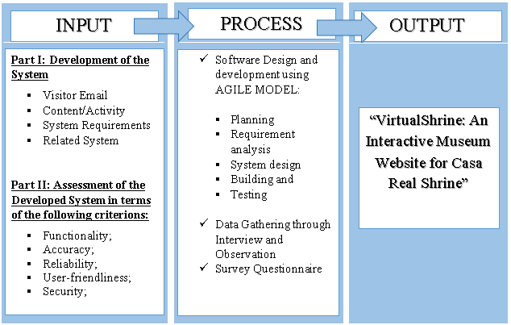

**Figure 1.** **Conceptual Model of the System Development**

**Initiation Phase**

The initiation phase begins when the client identifies the idea, need, or chance to improve the system. The purpose of the Initiation Phase is to: (a) Identify ways to further improve the system from the current situation that left a dent in visitors count, scarcity relating to the museum. (b) Ideally is to provide answers to every occurring problem.

         In this study, Virtual Shrine focused on the virtualization of the museum for visitors reassuring the safety of the visitors without compromising any content and added content as well. Adding Online Booking Admission to the system will add more security for data.

         And popular museums have done online 3D virtual tours around 1999, boosting the number of visitors both online, and in person, using the technology now as an advantage to the system. Through an online web-based system the visitors can take the tour anytime and with the Online Booking making it convenient for any visitors.

         Attentiveness to the systems performance will make sure the plans will proceed as intended in the project for a higher chance of success.

         Upon approval of the proposed system, VirtualShrine: An Interactive Museum Website for Casa Real Shrine used the feasibility study and support documentation to begin the planning phase.

**Planning Phase**

The Planning phase is a step before developing a software. This will help the developers to avoid problems in the early stage of developing the project that might help them for the future of the software. In creating the VirtualShrine website, the features of the software are important for the developers. That's why creating a plan is a must for the satisfaction of their audience.

A project becomes nothing more than a collection of tasks without a plan. The challenge for most businesses is not whether or not they have a plan, but how well that plan has been laid out and implemented. Weedmark (2019)

Weedmark (2019) also added that there are aspects for a good project plan. (a) Describe the project. This will state the main objective of the problem and problem that they may encounter, and they can solve it. The proponents of Casa Real Virtual Museum are going to reintroduce the importance of museum to the new generation of people. (b) Break down the project into specific tasks. Make certain that each activity flows naturally into the next. Since the project has many features, the proponents need to divide the task to different members including the developers. (c) Estimate the resources required for the project and make a resource plan to guarantee that the appropriate resources are gathered successfully. Creating the virtual museum needs a device to fulfill other features including 360 cameras for the virtual tour and personal computer/laptops on creating the project. (d) Develop the project schedule since the task is divided you also need to include a due date. The Proponents need to value the time of the project since the project is big time is important to avoid problems that can affect the project. (e) Develop a communication plan. Communication is a must for the proponents to make sure the project development is improving, and it includes the client for their suggestions and problems about the given project. (f) Write the statement of Work (SoW) This document outlines the tasks to be completed, deliverables, and the intended outcome once the project is completed. The proponents of Casa Real Virtual Museum should complete all the given tasks and to make sure to always consult in the Management of Casa Real Shrine to fulfill all the requirements they need.

**Design Phase**

The Design Phase includes turning every gathered information, functions, and request during the initiation and planning phases into a well-constructed design with specifications that developers use to create systems during the development phase.

As used in this study, with a thorough look at ideas for the designs, it seems there are numerous ways to implement program designs. Using Object Oriented Analysis and Design (OOAD), to identify and connect important parts or components, expanding layouts to verify each branch of systems and connections.

         Contemporary design techniques are commonly used because of its minimalist design that aren’t outdated, due to its popularity that can be used as a tool in prototyping that creates the basic foundation of items such as the layouts, system architectures. Providing end-users, designers and programmers with digital prototyping should inspect the presented prototype design in an iterative process until the design is on par with the ideal design.

         However, in designing the website for VirtualShrine, the management is very open to any ideas and will also be prepared to make changes even after presenting the system design.

         It is also important to document the complete design precisely by the designer with specific details to aid the programmer in developing and changes it may encounter. The full document will also provide help in managing the final output of the program and to verify if the system followed the original goals.

**Development Phase**

Converting the design phase into executable programs is part of the development phase.

Effective development standards at this point include specifications that the researchers design before programming begins. The processes aid in the comprehension of program designs and functional requirements.

Many programmers employ a variety of strategies to create computer programs. Procedural programming approaches have traditionally been used to construct big transaction-oriented programs connected with financial organizations. Line-by-line scripting of logical instructions that are combined to make a program is what procedural programming entails. The generation and testing of source code, as well as the refinement and finalization of test strategies, are all important procedural programming tasks. Individual programmers often write and test program modules or components, which are little routines within an application that execute a certain task Completed components are combined with other components and inspected, usually by a group of programmers, to ensure that they work together effectively. As component groups are gradually merged and interfaces between component groups and other systems are tested, the process continues.

In developing the Casa Real Shrine Museum website, system documentation includes the system description which provides the explanations of operating environments as well as the interconnected input, processing, and output operations of integrated application systems.

System flowcharts and models identify the source and kind of input information, processing and control actions and the nature and location of output information as part of the system documentation.

Flowcharts have traditionally been used by designers and developers to show graphical perspectives of procedural program sequencing. Flowcharts are a useful tool for illustrating complicated programs and processes. There is flowcharting software available that can automatically chart programs or allow programmers to dynamically chart programs without having to design them manually.

Operator instructions for all processing applications should be established by organizations. The instructions should detail how to complete certain tasks, as well as how operators should respond to system requests or interruptions. Only information relevant to the computer operator's job should be included in the documentation. An operator should not have access to program documentation such as source listings, record layouts, or program flowcharts. Operator instructions should be detailed enough that an experienced operator unfamiliar with the application can effectively complete a program without assistance.

End-user instructions that define how to use the museum website were also established by the built system. Operation manuals, online help features, and system error messages are all examples of instructions that help operators to manage the back end.

**Testing Phase**

Organizations must undergo a beta test during the testing phase to ensure the accuracy of programmed code, the inclusion of desired functionality, and the website's compatibility. Thorough testing is required to ensure that systems meet the needs of the organization and the end users. Testing teams are composed of software engineers and end users who are responsible for gathering and loading representative test data into a testing environment. Finally, testers typically find program faults or errors throughout the testing process. There should be procedures in place to guarantee that programmers address faults as quickly as possible and that any changes or revisions are documented. By decreasing tester downtime, quickly resolving issues enhances testing efficiencies. It also saves a programmer time troubleshooting a section of a program that isn't working because another programmer hasn't debugged a faulty linked code. Corrections and adjustments must be documented in order to maintain the integrity of the overall program documentation.

**VirtualShrine: An Interactive Museum Website for Casa Real Shrine of Malolos Gantt Chart**

The Gantt Chart, as illustrated in Figure 2, displays the schedule that the system's proponents will follow during its development. The Gantt Chart was used to track the progress of the system's development.

**Figure 2.** **VirtualShrine: An Interactive Museum Website for Casa Real Shrine of Malolos Gantt Chart**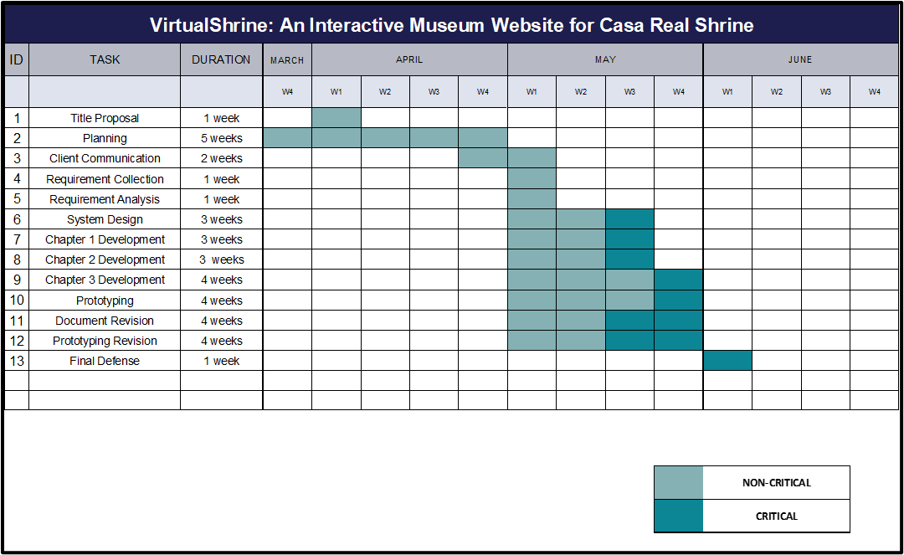

**Implementation Phase**

The implementation phase involves an approved website into production environments. In this stage, the primary tasks include the implementation schedule, training end users, and access to the website. In addition, Casa Real Shrine should input and verify data, configure, and test system and security parameters, and conduct post-implementation reviews.

Verifying the input data and security parameters for accuracy is an important element of the implementation process. Organizations frequently run a new system alongside an old system until the new system's quality and reliability are verified. During the verification process, employees should document any programming, procedural, or configuration changes.

**Project Evaluation**

In this stage, management should perform post-implementation evaluations at the end of a project to confirm that project objectives have been met and to evaluate project management actions. Management should conduct interviews with all people and staff members who are actively involved in the operational usage of a product or document and resolve any issues that are discovered.

**Maintenance Phase**

It entails making changes to software and documentation to support its operational effectiveness throughout the maintenance period. It entails making modifications to improve a system's or website's performance, resolve issues, increase security, and meet user needs. The museum should implement suitable change management standards and procedures to guarantee that alterations do not disrupt operations or harm a system's functionality or security.

**System Specifications**

Software Specifications. The system was developed using Visual Basic .Net and ASP.Net. The Visual Basic .Net and ASP .Net are software under the Visual Studio.NET. These applications will be used in creating web pages as the front-end of the application. The .NET framework features will be used for the well optimized web application.

The PHP Admin were used as the database application of the web. This will be the storage of data and other information needed by Casa Real Shrine. Jasper Report were used to display different reports.

**Hardware Specifications**

Hardware Specifications. The performance of the web application is based on the hardware used in deploying the system.

Below are the recommended hardware requirements:

**Requirements for Web Server**

Table 1 shows the requirements for the Web Server. The minimum requirement for the processor is 1.6 GHz CPU and the recommended requirement is 2x1.6 GHz CPU. For RAM, the minimum requirement is 1.75 GB RAM, and the recommended requirement is 3.5 GB RAM. And lastly, for HDD, both the minimum and recommended requirement is 40 GB.

|  |  |  |
| --- | --- | --- |
| **Hardware Requirement** | **Minimum Requirement** | **Recommended Requirements** |
| Processor | 1.6 GHz CPU | 2 x 1.6 GHz CPU |
| RAM | 1.75 GB RAM | 3.5 GB RAM |
| HDD | 40 GB | 40 GB |

**Table 1. Requirements for Web Server**

**Requirements for Database Server**

Table 2 shows the requirements for the Database Server. The minimum requirement for the processor is 2x 1.6 GHz CPU and the recommended requirement is 4x1.6 GHz CPU. For RAM, the minimum requirement is 3.5 GB RAM, and the recommended requirement is 7 GB RAM. And lastly, for HDD, both the minimum and recommended requirement is 40 GB.

|  |  |  |
| --- | --- | --- |
| **Database Server Requirement** | **Minimum Requirement** | **Recommended Requirements** |
| Processor | 2x 1.6 GHz CPU | 4 x 1.6 GHz CPU |
| RAM | 3.5 GB RAM | 7 GB RAM |
| HDD | 40 GB | 40 GB |

**Table 2. Requirements for Database Server**

**Requirements for Android Server**

Table 3 shows the requirements for the Android Server. The minimum requirement for the processor is ARM Mali-T880 MP4 and the recommended requirement is ARM Mali-G52 MP2. For RAM, the minimum requirement is 2.5 GB RAM, and the recommended requirement is 7 GB RAM. And lastly, for HDD, both the minimum and recommended requirement is 40 GB.

|  |  |  |
| --- | --- | --- |
| **Database Server Requirement** | **Minimum Requirement** | **Recommended Requirements** |
| Processor | ARM Mali-T880 MP4 | ARM Mali-G52 MP2 |
| RAM | 2.5 GB RAM | 7 GB RAM |
| HDD | 40 GB | 40 GB |

**Table 3. Requirements for Android Server**

**Requirements for IOS Server**

Table 4 shows the requirements for the IOS Server. The minimum requirement for the processor is Apple A4 and the recommended requirement is Apple A6. For RAM, the minimum requirement is 2.5 GB RAM, and the recommended requirement is 7 GB RAM. And lastly, for HDD, both the minimum and recommended requirement is 40 GB.

|  |  |  |
| --- | --- | --- |
| **Database Server Requirement** | **Minimum Requirement** | **Recommended Requirements** |
| Processor | Apple A4 | Apple A6 |
| RAM | 2.5 GB RAM | 7 GB RAM |
| HDD | 40 GB | 40 GB |

**Table 4. Requirements for IOS Server**

**System Design and Processes**

**Front Office:** The website's front office consists of the following menus: (1) Home. The Home page is the system's default web page. The home page displays a welcome banner for visitors, as well as a "book a tour" and "plan your visit" buttons for visitors' convenience. The homepage also highlights featured exhibitions and information, upcoming events, galleries, and group trips. The homepage also includes a footer with basic information about the museum, contact information, quick links, and a list of social media pages that visitors can like or follow. (2) Plan your visit. This website displays information on the museum's operations, such as the opening time, location, museum map that can be seen and downloaded in PDF format, and health and safety guidelines that visitors must follow. This website will assist visitors in preparing for their visit to the museum, this way, they will have a hassle-free visit; (3) Booking Reservation. The visitor can book for reservation for their physical museum visit. Pre-booking is recommended to have a hassle-free visit. The visitor will enter the date and time of reservation, and the number of people who will visit; the system will also ask for the representative visitor information such as name, email that were used for the confirmation, mobile number, address, and the name of company, agency, or school if applicable. At the end of reservation, the visitor will receive an Acknowledgement Receipt on the email they provided with the following details:  (a) Reservation Date and Time; (b) Total number of visitors. (4) Virtual Tour. This page displays the virtual tours such as the permanent and current exhibits, virtual gallery with a 360 view of the 5 galleries available in the museum, and the narrated tours.

**Back Office:** The back office serves as the system administrator and website content manager site where they can view booking lists, approve, or decline bookings, update the website content, post an announcement, and add an assistant admin.

**Head Administrator:** The Head administrator is mainly the museum curators. The Back Office of the head administrator composed of the following menus: (1) Add user. They will be able to register an assistant administrator. (2) Edit user. able to set their own type of user that will handle the back office. (3) Edit user information. able to modify the assistant admin. (4) Remove user. Has the ability to delete assistant user account in the back office. (5) Reservation. Viewing, approving, and declining of reservation done by the visitor. (6) Update Contents. The head administrator will be able to add, update, and delete the content of the front office.

**Assistant Administrator**: The user of this application is mainly the employee of Casa Real Shrine who handles the booking reservations. The Back Office is composed of the following menus: (1) Log In. The user of the system can log in to access other functions or menus of the system. Required username and password assigned by the head administrator. See security matrix for access role (Table 5); (2) Reservation. Viewing, approving, and declining of reservation done in this module. Any action done by the administrator regarding the status of the reservation application by the client, the system will automatically notify the client via email they provided during the booking process. Reason for declined application must be stated; (3) Update Contents. The assistant administrators can update the content on the website, such as updating the gallery contents, new exhibits, and museum information; (4) Post Announcements. Posting of announcements and events. Figure 3 shows the flow chart of the back-office part of the website. Only the administrator can access the back office of the system.

**Context Diagram (Level 0)**

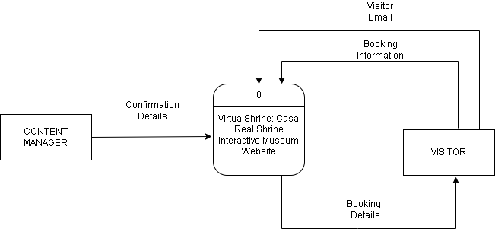The figure 3 shows the Level 0 of the Context Diagram, this displays the input and output of the booking of Casa Real Shrine

**Figure 3. Context Diagram (Level 0)**

**Data Flow Diagram (Level 1)**

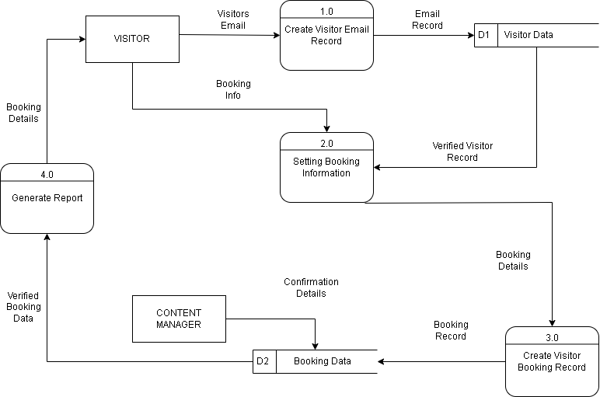The figure 4 shows the Level 1 of Data Flow Diagram, the system displays the process specifically from the Visitors to the content manager/admin who will interact with the system.

**Figure 4. Data Flow Diagram (Level 1)**

**Entity Relationship Diagram – Booking System**

The figure 5 displays the data for the booking system.

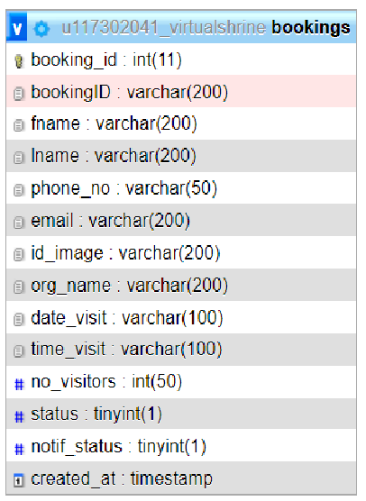

**Figure 5. Entity Relationship Diagram – Booking System**

**Entity Relationship Diagram – Admin and Type of User**

The figure 6 displays the data for the Admin User.

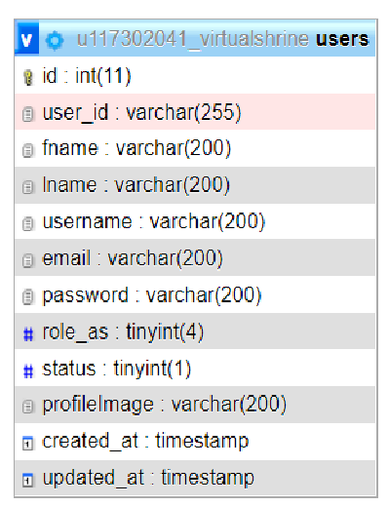

**Figure 6. Entity Relationship Diagram – Admin and Type of User**

**Entity Relationship Diagram – Exhibit**

The figure 7 displays the data for the Exhibit.

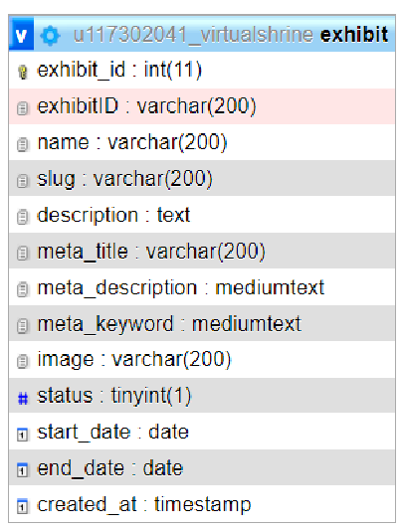

**Figure 7. Entity Relationship Diagram – Exhibit**

**Entity Relationship Diagram – Exhibit Display**

The figure 8 displays the data for the Exhibit Display.

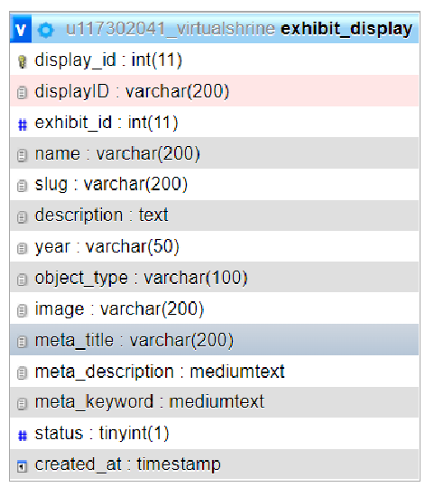

**Figure 8. Entity Relationship Diagram – Exhibit Display**

**Entity Relationship Diagram – Blog**

The figure 9 displays the data for the Blog.

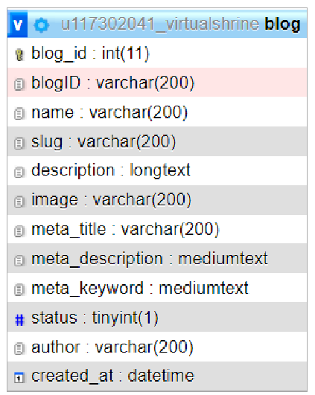

**Figure 9. Entity Relationship Diagram – Blog**

**Entity Relationship Diagram – Audit log**

The figure 10 displays the data for the Audit log.

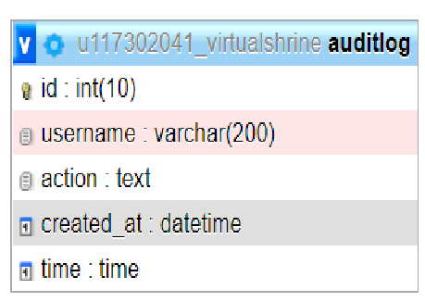

**Figure 10. Entity Relationship Diagram – Audit log**

**Entity Relationship Diagram – Categories and Posts**

The figure 11 displays the relationship between categories and posts.

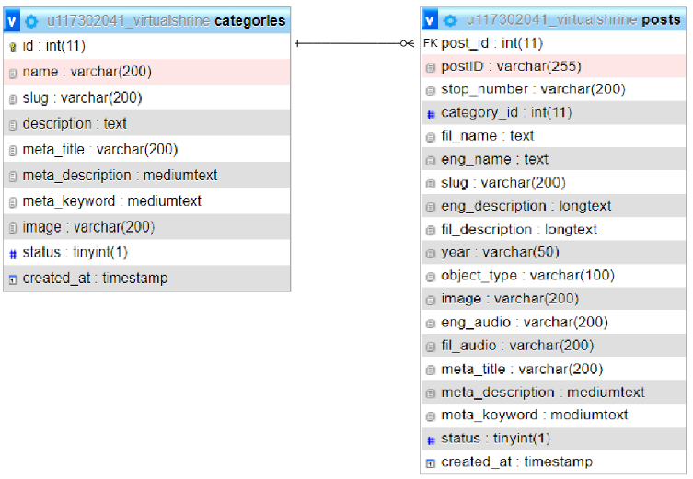

**Figure 11. Entity Relationship Diagram – Categories and Posts**

**Use Case Diagram**

The figure 12 shows the use-case diagram that shows and describes the context and objectives of an entire system to its users.

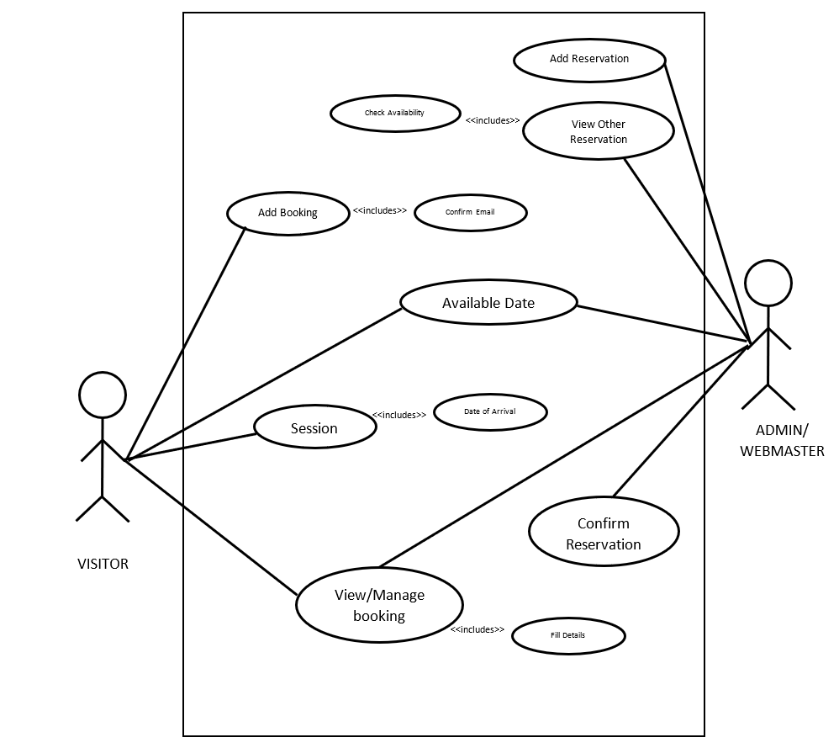

**Figure 12. Use Case Diagram**

**Booking Admission Flowchart**

The figure 13 shows the booking procedure done in the booking reservation website page.

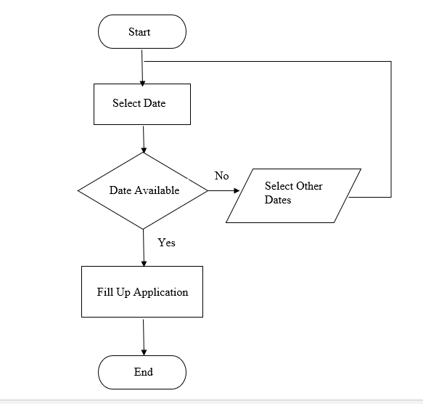

**Figure 13. Booking Admission Flowchart**

**Content Management Flowchart**

The figure 14 displays the process on how the admin monitors and updates the website content.

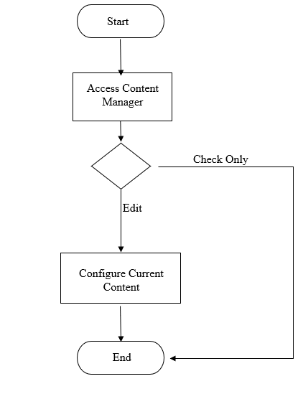

**Figure 14. Content Management Flowchart**

**Admin View VTOC**

The figure 15 shows the whole flow of the Admin/Webmaster view of the VirtualShrine website content management system.

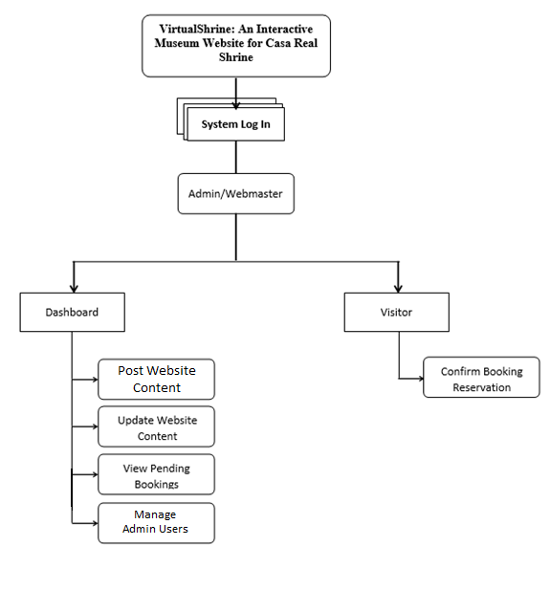

**Figure 15. Admin View VTOC**

**Conceptual System Design**

The VirtualShrine: An interactive museum website for Casa Real is an interactive website that offers interactive features that would help the museum attract more visitors. One of the functionalities of the system is browsing the features and book reservation for the physical museum visit in the desired date and time of the visitors. Financial Transactions such as selling products from the museum gift shops are not included in this system. The system also does not require the visitor to register for an account, the only time that the system will ask for the visitor’s information is when they book for reservations.

**System Architecture**

**The Client’s Access to the Website**

Figure 16 shows the user’s access to the website via the internet through their computer terminal.

The web server replies and saves the client’s request to the database server.

The content manager can access the back office of the system via an intranet connection to maintain and update the system.

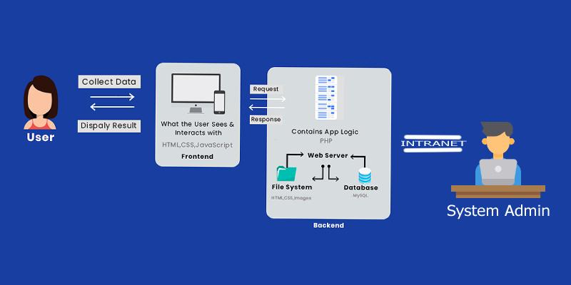

**Figure 16. The Client’s Access to the Website**

**Security Matrix**

This security matrix applies only on the Back-Office application. The matrix shows the accessibility rights of every user of the system.

The following are the different modules that the Administrator can access and modify, Upload/Update the contents of the museum like a virtual gallery.

|  |  |  |  |  |  |  |  |  |  |  |  |  |  |  |  |  |  |  |  |  |  |  |  |  |  |  |  |  |  |  |  |  |  |  |  |  |  |  |  |  |  |  |  |  |  |  |  |  |  |  |  |  |
| --- | --- | --- | --- | --- | --- | --- | --- | --- | --- | --- | --- | --- | --- | --- | --- | --- | --- | --- | --- | --- | --- | --- | --- | --- | --- | --- | --- | --- | --- | --- | --- | --- | --- | --- | --- | --- | --- | --- | --- | --- | --- | --- | --- | --- | --- | --- | --- | --- | --- | --- | --- | --- |
| |  |  |  |  | | --- | --- | --- | --- | | **Module** | **Head**  **Admin** | **Assistance  Admin** | **User** | | Log In | ✔ | ✔ |  | | View All Booking Reservation | ✔ | ✔ |  | | Approve/Decline Reservation | ✔ | ✔ |  | | Upload/Update website content | ✔ | ✔ |  | | View Website Content | ✔ | ✔ | ✔ | | Add User | ✔ |  |  | | View User Information | ✔ |  |  | | Edit User Information | ✔ |  |  | | Archive User | ✔ |  |  | | Book Reservation | ✔ | ✔ | ✔ | | Archive Contents | ✔ |  |  | | Update Personal Profile | ✔ | ✔ |  | |

**Table 5. Security Matrix**

**The Online Booking Reservation Process**

The booking reservation process of VirtualShrine can be done through online transactions as shown in Figure 6. However, there are some instances that the visitor is not actually using the internet to have their reservation. They visit the museum as walk-in customers.

In order to handle the data that will be submitted by the customer, the system will use a database server which is directly connected to a web server for internet connectivity. Maintenance, modifications, and update can be done by the administrator.

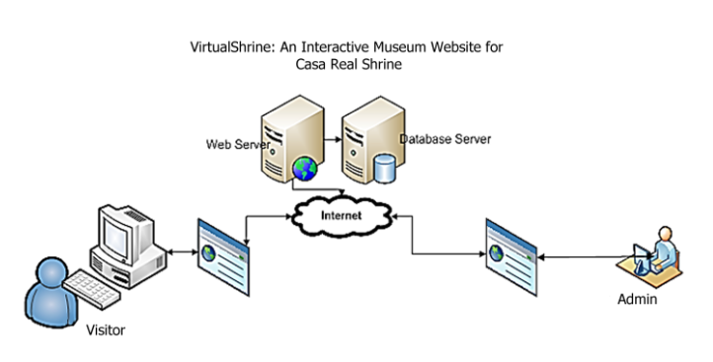

**Figure 18. Online Booking Process**

**The Walk-in Admission Process**

Figure 18 will show the illustration for the walk-in admission process. For the customer to make visiting admission, the following steps must be followed:

Step1: Customer inquiries at the Museum staff about the visiting slot availability.

Step 2: The Museum staff will log in to the System Back Office. He will ask for the date of reservation and what to reserve. Using the System, the museum staff can give the availability of the admission slots.

Step 3: Once the visitor decides to book for admission, the clerk will ask the user the basic information for profiling purposes.

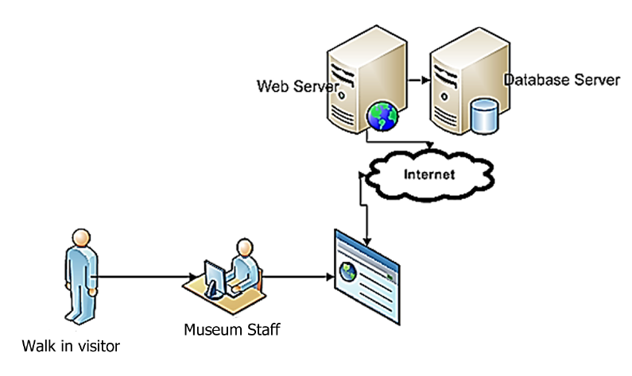

**Figure 19. Walk-in Admission Process**

**Network Infrastructure**

Figure 19 will show the network infrastructure of the VirtualShrine Website.

Since the proposed system is an interactive website, Internet connection is particularly important. As can be seen from the figure (Fig. 18), the visitor can browse the VirtualShrine website, and their reservation can be done.

Also, the system will allow website visitors to search for museum information such as operation hours and location from the museum website.

On the part of the Administrator (back-office account), the system will allow the Website Manager (administrator) to make modifications including updating the contents of the website. They can also approve and reject a booking from the visitor.

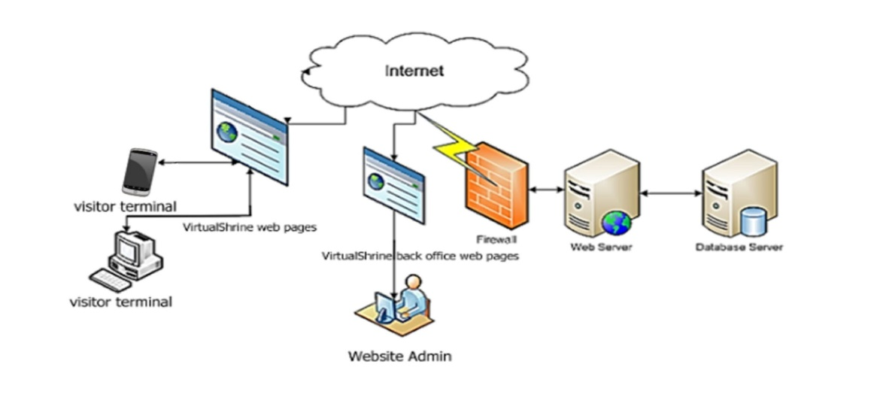

**Figure 20. The Network Infrastructure**

**Description of Prototype**

**VirtualShrine Homepage**

Figure 21 displays the home page of Casa Real Shrine. This page was the default page shown in the browser when a user loads the website.

The following were what can be seen in the website homepage; (1) header. It was located on the top part of the website. The header includes the website logo, and navigation menu; (2) Welcome banner. The welcome banner displays a short welcome greeting for VirtualShrine visitors, the “Book a tour” and “Plan your visit” button, and the basic museum information such as the day and time of museum operation; (3) What to see. This part of the website will display an overview of what the visitor would see on the website; (4) Featured Exhibits. The main objective of this feature is to make the online visitors aware of the ongoing exhibits on the museum, this will serve as the exhibit promotion; (5) Upcoming Events. Announcement about the upcoming events in the museum will be displayed; (6) Museum Fundraising. This part of the homepage served as a promotion for the fundraising of the museum. and lastly; (7) Website Footer. It’s located on the bottom part of the webpage, the footer includes the brief introduction about the Casa Real Shrine Museum, contact information, quick links, links to the museum social media accounts, and a copyright notice.

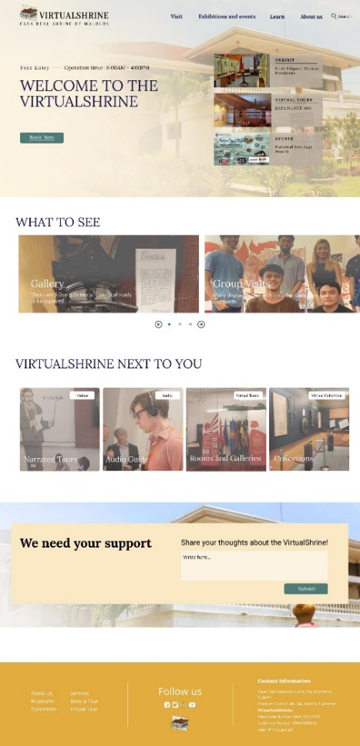

**Figure 21. VirtualShrine Homepage**

**Data Privacy Issue disclaimer**

Figure 22 displays the data privacy issue disclaimer, this was displayed before allowing the visitor to proceed to the booking page, this page serves as a reminder and an agreement for both the museum and the visitor regarding the use of the data that was provided by the visitor during the booking process.

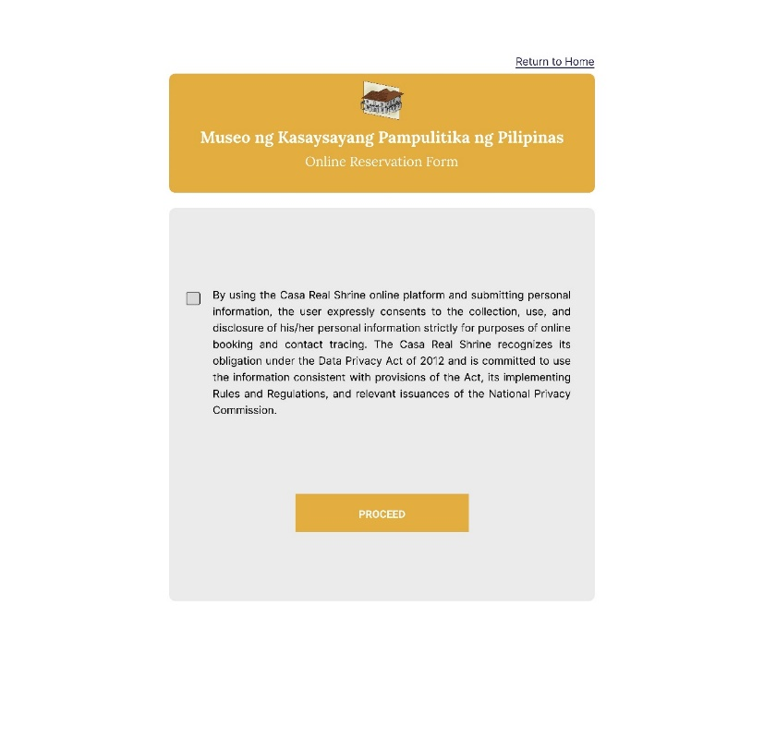

**Figure 22.** **Data Privacy Issue disclaimer**

**Data Privacy Issue disclaimer – Warning**

Figure 23 shows the Data Privacy Issue disclaimer – Warning.The visitor have to check the checkbox that means they agree to the terms and conditions. But if the visitors dis not click the checkbox and clicked the proceed button, the website can display a warning reminding them to click the checkbox first before proceeding.

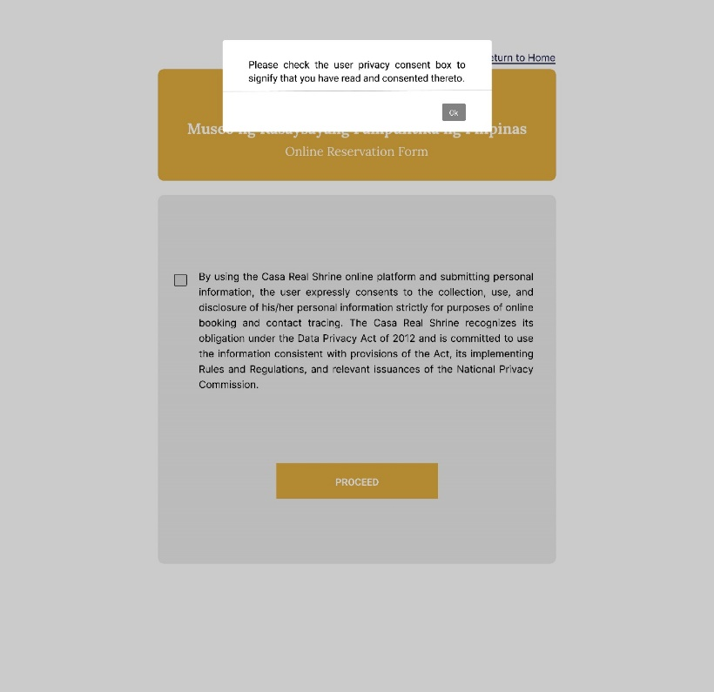

**Figure 23.** **Data Privacy Issue disclaimer – Warning**

**Online Reservation Form page – Online Reservation Form**

Figure 24 displays the Online reservation form. the website will ask for the personal information of representative visitor, this includes the representative name, email for the confirmation of the reservation, Permit letter for the visit from the visitor’s institution or organization, and valid ID to confirm if the booking was from a legit individual or organization, and lastly, the name of company, agency, or school.

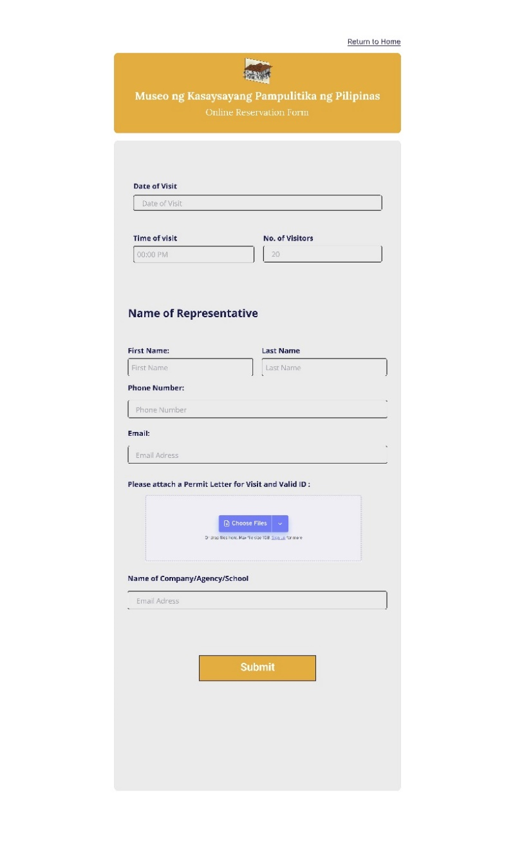

**Figure 24.** **Online Reservation Form page – Online Reservation Form**

**Online Reservation Form page – Calendar**

The Online reservation form also provides a calendar. The availability of the date is presented through a color code; yellow means admissions are available, green is the day the visitor selected, gray means the museum is closed, and dark yellow for the dates that are not available.

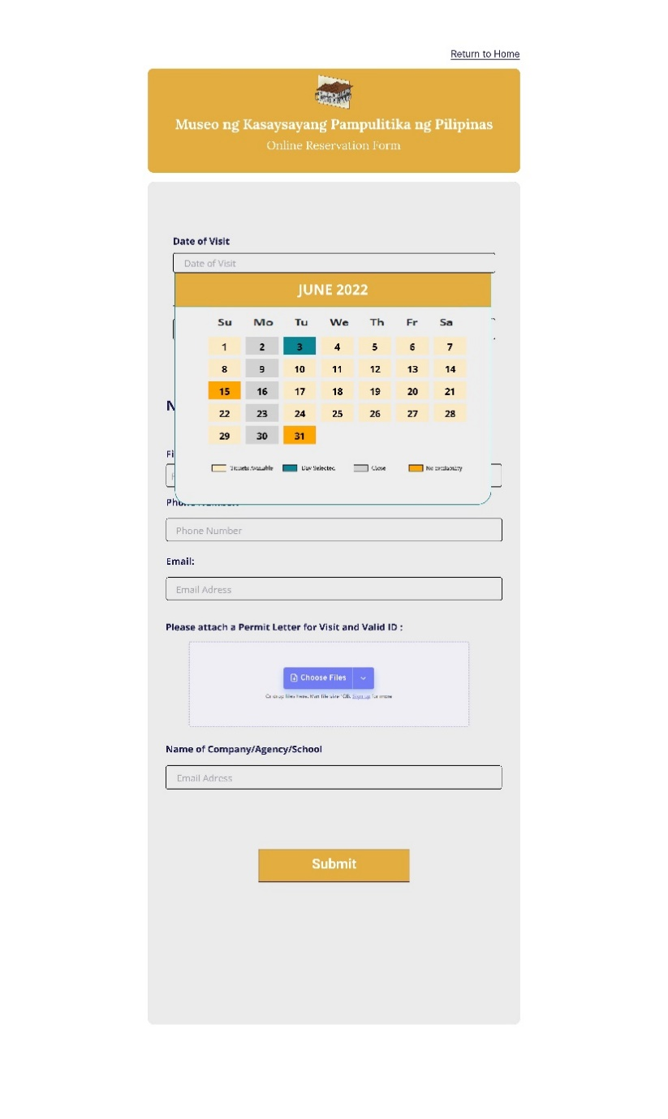

**Figure 25. Online Reservation Form page – Calendar**

**Reservation Confirmation page**

Figure 26 displays the Confirmation page of the reservation. Once the visitor successfully fills out the form, the website will display a confirmation message.

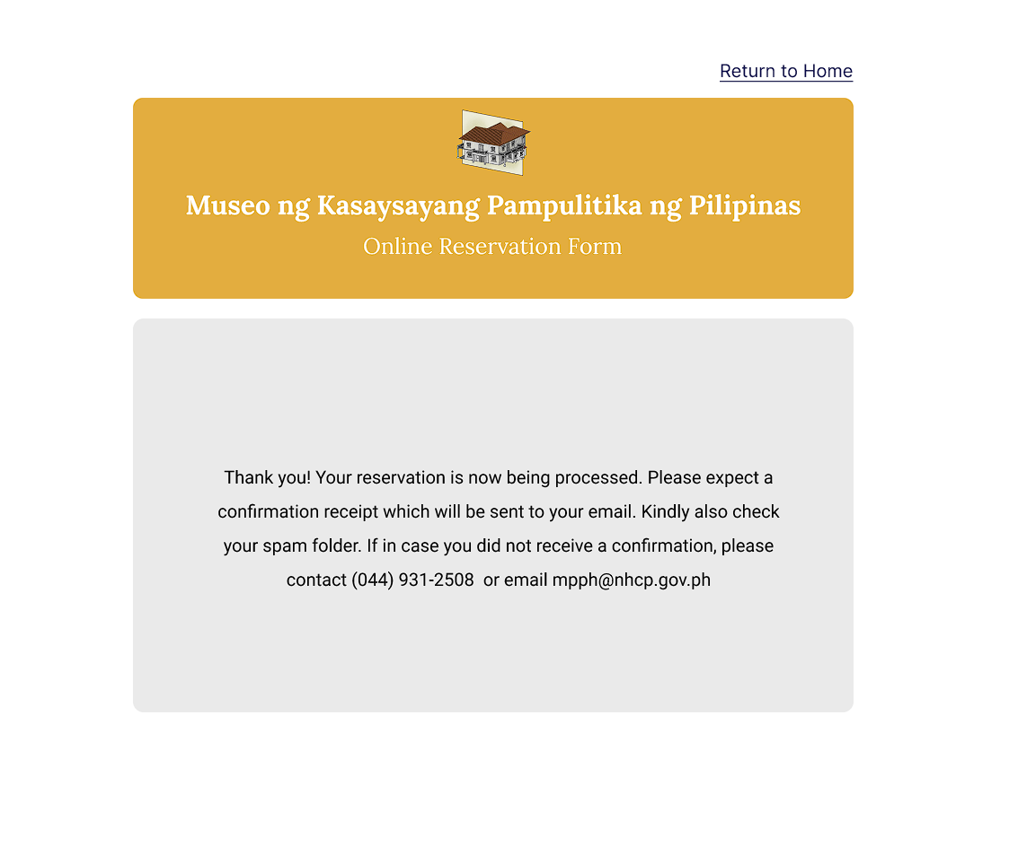

**Figure 26. Reservation Confirmation page**

**Plan your visit page**

Figure 27 shows the ‘plan your visit’ page. This is where the VirtualShrine visitors could view the general information they need to know before they visit the physical museum. This page includes the information about the General Admission and Health and Safety guidelines, museum operation date and time, location, and the thumbnails that link to another page such as the galleries, educational tours, and exhibitions and events.

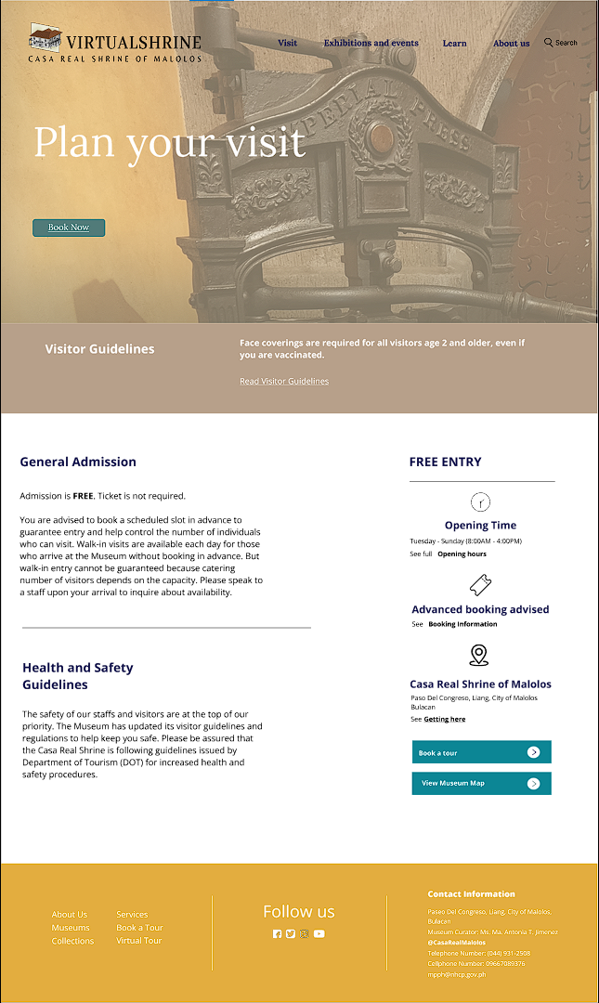

**Figure 27. Plan your visit page**

**Galleries page**

Figure 28 shows the Virtual Shrine website's Galleries page. This page allows website visitors to browse the museum's galleries. Each gallery is distinguished by the floor on which it is placed. The proponents did this so that the VirtualShrine visitor would know on which floor each gallery is placed.

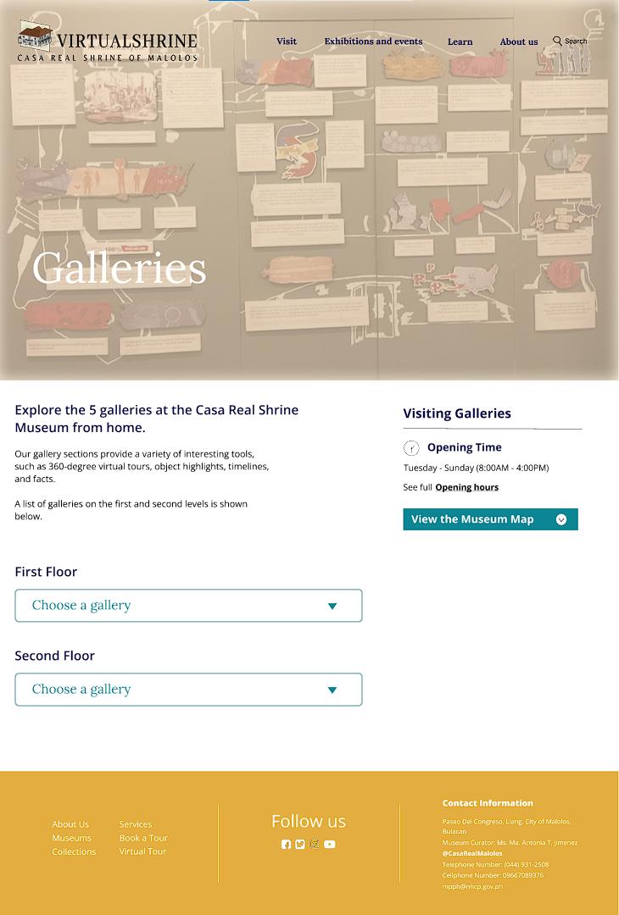

**Figure 28. Galleries page**

**Virtual Tours page**

Figure 29 displays the VirtualShrine’s virtual tours page. This page displays the virtual museum tours for the VirtualShrine visitors.  The goal is for website visitors to be able to experience the museum without having to visit the real museum. This page also contains virtual tour tips that could assist website visitors in navigating the tours so that they can enjoy the virtual tour without difficulty.

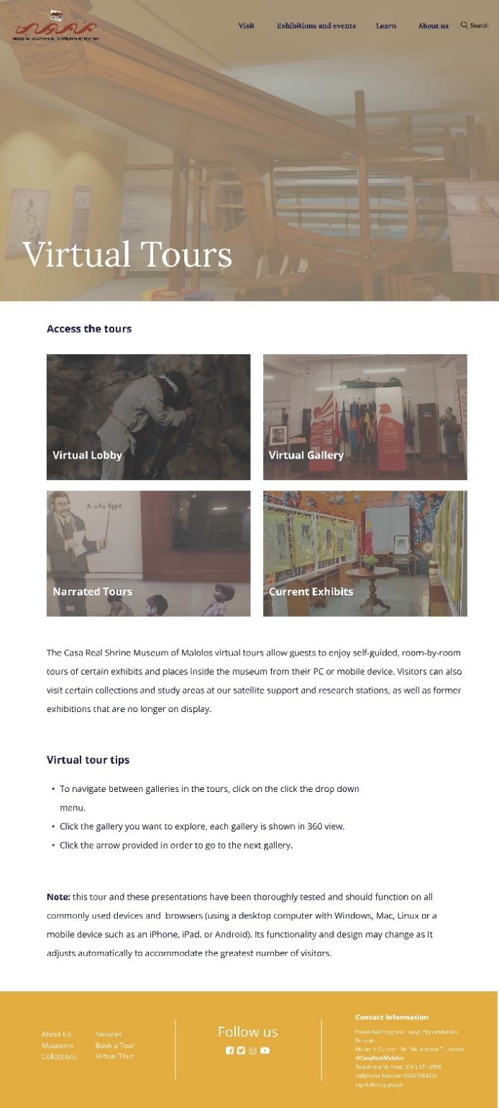

**Figure 29. Virtual Tours page**

**Virtual Tour – Gallery 360° View**

Figure 30 displays one of the VirtualShrine feature, the Virtual Gallery 360° view. This feature is added into the website to allow the VirtualShrine visitor witness how the inside of the Casa Real looks like.

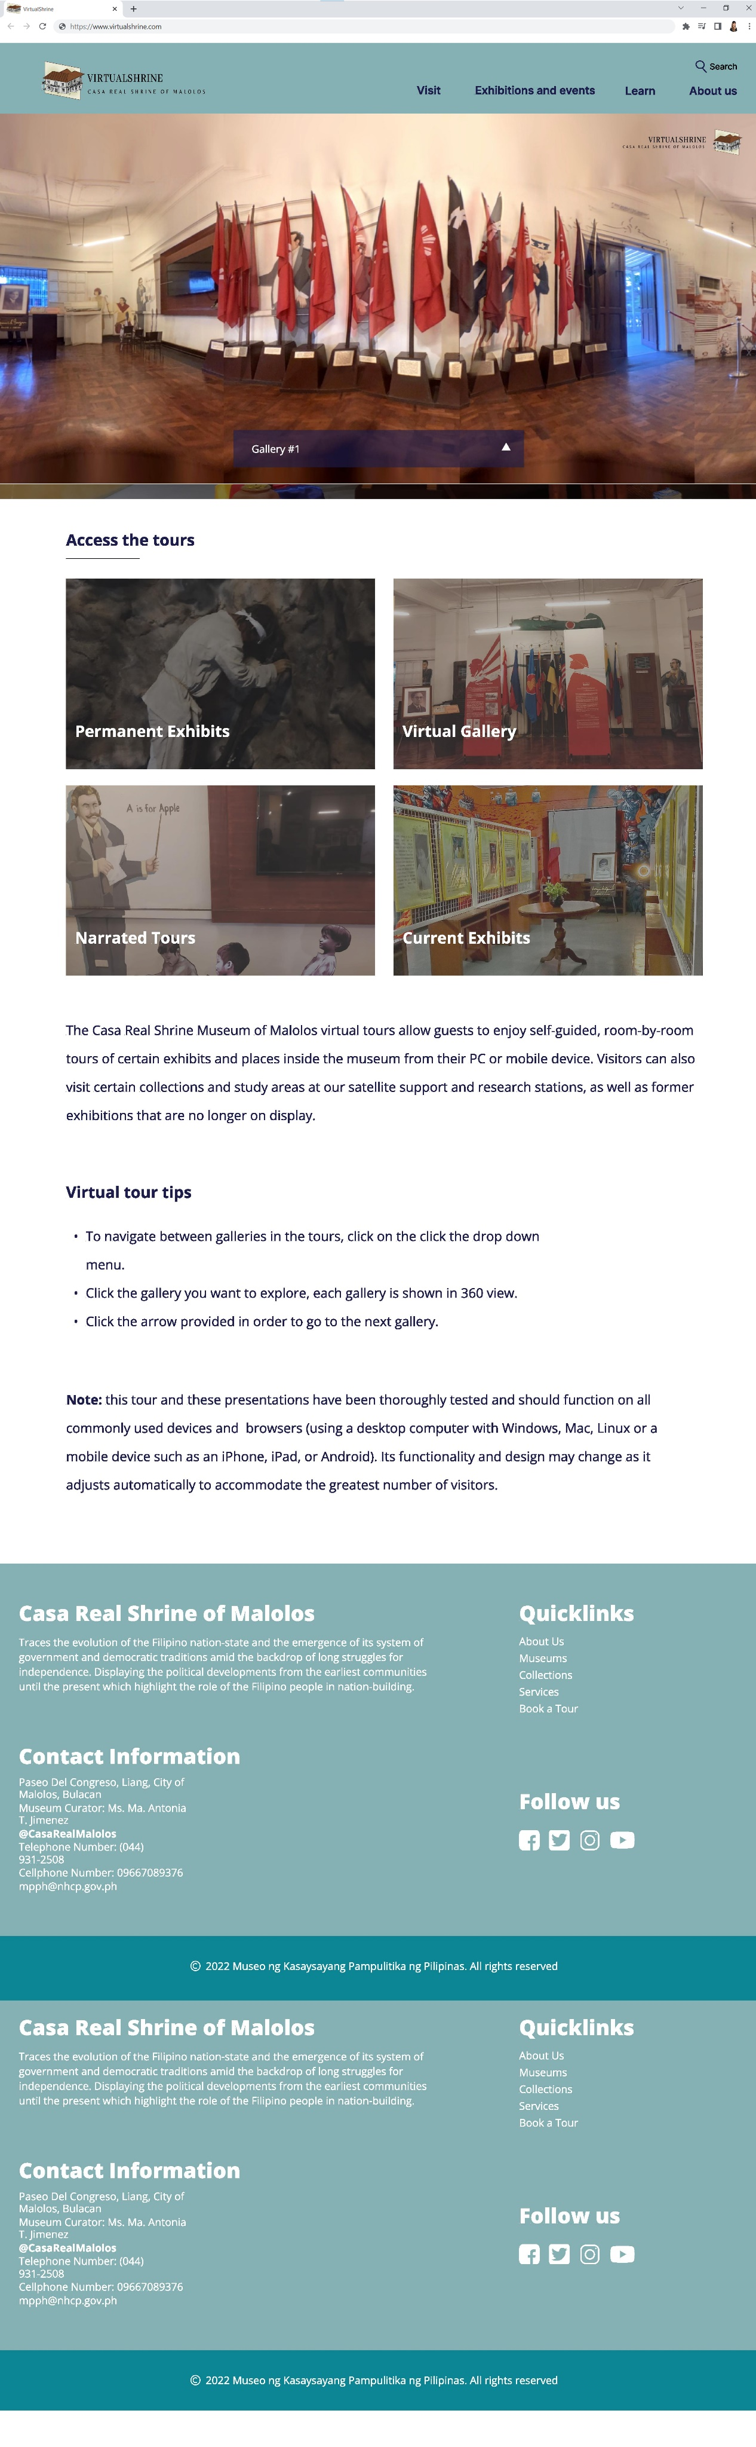

**Figure 30. Virtual Tour – Gallery 360° View**

**Gallery 360° View Navigation**

Figure 31 illustrates how the visitor of VirtualShrine can go from one gallery to another. By selecting an option from the drop-down menu, the website will display gallery selections, from which the visitor can select the next gallery to explore.

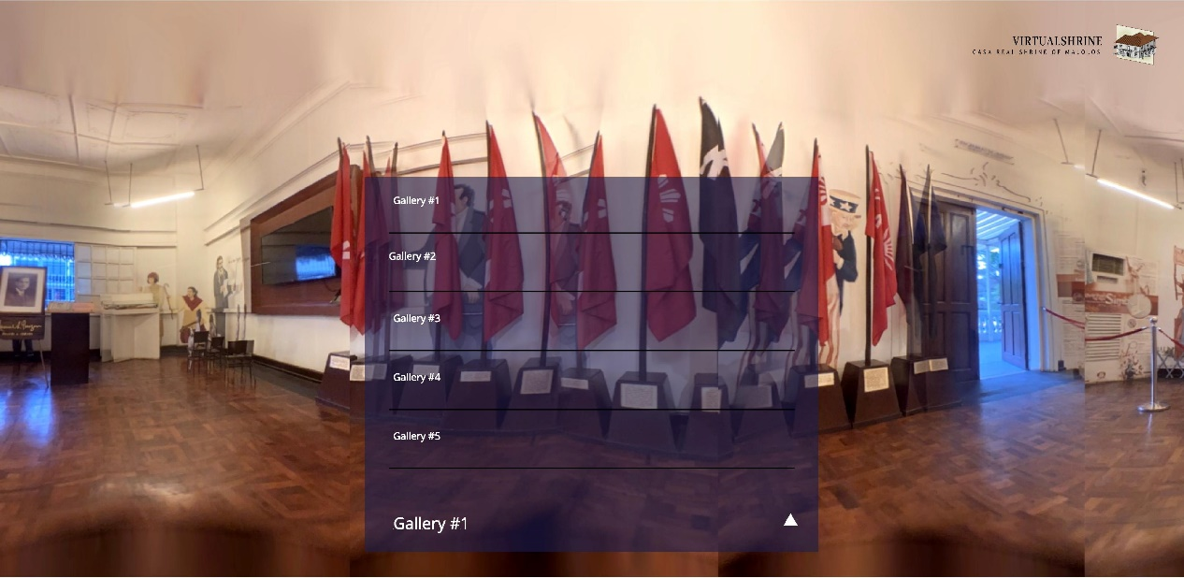

**Figure 31. Virtual Tour – Gallery 360° View Navigation**

**Virtual Tour – Gallery 360° View Navigation**

Figure 32 displays the navigation of Gallery 360. Once the VirtualShrine visitor clicks on any of the gallery on the drop-down menu, the website will automatically redirect the visitor to the chosen gallery.

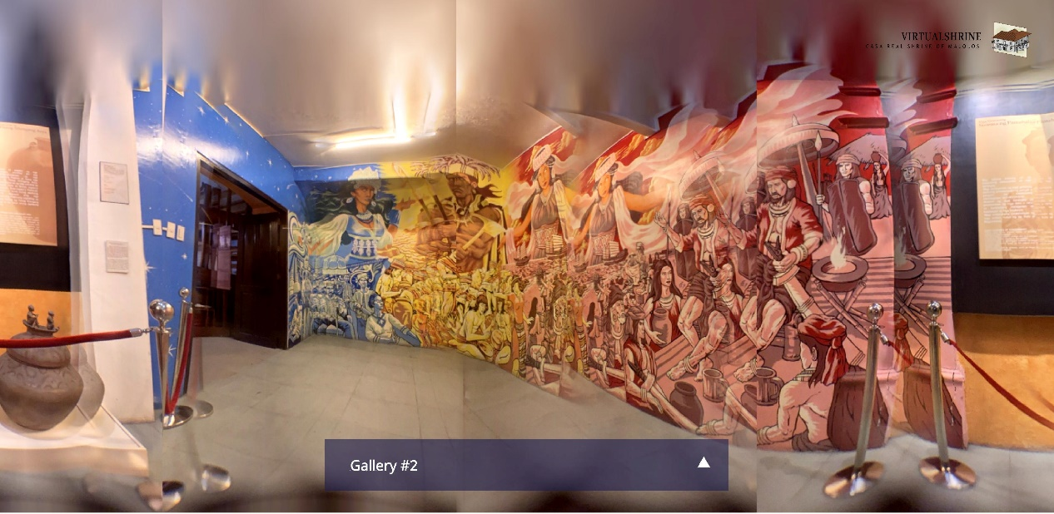

**Figure 32.** **Virtual Tour – Gallery 360° View Navigation**

**Gallery 360° Display Short Information**

Figure 33 displays the Short Information navigation of the display. The visitor will just have to click the “click me” button found right next to the display.

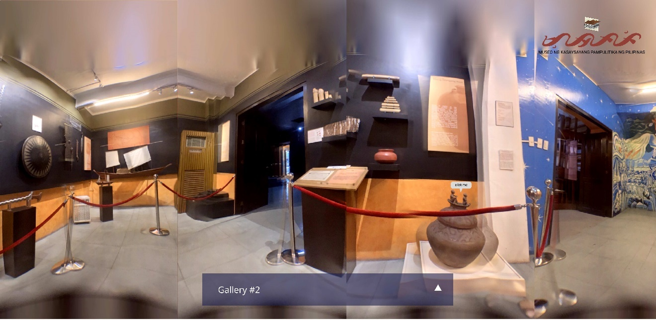

**Figure 33.** **Virtual Tour – Gallery 360° Display Short Information**

**Gallery 360° Display Short Information**

Figure 34 displays the Gallery 360° Display Short Information. After clicking the “click me” button, the website will automatically display the short information regarding the display.

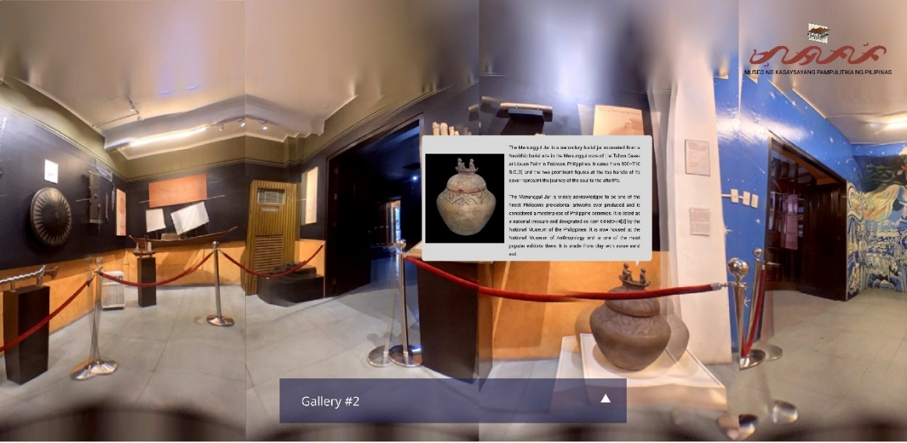

**Figure 34.** **Virtual Tour – Gallery 360° Display Short Information**

**Virtual Tour - Virtual Lobby Events**

Figure 35 displays one of the features of the virtual tour. The Virtual Lobby. On this page, it displays all the avialble events that the visitor can join in to.

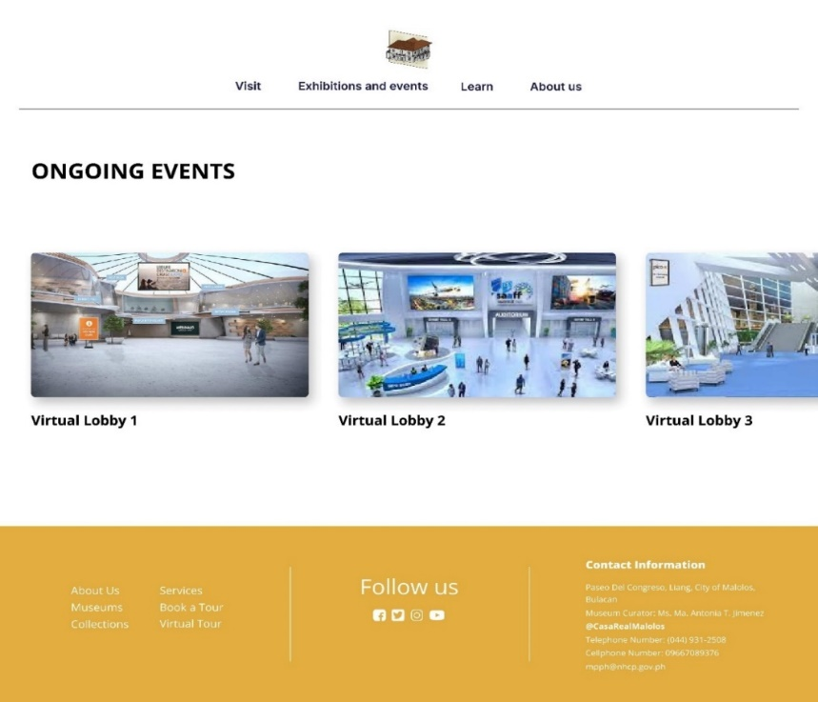

**Figure 35.** **Virtual Tour - Virtual Lobby Events**

**Virtual Lobby**

Figure 36 displays the virtual lobby where the even are being help. It has an interactive features that the visitors can use, like help desk, exhibit halls, and more depending on the type of event that is being held.

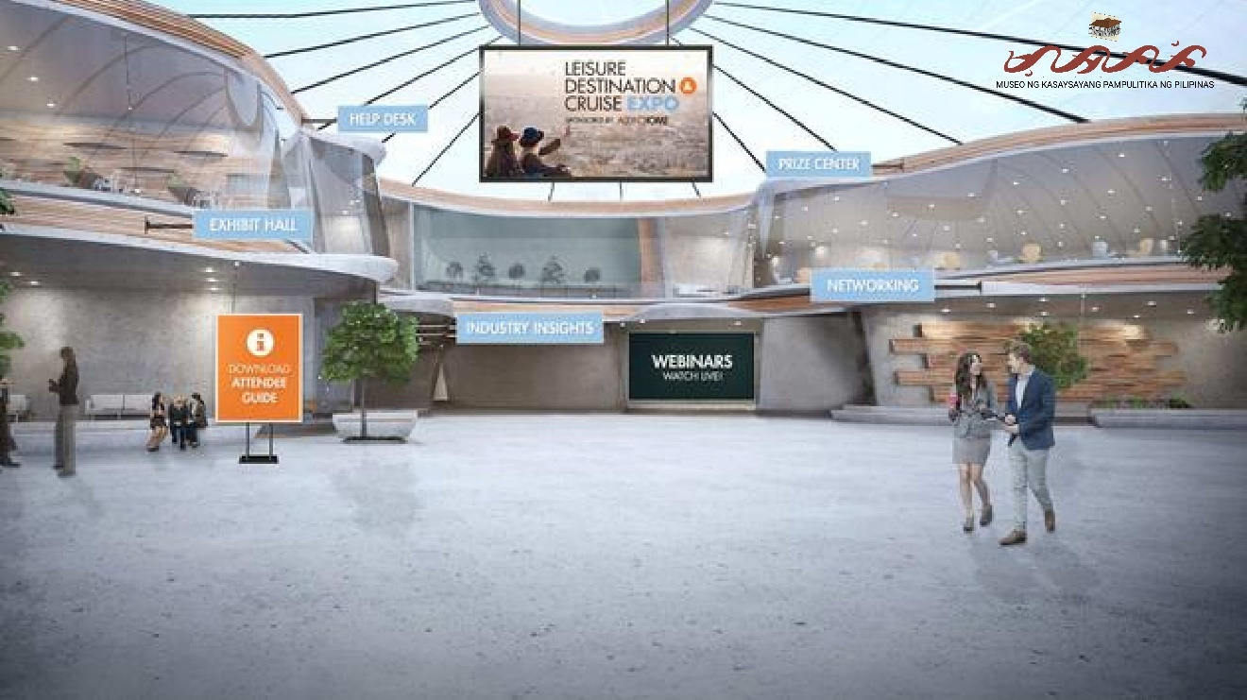

**Figure 36. Virtual Lobby**

**Audio Guide**

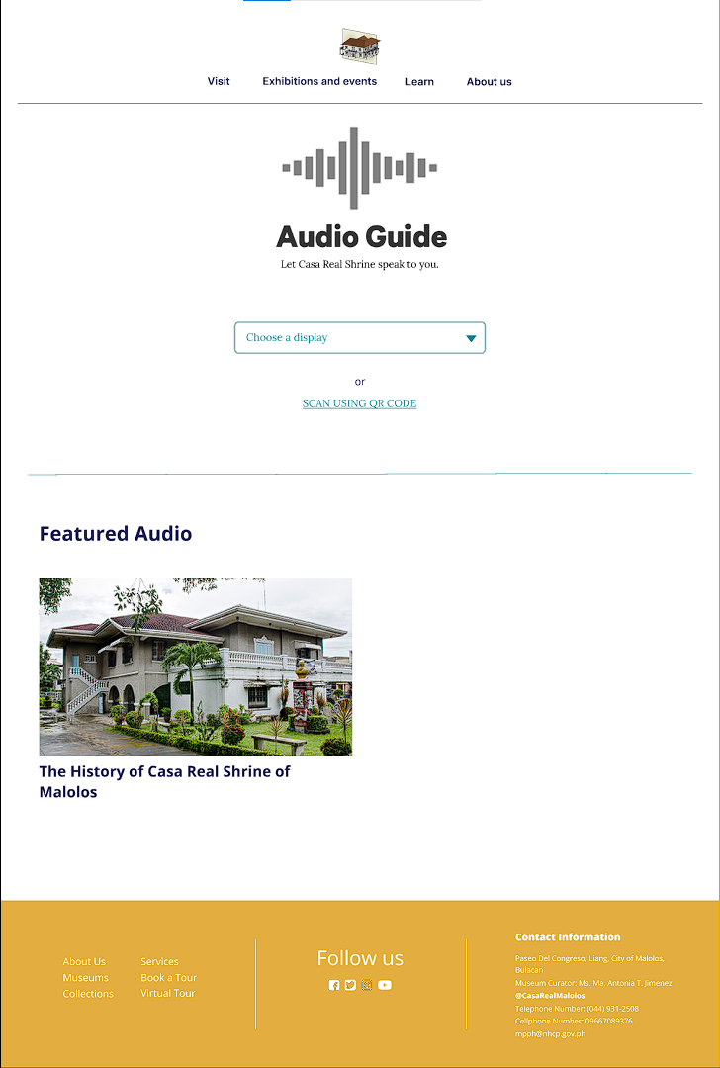Figure 37 shows the Audio Guide page of the VirtualShrine. This is one of the features offered in the VirtualShrine, the purpose of this feature is to deliver a spoken commentary about the exhibit or display. This feature will allow the visitors to have more flexibility as they explore throughout the museum.

**Figure 37. Audio Guide**

**Audio Guide – Choose a gallery**

Figure 38 displays how to access the audio contents, the visitor must first choose a gallery from the drop-down menu.

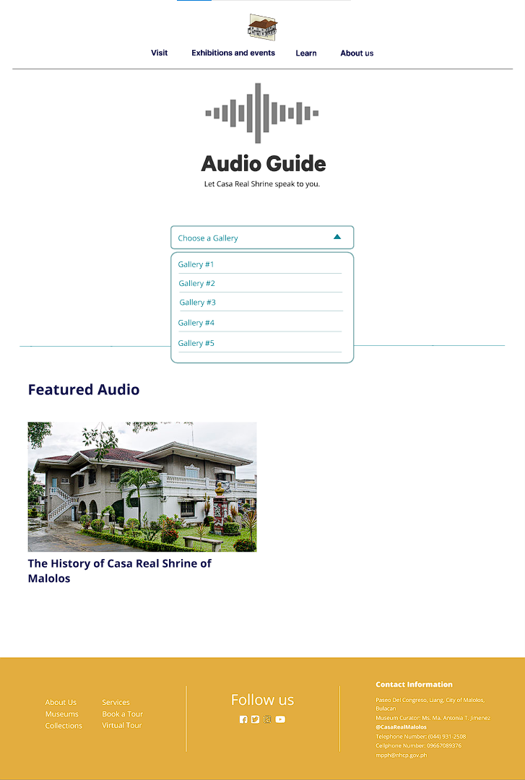

**Figure 38. Audio Guide – Choose a gallery**

**Audio Guide – Gallery Playlist**

Figure 39 displays the gallery Playlist. Once the visitor chooses a gallery, the website will redirect to the Gallery playlist where all the audio guides for the specific galley are displayed. The visitor can also choose a language they desire, they can select a language on the radio button located at the upper part of the page. After choosing a language, the visitor can now choose any audio to play.

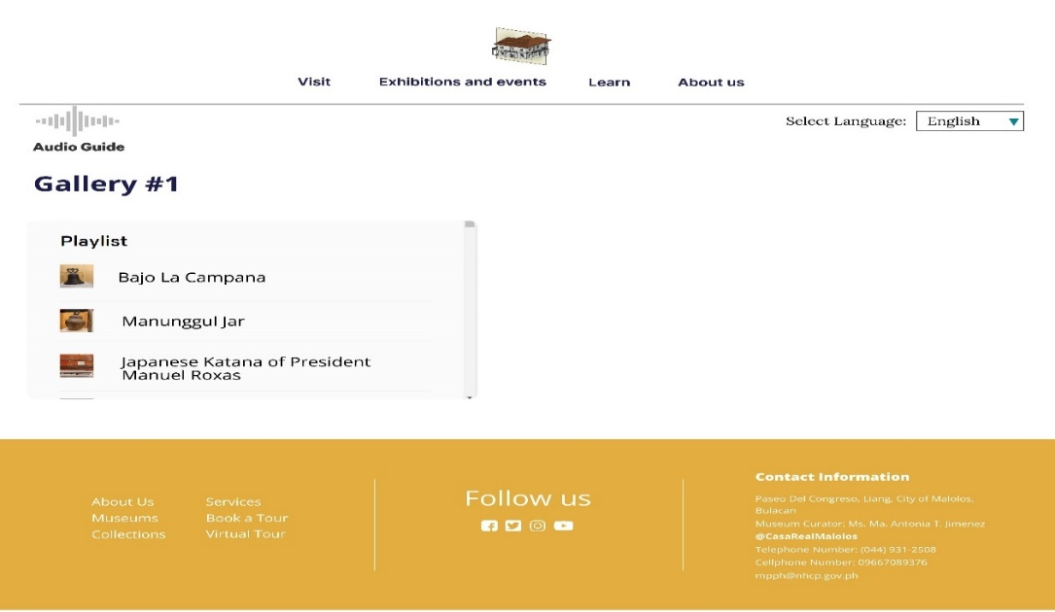

**Figure 39.** **Audio Guide – Gallery Playlist**

**Audio Guide – Playlist**

Figure 40 displays the Audio Guide Player. After the visitor chooses an audio from the playlist. The website will automatically play the audio.

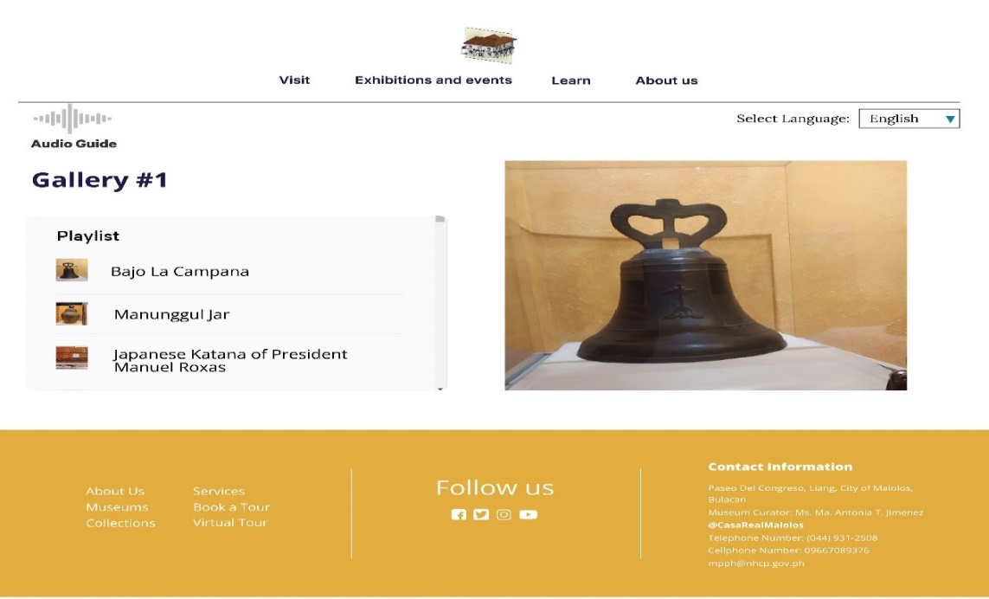

**Figure 40. Audio Guide – Player**

**Head Admin – Log in page**

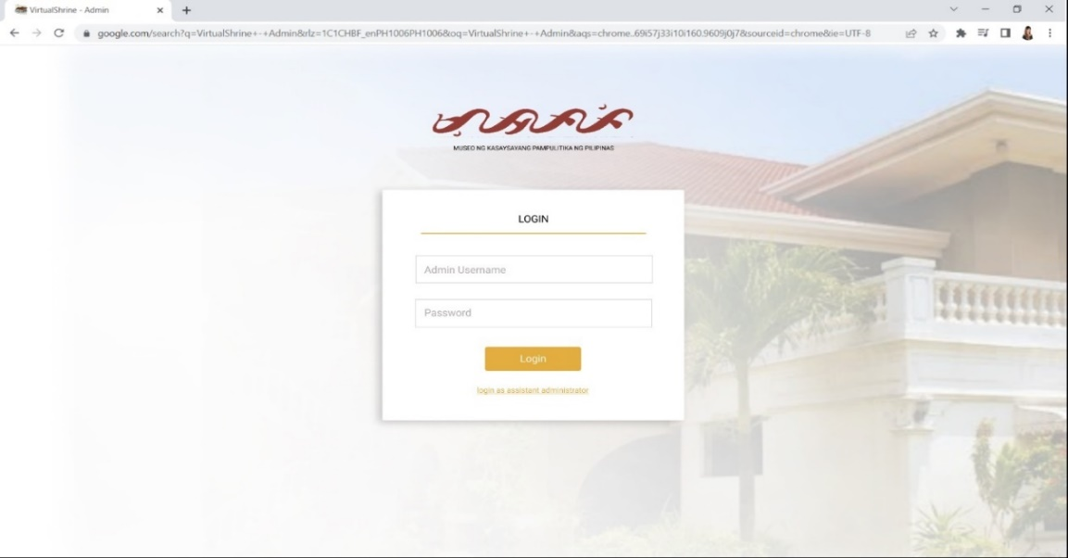Figure 41 displays the Log in page for the head admin.

**Figure 41. Head Admin – Log in page**

**Head Admin – Main Dashboard**

Figure 42 shows the Main dashboard for the head admin. Once the head admin successfully signs in into the system, they will be able to access the main dashboard. The main dashboard displays a visual statistical presentation of the Visitor analytics, widgets displaying the new users/admins, user/admin activity, and calendar.

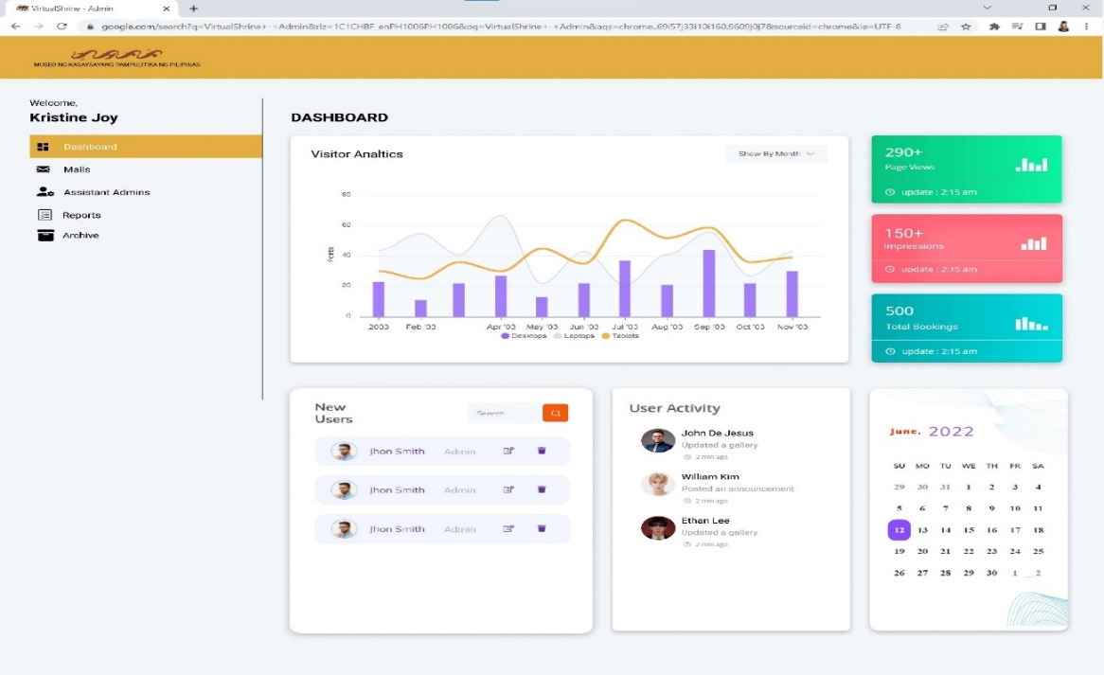

**Figure 42.** **Head Admin – Main Dashboard**

**Head Admin – Assistant Admin Menu**

Figure 43 displays the Assistant Admin Menu of the main admin dashboard. This is where the main admin will be able to view and manipulate the assistant admin information, actions such as edit, and archive of user information is provided.

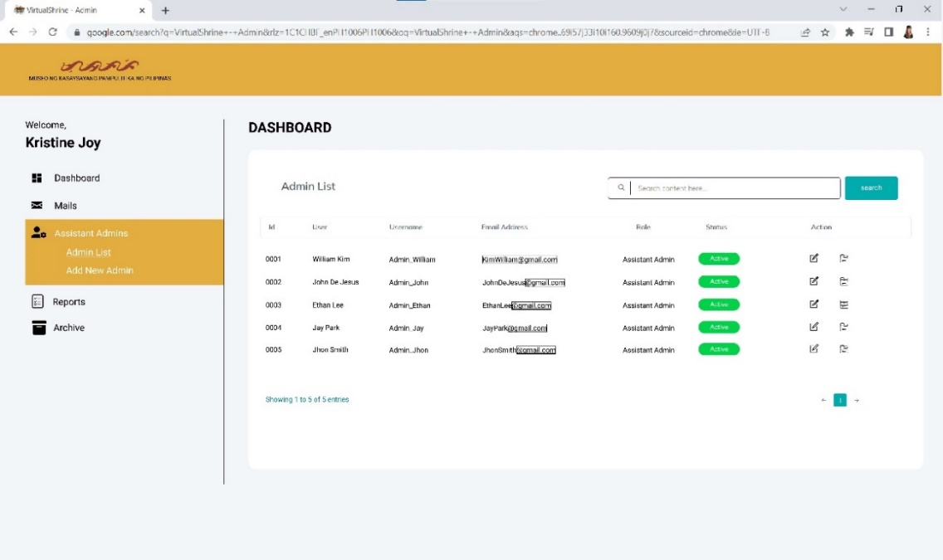

**Figure 43. Head Admin – Assistant Admin Menu**

**Head Admin – Edit User Information**

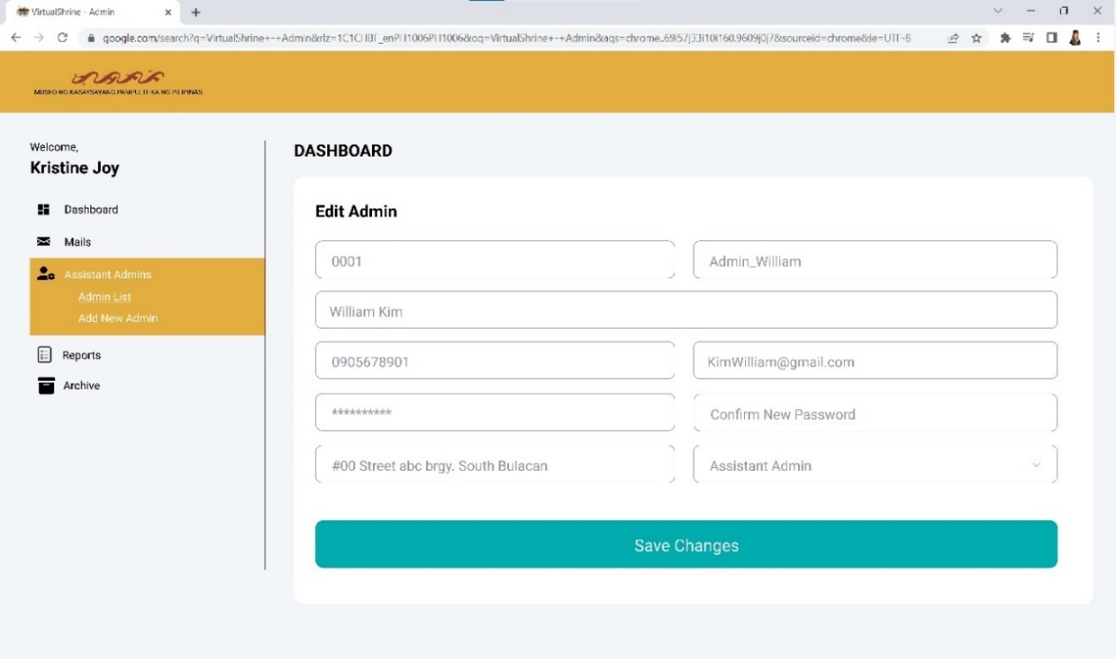 Figure 44 displays the Edit User Information page of the admin dashboard. This page allows the main admin to edit the existing user information.

**Figure 44. Head Admin – Edit User Information**

**Head Admin – Add a new Admin**

Figure 45 displays the Add a new admin page, this page allows the head admin to add a new assistant admin into the system. The main admin just has to provide the information such as the ID, Username, Name, Phone number, Email Address, Password, Address, and the Role.

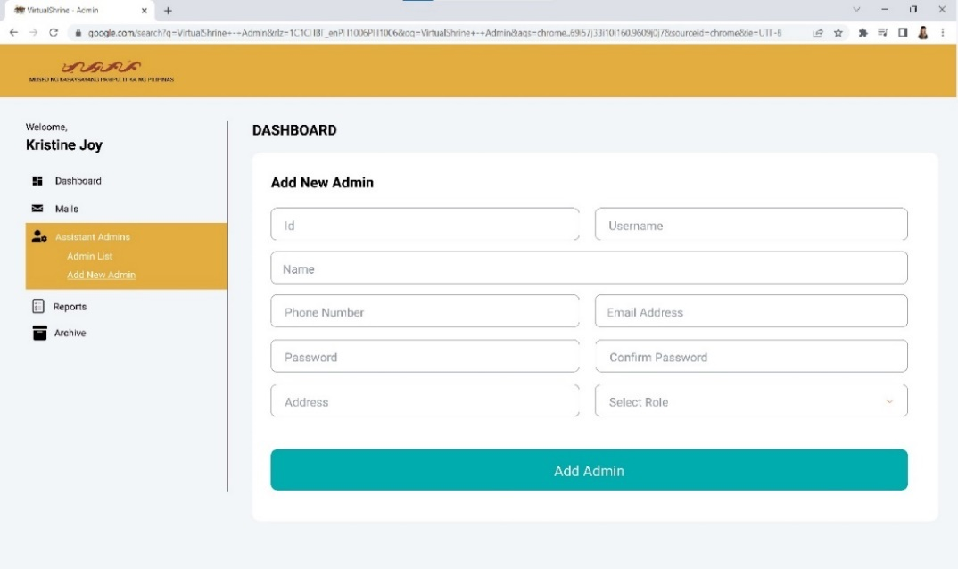

**Figure 45. Head Admin – Add a new Admin**

**Head Admin – Archive Account**

Figure 46 displays the Archive Account page of the admin dashboard. This allows the admin to archive an account that is no longer being used. The main admin will have to provide the reason for archiving the account in the remarks area. Then, the admin can proceed to click the archive account button and the account is saved on the archives.

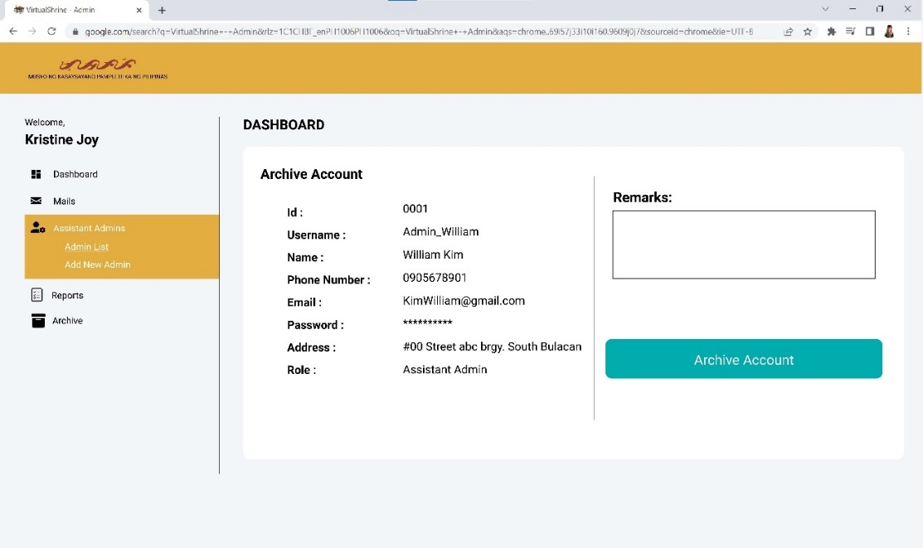

**Figure 46. Head Admin – Archive Account**

**Head Admin – Archive Menu**

Figure 47 displays the Archive Menu of the Main Admin dashboard. This page displays the accounts that have been archived by the main admin.

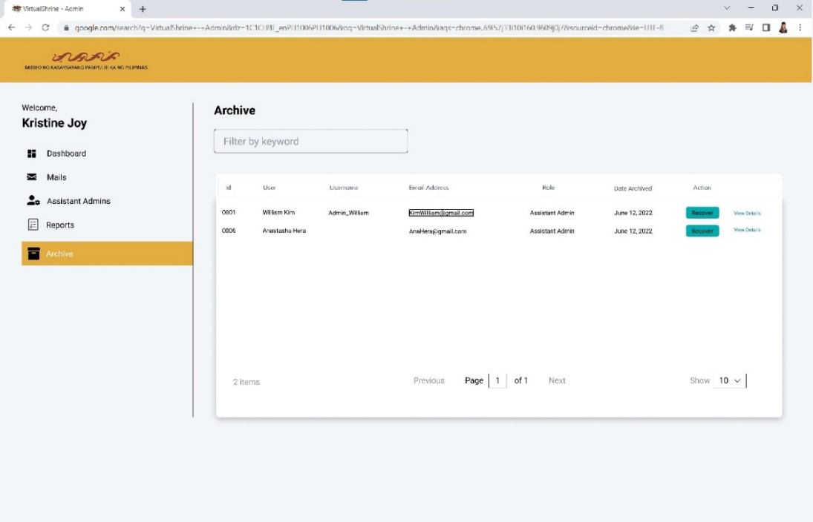

**Figure 47. Head Admin – Archive Menu**

**Head Admin – View Archived Account Details**

Figure 48 displays the details of the archived account where all the information of the previous user is stored, also the remarks of the main admin.

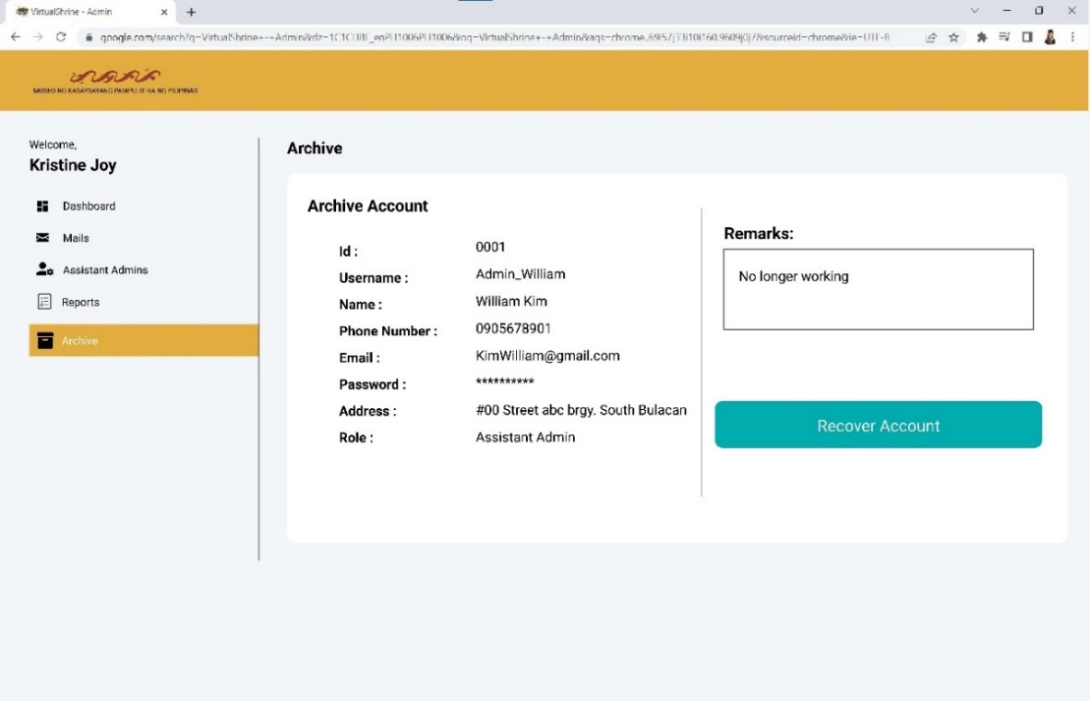

**Figure 48. Head Admin – View Archived Account details**

**Head Admin – Audit Logs Menu**

Figure 49 displays the Audit Logs Menu of the Main admin dashboard. This page will display the actions done by the assistant admins, and this will allow the main admin to monitor the changes made on the website by the assistant admins, this will also serve as a tracking record. The export button will allow the admin to print the audit log for documentation purposes.

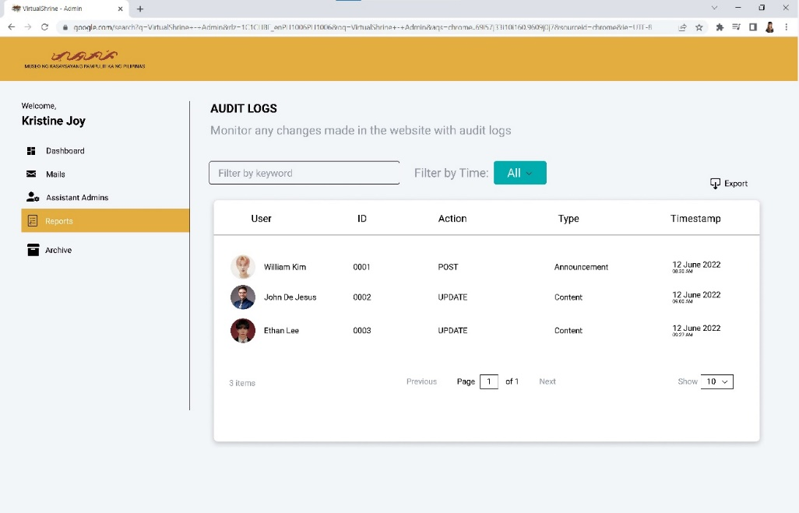

**Figure 49. Head Admin – Audit Logs Menu**

**Assistant Admin – Sign in page**

Figure 50 displays the assistant admin sign in page. This page will allow the assistant admin to access the dashboard. Only those users who were created by the head admin will be able to access the dashboard.

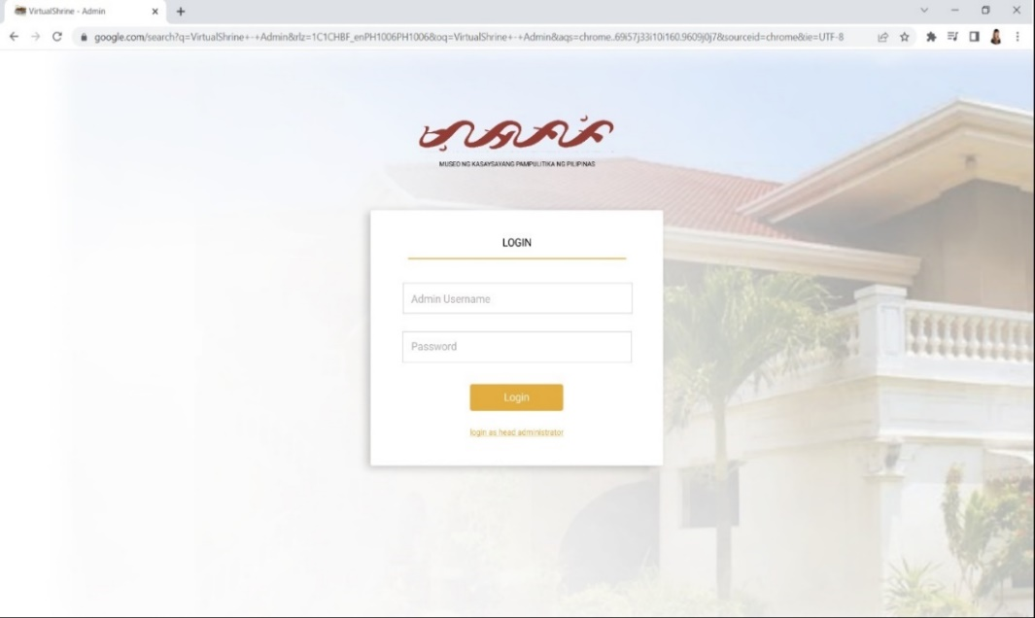

**Figure 50. Assistant Admin – Sign in page**

**Assistant Admin – Dashboard**

Figure 51 displays the Assistant Admin dashboard. If the user successfully signs in into the system using the username and password provided by the head admin, they can access the assistant admin dashboard. This dashboard displays the Visitor Analytics, Website Visit and Impressions, total Bookings, Pending bookings, and the calendar.

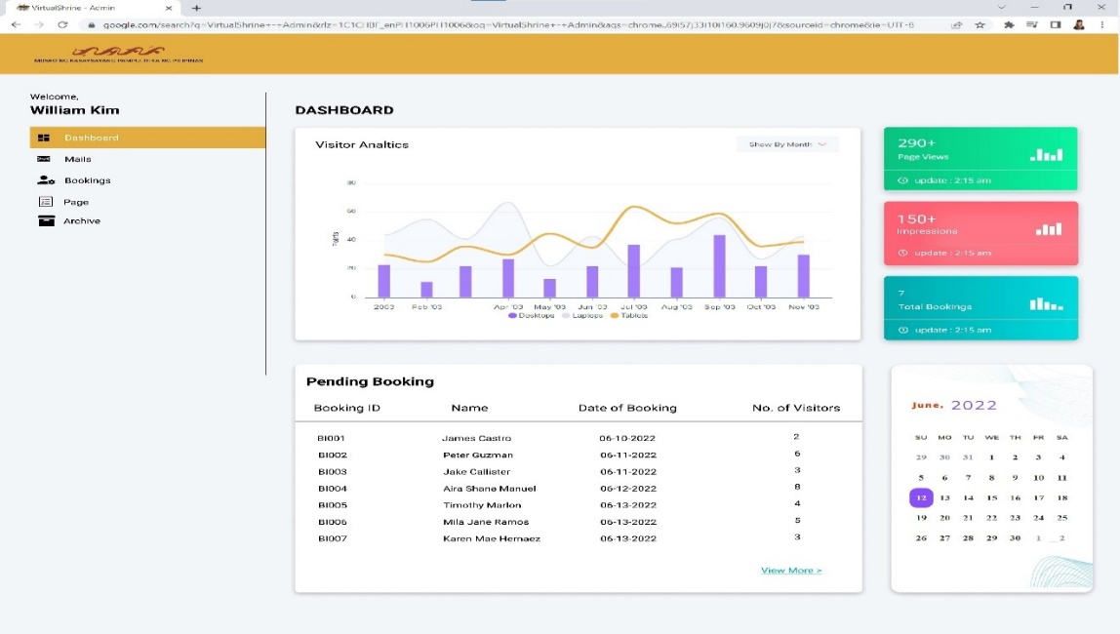

**Figure 51.** **Assistant Admin – Dashboard**

**Assistant Admin – Pending Bookings**

Figure 52 displays the Pending Bookings page where all the pending visitor bookings are displayed. This page allows the assistant admin to check and validate the submitted bookings, the assistant admin can approve or reject the bookings.

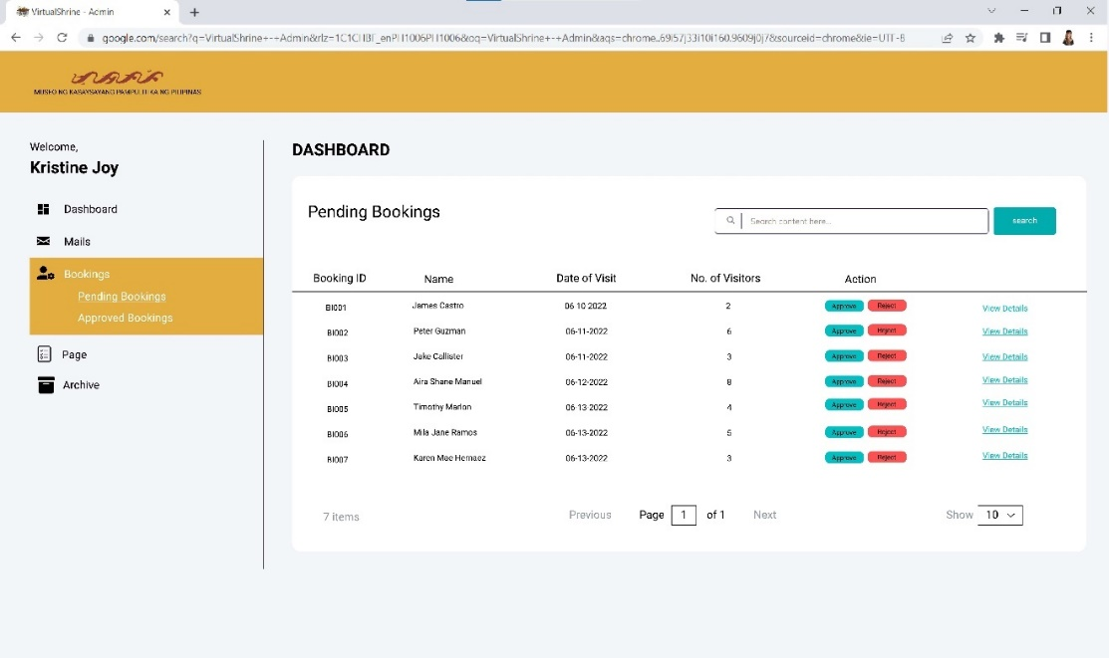

**Figure 52. Assistant Admin – Pending Bookings**

**Assistant Admin – Booking Details**

Figure 53 displays the booking details page; this page allows the assistant admin to view the full booking information of the visitor. The approve or reject button is also provided on this page.

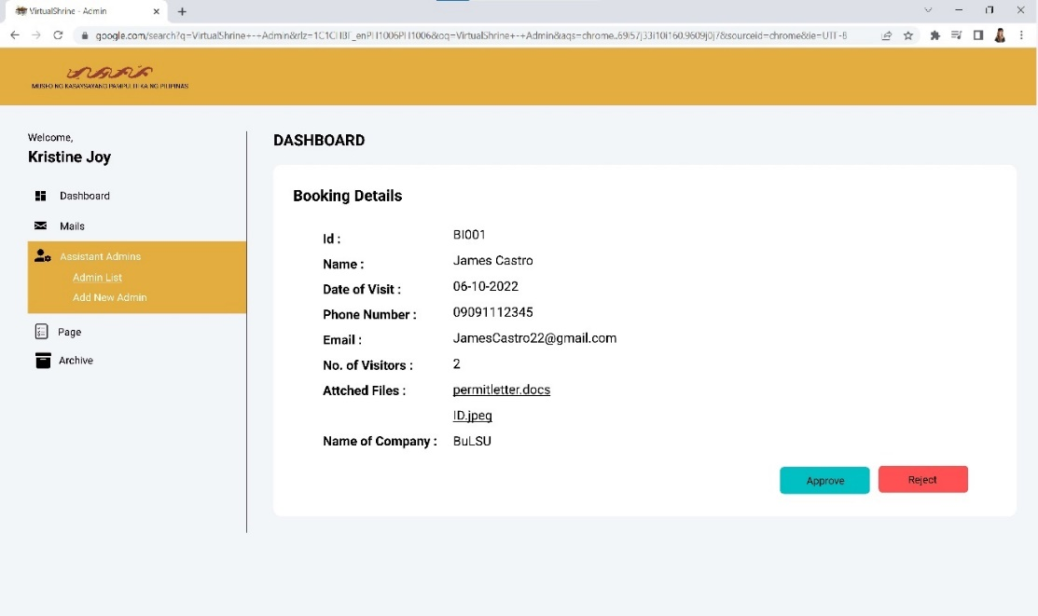

**Figure 53. Assistant Admin – Booking Details**

**Assistant Admin – Approved Bookings**

Figure 54 displays the Approved Bookings page. This page displays all the bookings that has been approved by the assistant admin. This page also display the status of the booking visit, whether if the booking is either confirmed or cancelled by the visitor.

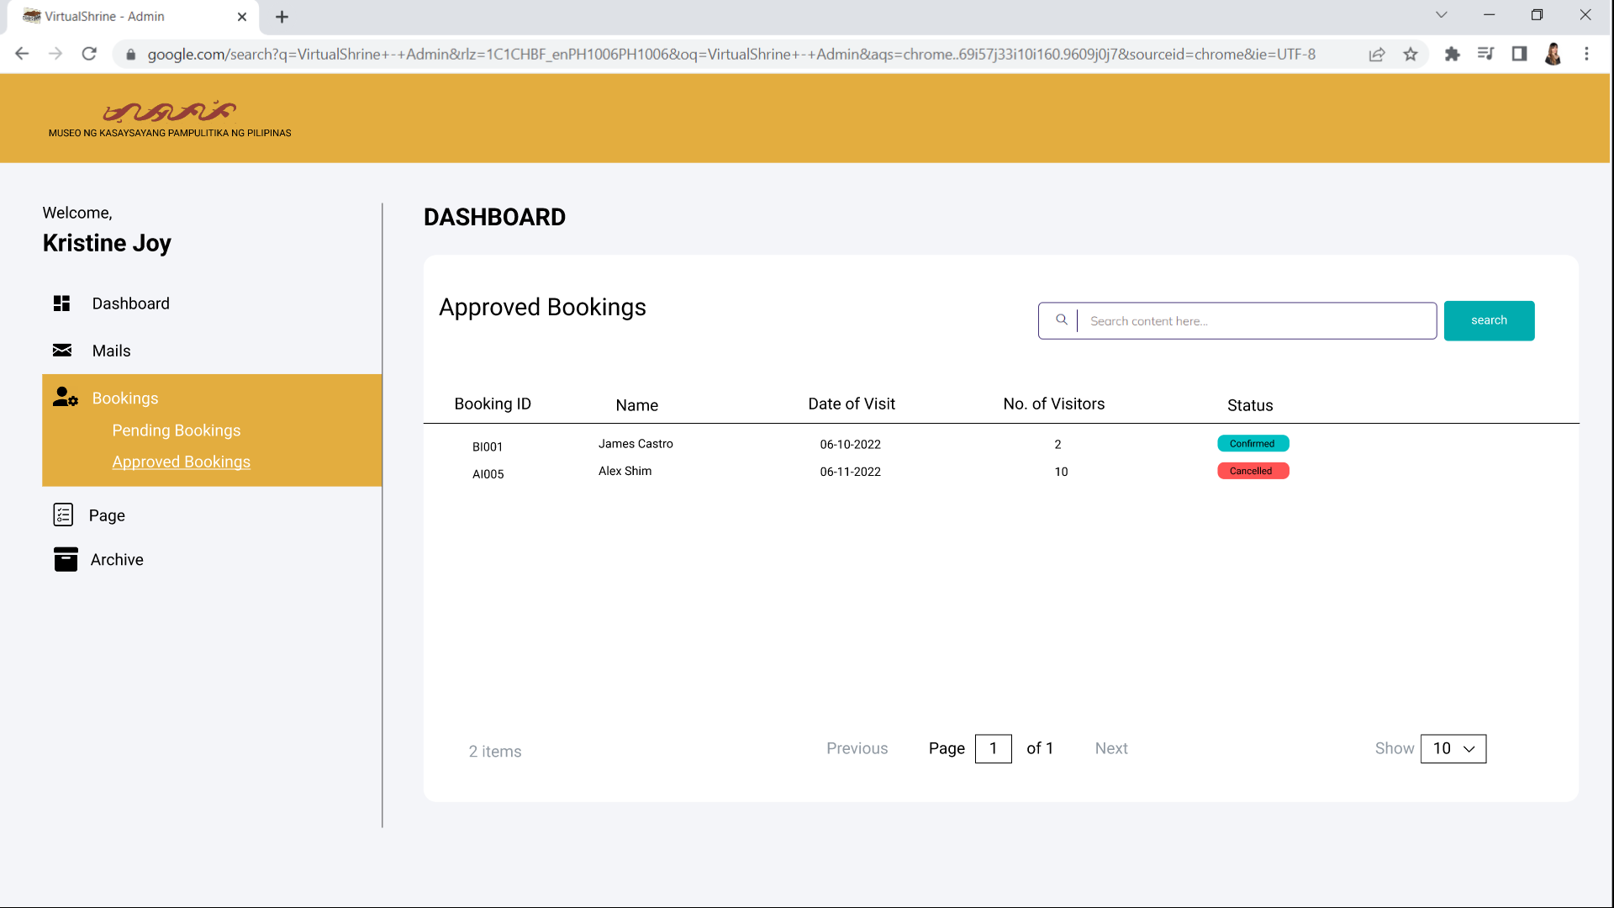

**Figure 54. Assistant Admin – Approved Bookings**

**Assistant Admin – Content Management**

Figure 55 displays the Content Management page. This is where the assistant admin be able to manipulat and update the web pages.

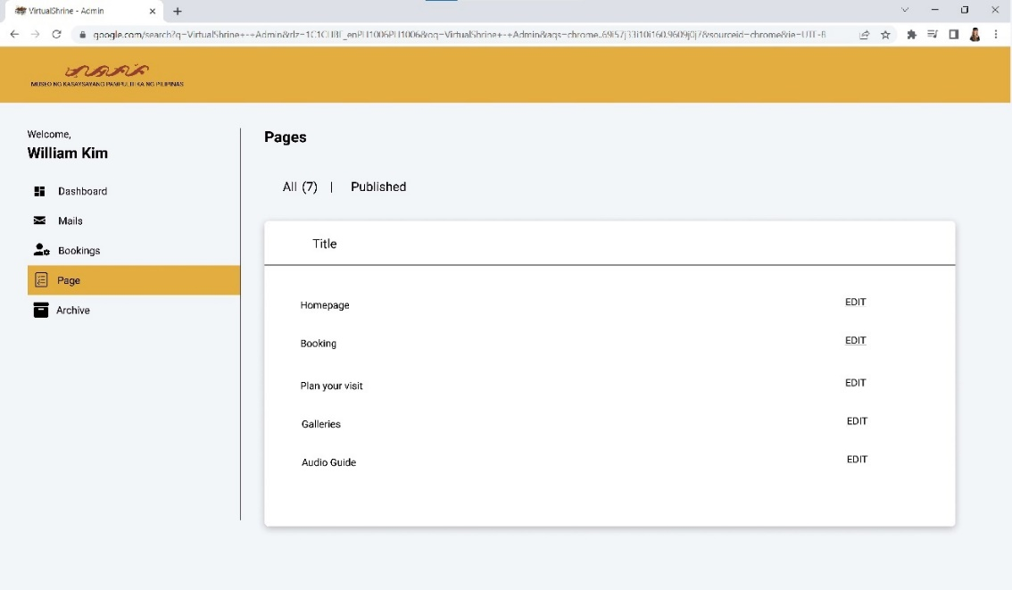

**Figure 55. Assistant Admin – Content Management**

**Assistant Admin – Add Post**

Figure 56 displays the add post dashboard in Assistant Admin panel. This dashboard menu allows the admins to post content on the website.

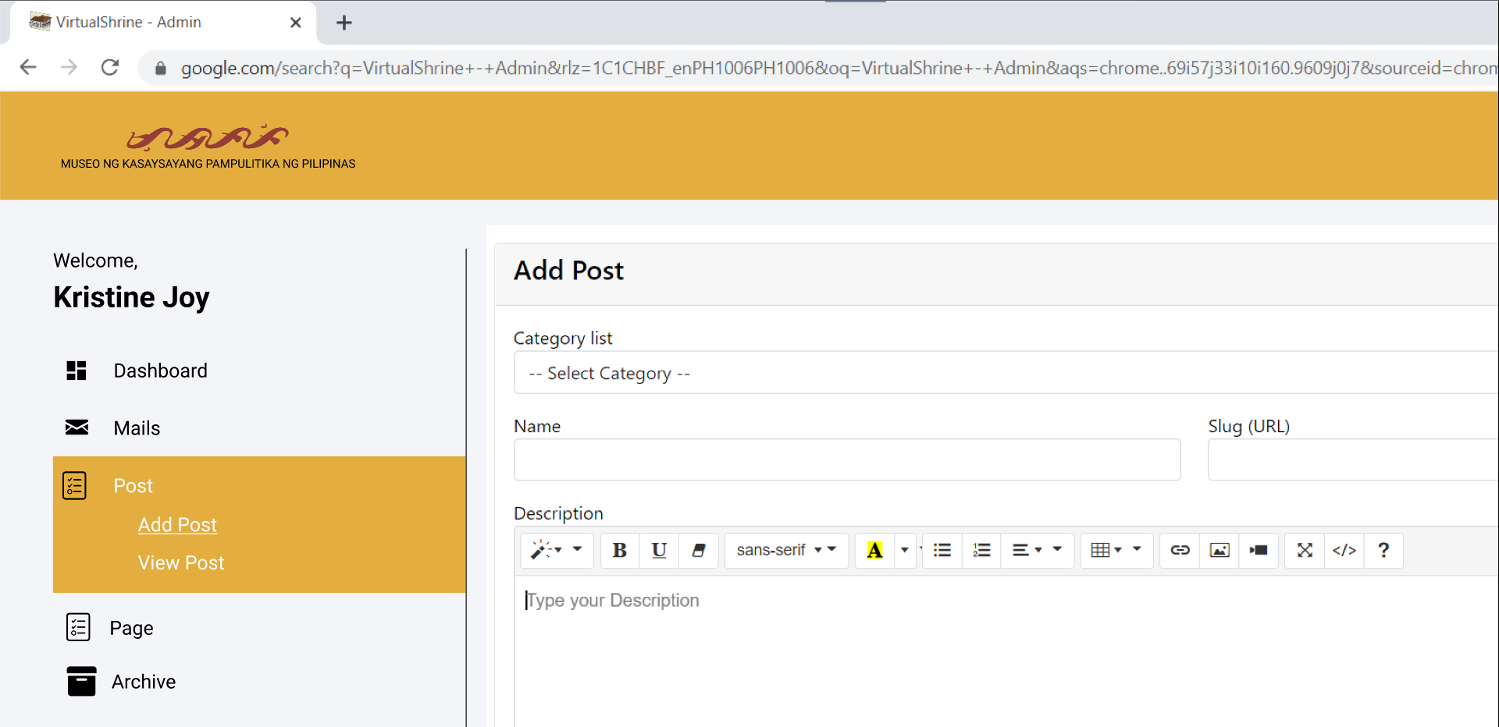

**Figure 56.** **Assistant Admin – Add Post**

**Assistant Admin – View Post**

Figure 57 displays the view post dashboard in Assistant Admin panel. This dashboard menu allows the admins to view the contents uploaded on the website. This dashboard also allows admin to make actions towards the post such as editing or archiving a post.

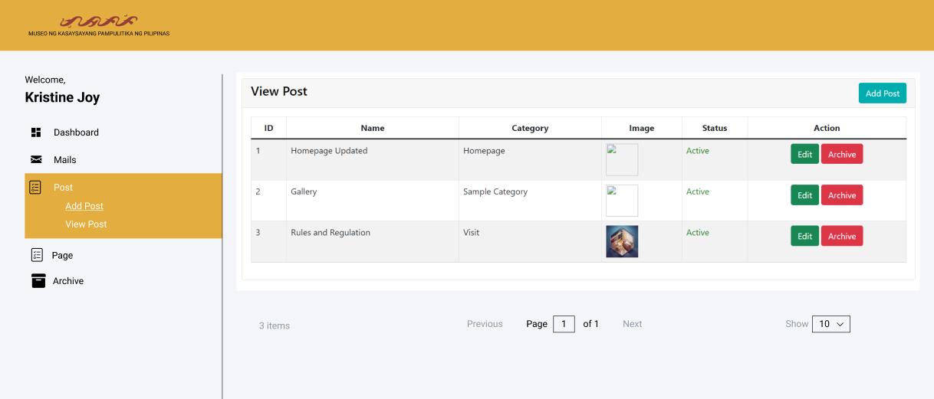

**Figure 57.** **Assistant Admin – View Post**

**Assistant Admin – Edit Post**

Figure 58 displays the edit post dashboard in Assistant Admin panel. This feature allows the admins to edit a post.

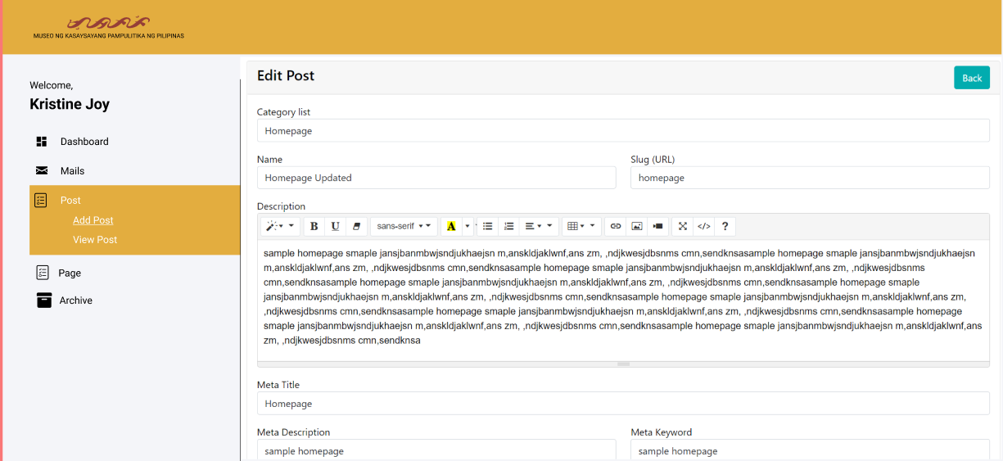

**Figure 58.** **Assistant Admin – Edit Post**

**CHAPTER IV**

**RESULTS AND DISCUSSION**

The main purpose of this chapter is to provide the presentation, analysis and interpretation of data that has been categorized in accordance with the sequence of questions enumerated in the first chapter. All of the data collected from the evaluators were presented in tabular form with corresponding discussion and explanation of the findings obtained.

**Part I. Development of VirtualShrine: An interactive museum website for Casa Real Shrine**

Over time, museums continue to be forgotten by people, so some of them do not know about the importance of history. One of them is the Casa Real Shrine of Malolos. Because of the continuous advancement of modern technology, some of what can be seen in the museum can also be seen on the internet, the proponents have looked for a way so they introduced the “Virtual Shrine” a website that people can use to see what’s inside of the Casa Real Shrine and can book for their visit via online booking.

* 1. **Online Booking Reservation**

**Booking Consent Form**

Figure 59 displays the Booking Consent Form page. This page contains a statement regarding the collection of the visitor’s booking information. This page is required because the visitor will have to provide their personal information. By checking the consent for checkbox, the visitor consents the collection of their information.

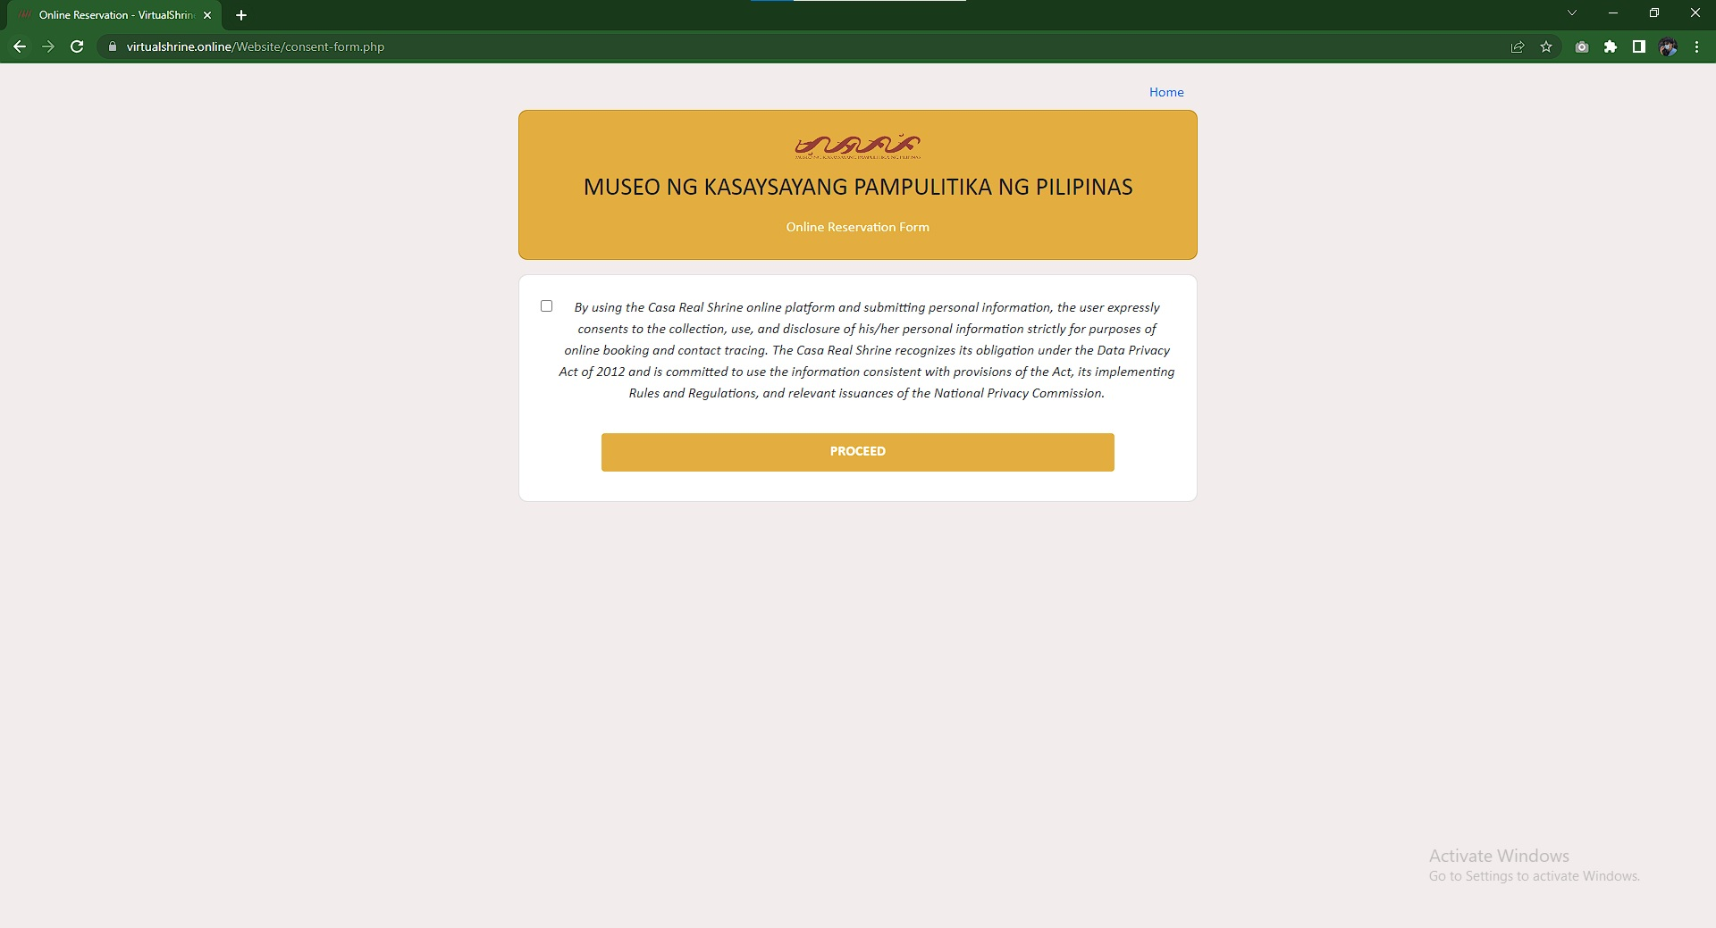

**Figure 59.** **Booking Consent Form**

**Booking Form**

This figure 60 displays the Booking form where the visitor could fill out all of the required fields such as Date of Visit, Session, Number of Visitors, First Name, Last Name, Email, Mobile Number, and attach a screenshot of their valid ID to confirm the user's booking for the date.

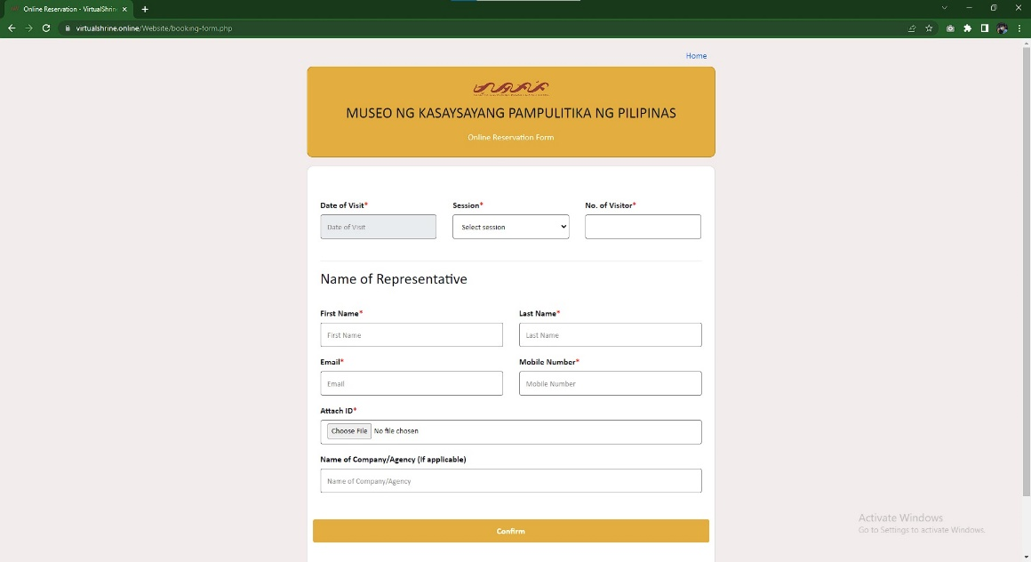

**Figure 60.** **Booking Form**

**Booking Submitted Confirmation Page**

Figure 61 displays the confirmation page that the visitor’s booking is submitted successfully and reviewed by the administrator if all the details that the visitor provided are valid.

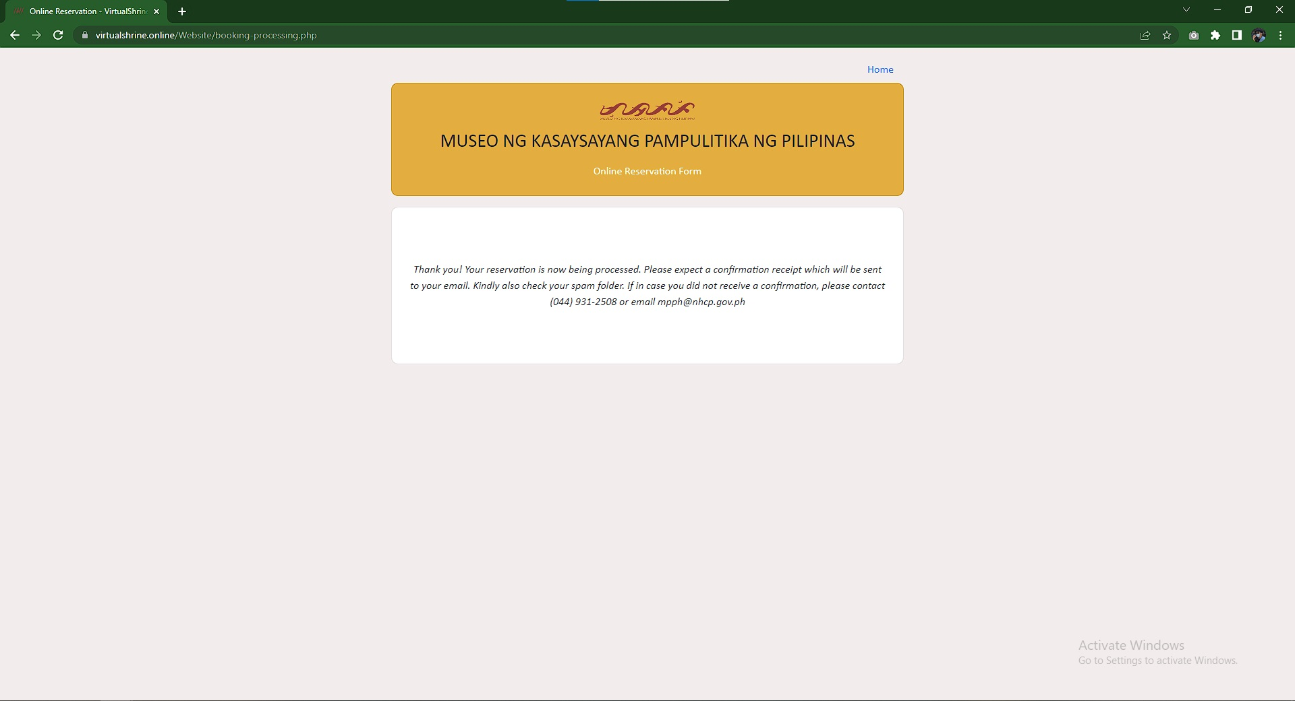

**Figure 61.** **Booking Submitted Confirmation Page**

* 1. **Virtual Museum Tour**

**Access to the Virtual Tour Page**

Figure 62 displays the access to the Virtual Tour page. One of the main features of the website is the Virtual 360, visitors can interact in the museum virtually meaning if they want to visit the museum, they can check it first on the website using this 360 features. Figure 62 displays the page before accessing the main features of the website which are indicated in the next figures.

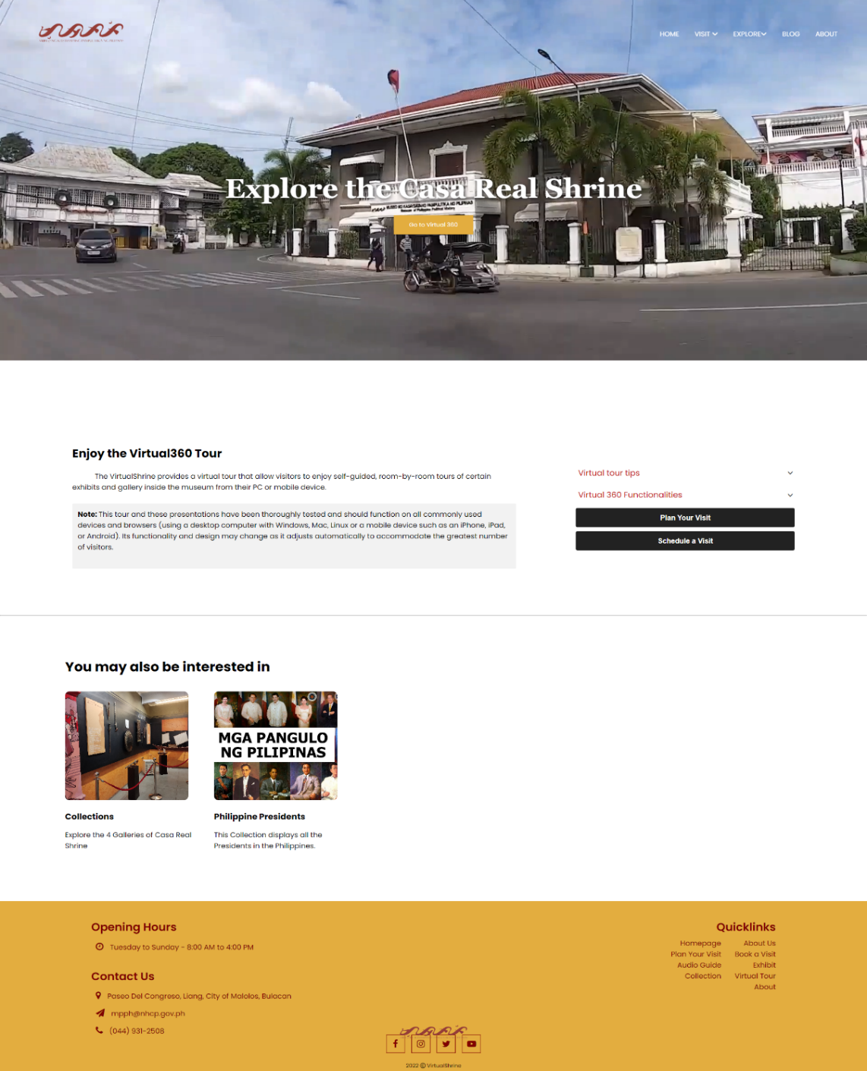

**Figure 62:** **Access to the Virtual Tour Page**

**Casa Real Shrine Virtual 360**

Figure 63 displays the landing page when the user opens the virtual tour. This page reflects the main gate of the Casa Real Shrine, the yellow Door icon is the hotspot for the user to access figure 63 or the lobby of the museum. At the bottom part of, the screen displays the controller for the virtual tour. This helps the user to familiarize themselves with the virtual 360 and navigate it easily. This controller includes Zoom In, Zoom Out, Auto Rotate, Show User Date, Thumbnail Menu, enter to full screen, and exit to virtual tour.

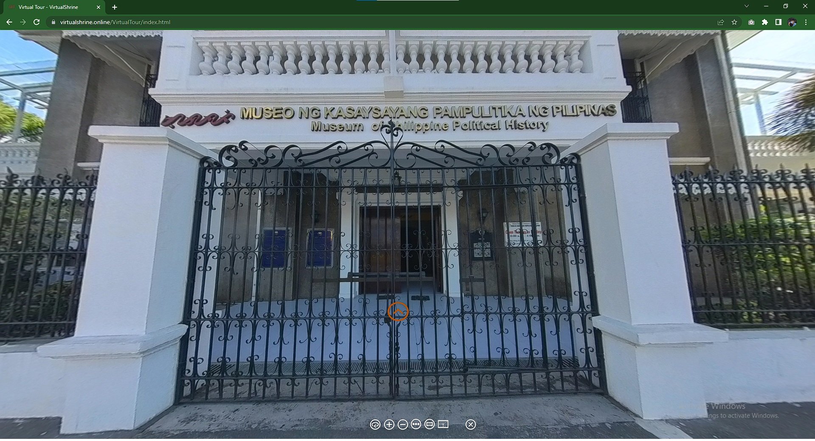

**Figure 63.** **Casa Real Shrine Virtual 360**

**Casa Real Shrine Lobby Virtual 360**

Figure 64 displays the first room of the museum after entering the building. The Visitor can swipe from left and right to view the surroundings of the room and to interact with other hotspots they can use for other information of the museum. The hotspot where the visitor can use to interact with the display in the museum. If the visitor presses the hotspot, the system will display a pop-up with the definition of the display.

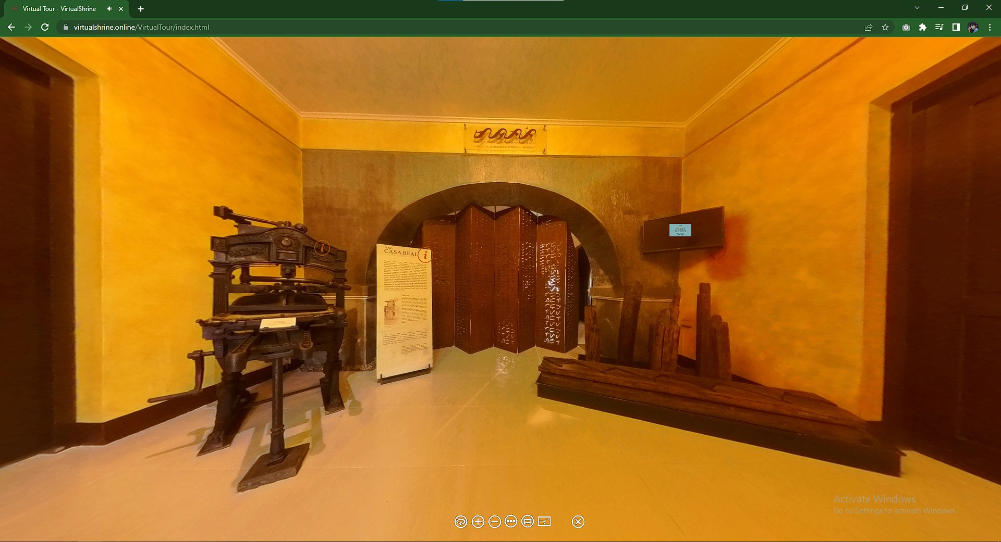

**Figure 64.** **Casa Real Shrine Lobby Virtual 360**

* 1. **Gallery Collections**

**Galleries**

Figure 65 displays the 4 galleries in the museum. Every cards lead to different rooms in the museum like Kaginhawaan(Prosperity), Paniniil(Oppression), Pagbabagong-puri(Revolution), Pagbuo ng bayan(Making the nation).

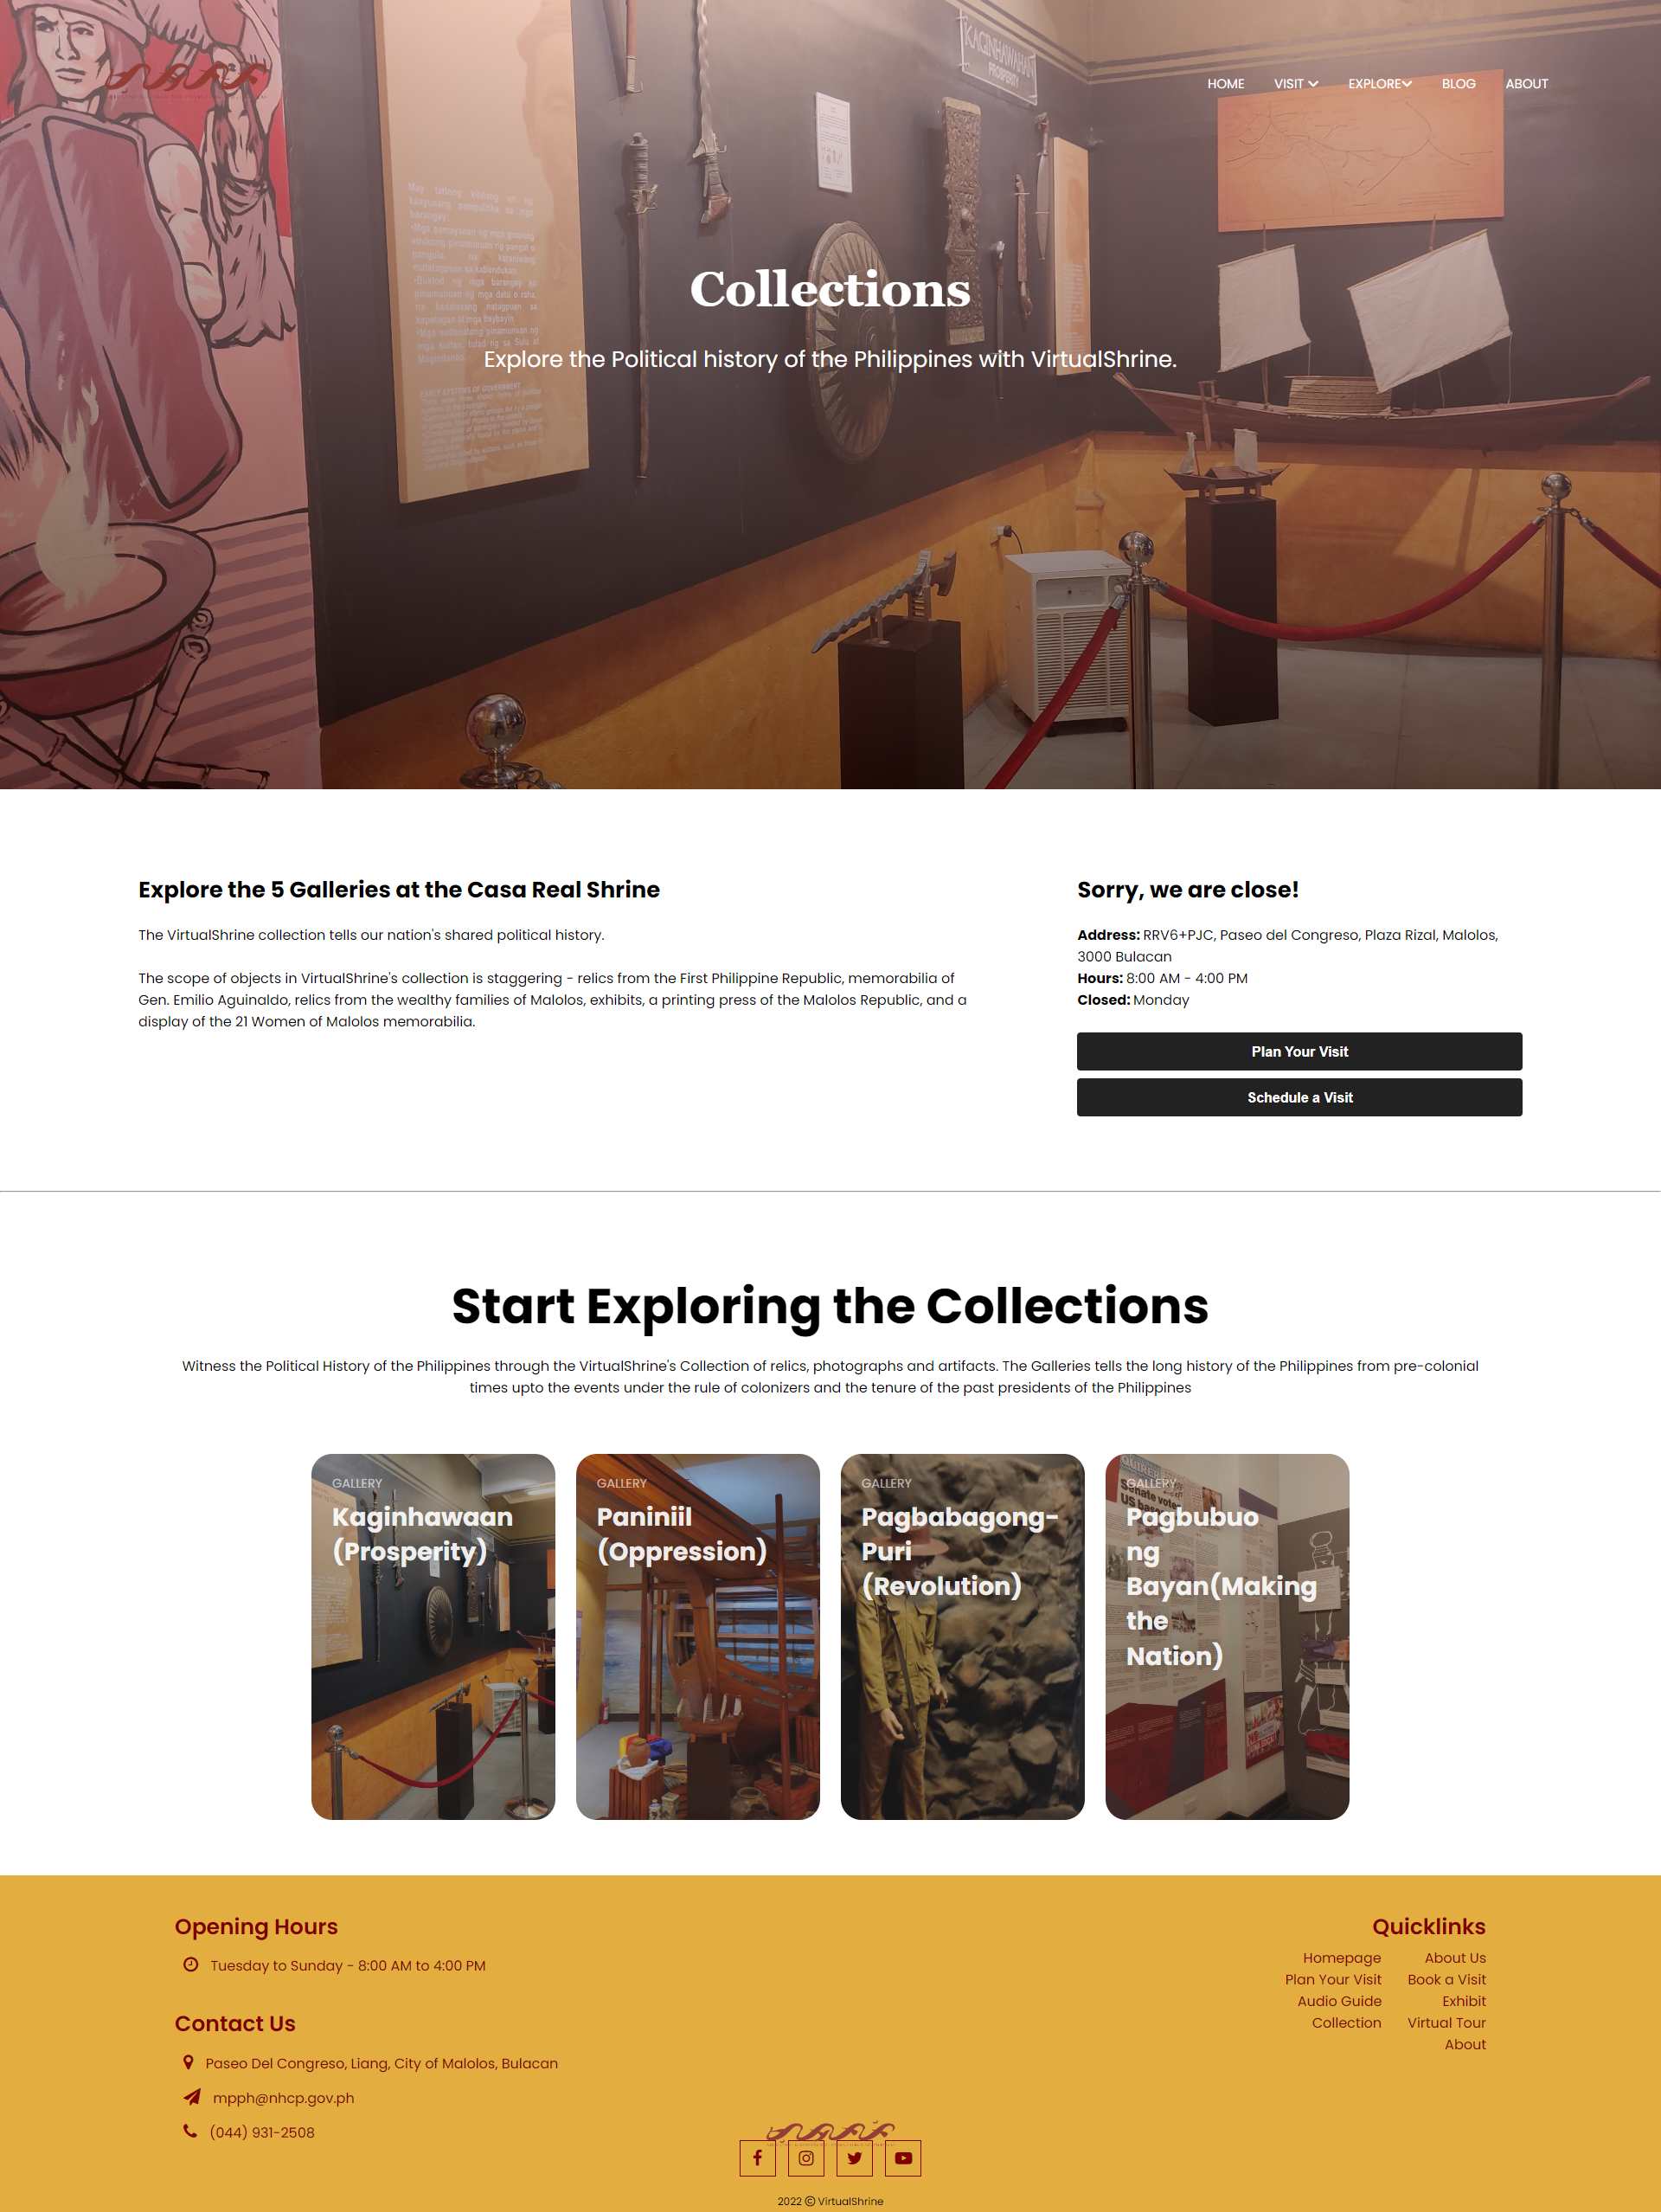

**Figure 65. Galleries**

**Galleries Collections**

Figure 66 displays the gallery Collections and the different displays found inside the gallery.

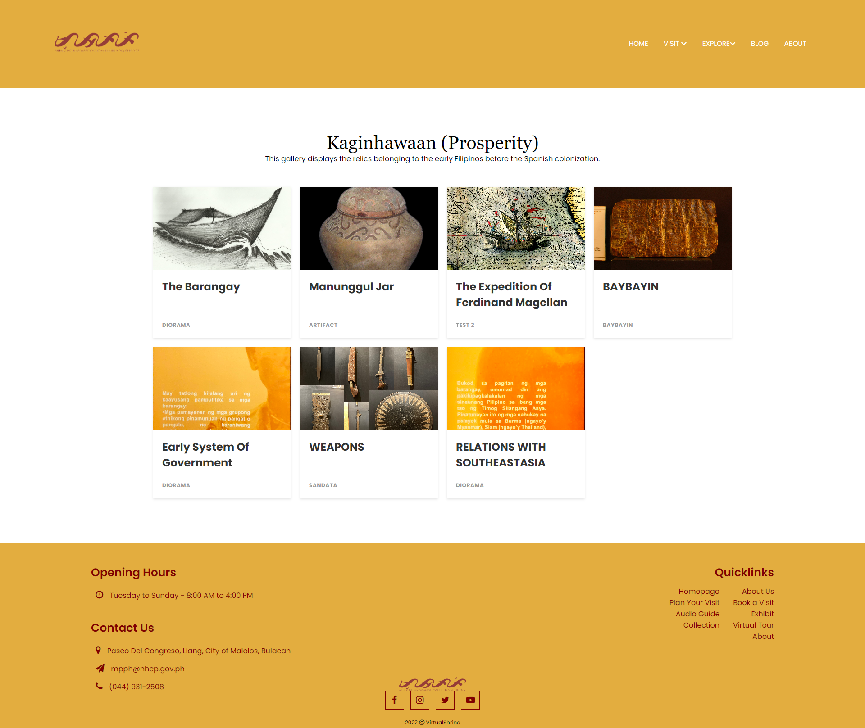

**Figure 66.** **Galleries Collections**

**Display Description**

Figure 67 display information about the display. Visitors can also download and print the artifact picture and description but with website mark to avoid plagiarism and copyrights.

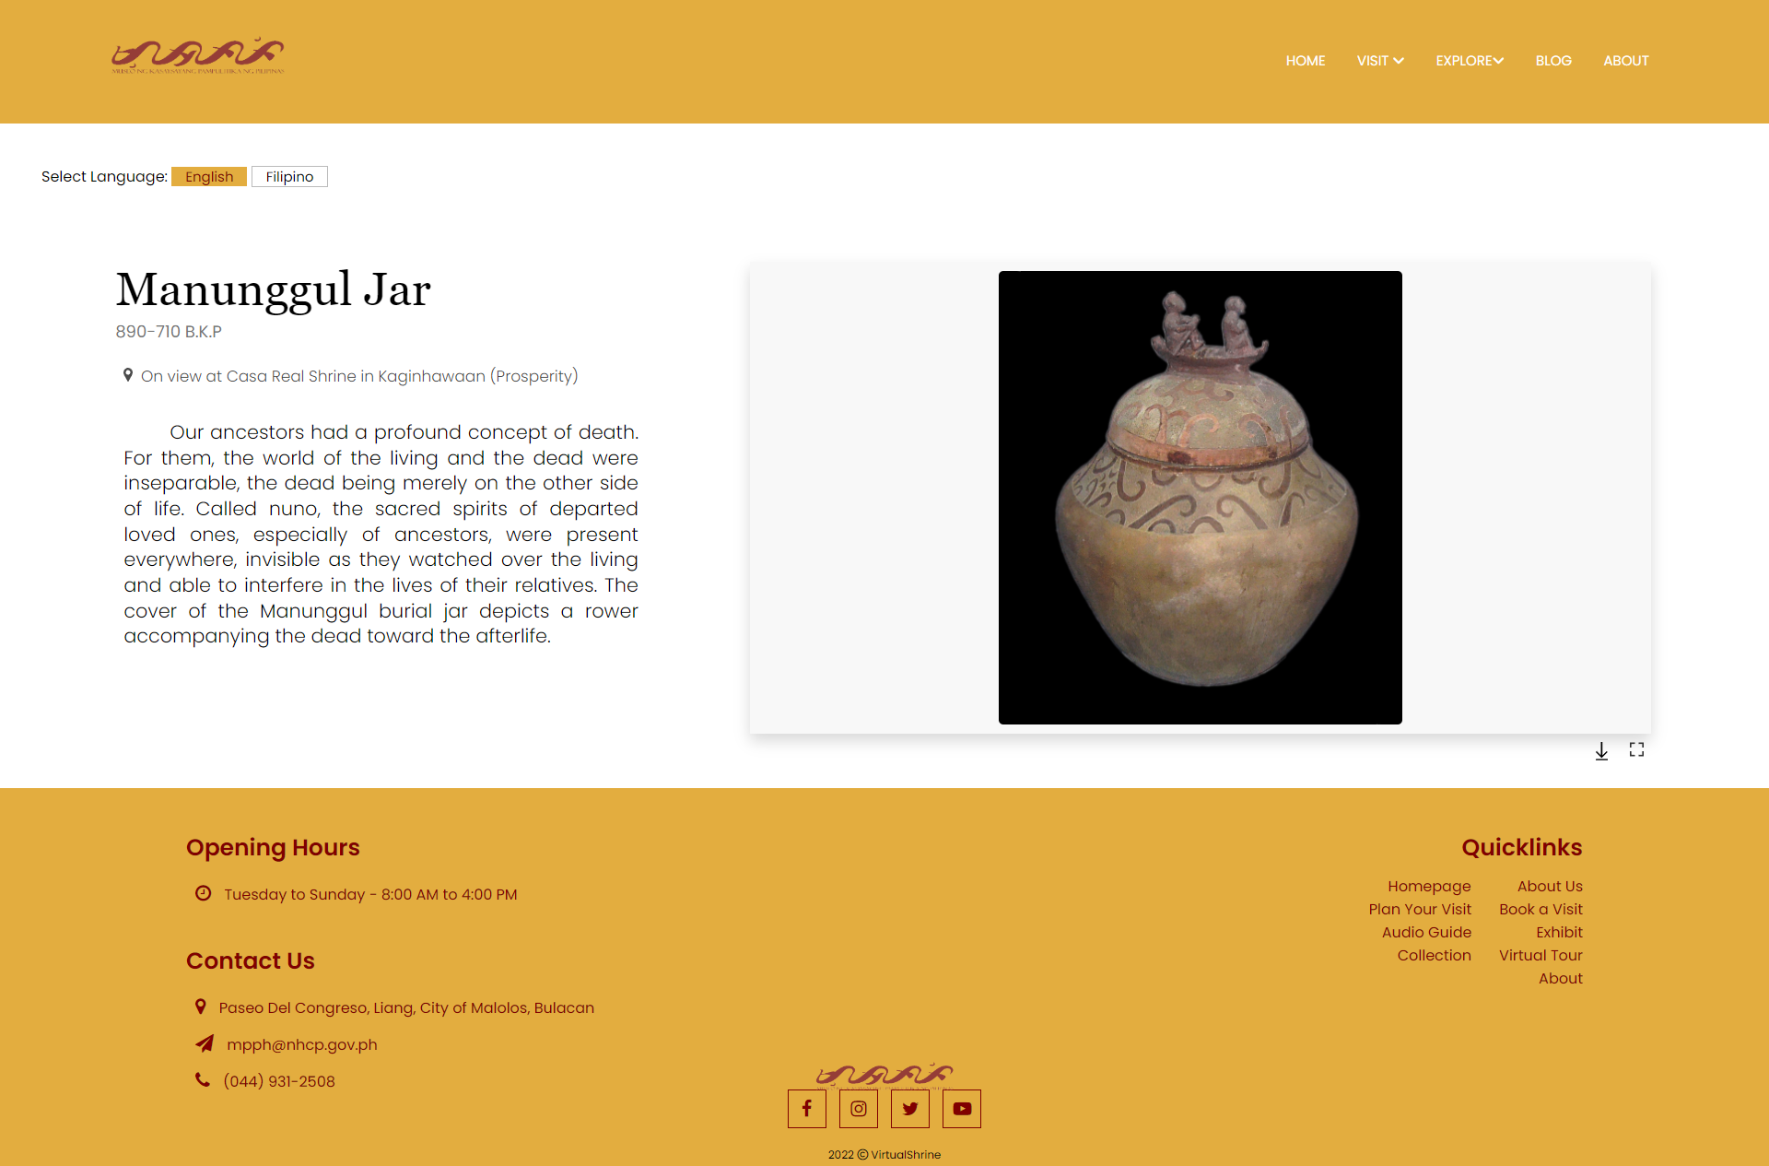

**Figure 67.** **Display Description**

**1.4 User Assisting Features**

**Plan Your Visit Page**

Figure 68 displays the general information regarding the operation of Casa Real Shrine such as the operation time and day, and Health and Safety Guidelines that is being implemented in the museum.

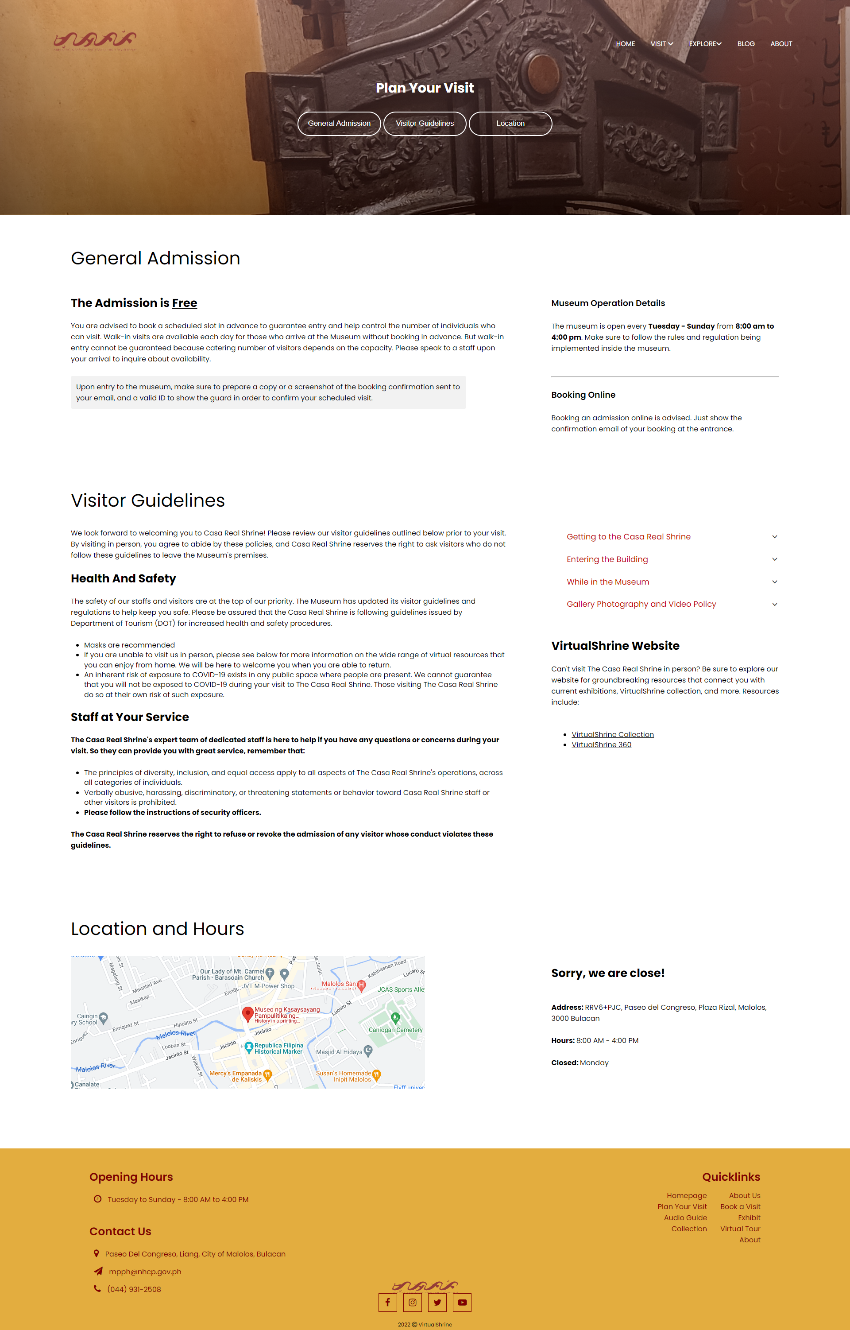

**Figure 68.** **Plan Your Visit Page**

**Audio Guide**

Figure 69 displays the audio guide page. To access the audio guides for each display, the user will have to input the audio stop number on the textbox provided .

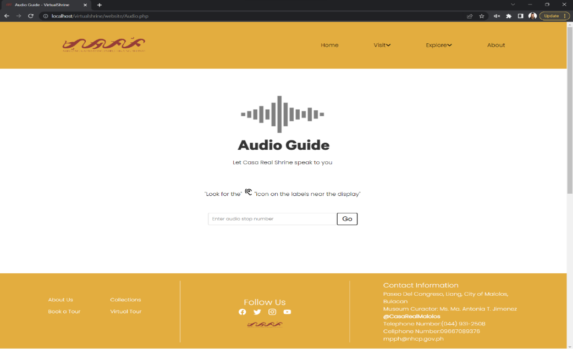

**Figure 69.** **Audio Guide**

**Part II. To design and develop a Management System**

In order to better manage the website content and allow admins to upload and modify the contents seen on the website, a Management System was developed.

**2.1 Manage User Admins**

**User Management**

Figure 70 shows the user management panel. This is where the super admin can able to view all the assistant admins. This page displays a table containing the user information ID, Name, Username, and their Status. The action buttons, edit and archive is also available.

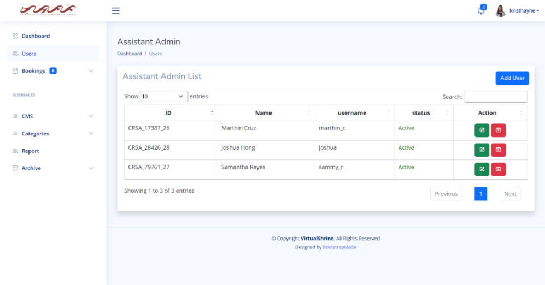

**Figure 70.** **User Management**

**Edit User Information**

Figure 71 displays the Edit User Information form. This is the form where the Super Admin can make modifications or changes to the user information. The admin can make any alterations they wish to the user information by simply changing the value in the text area.

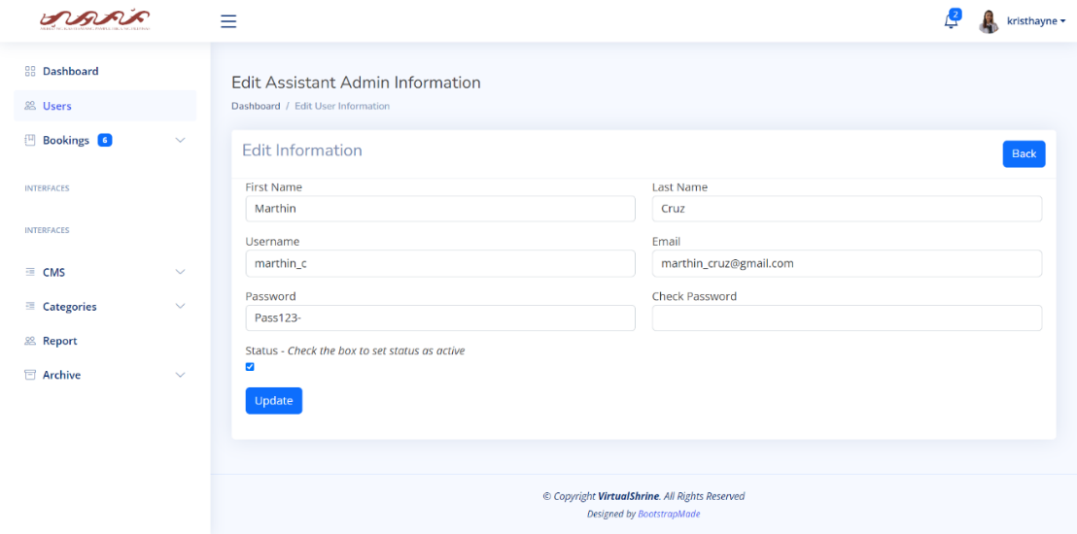

**Figure 71.** **Edit** **User Information**

**Add New User**

Figure 72 displays the Add User Information form. This is the form where the Super Admin can add the information of the new admin.

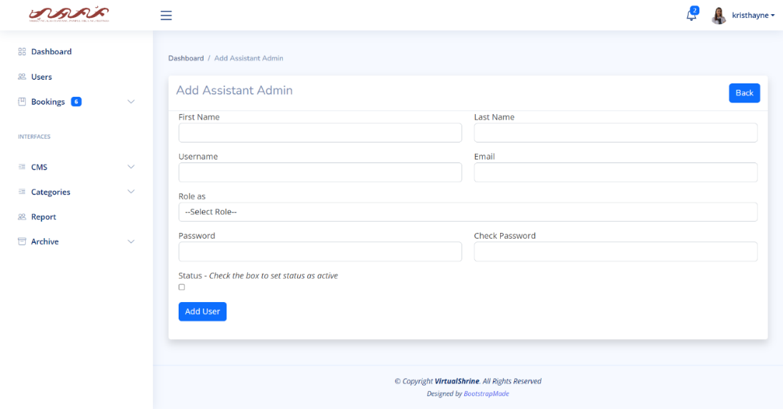

**Figure 72.** **Add New User**

**2.2 Accept and Reject Visitor Booking**

**View all Pending Booking**

In Figure 73, a table displays the pending bookings, including the Booking ID, Name of Visitor, Date of Visit, Number of Visitors, and status of the booking. For additional information, the admin can click “View Details”.

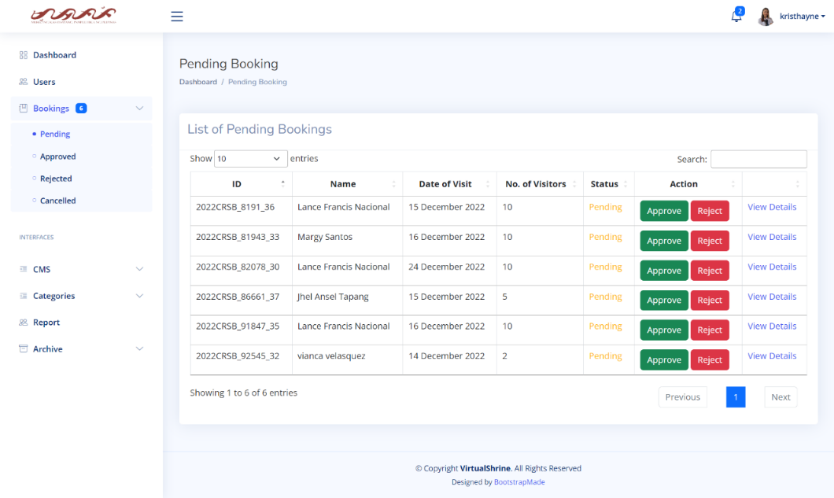

**Figure 73.** **View all Pending Booking**

**View More booking details**

Figure 74 displays the page where the complete booking information is displayed. This page displays the Booking ID, Name, Phone No., Email, Attached File, Date of Visit, and Number of Visitors. The admin can also perform an action on this page either to approve or reject the booking.

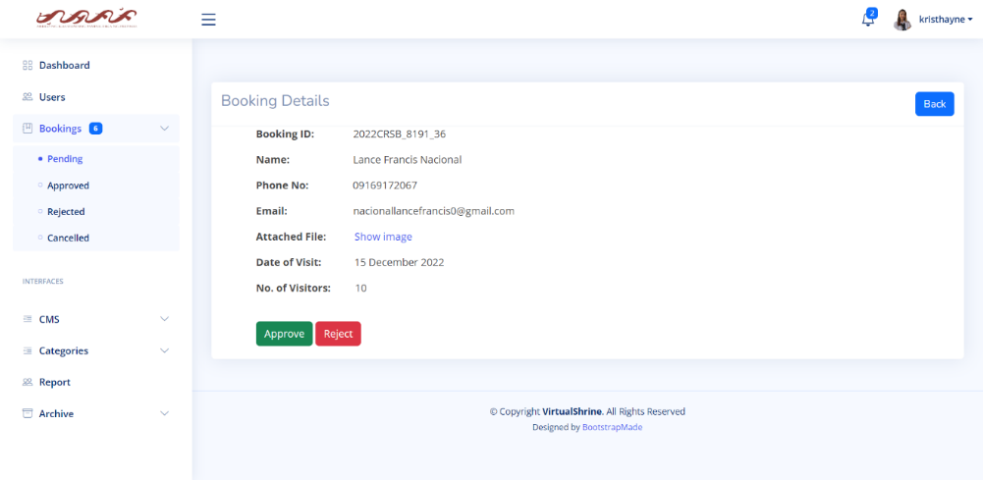

**Figure 74.** **View More booking details**

**View More booking details**

Once the admin clicks the "show image" button, Figure 75 displays the page response. This feature is used to allow admins to verify the legitimacy of the attached ID.

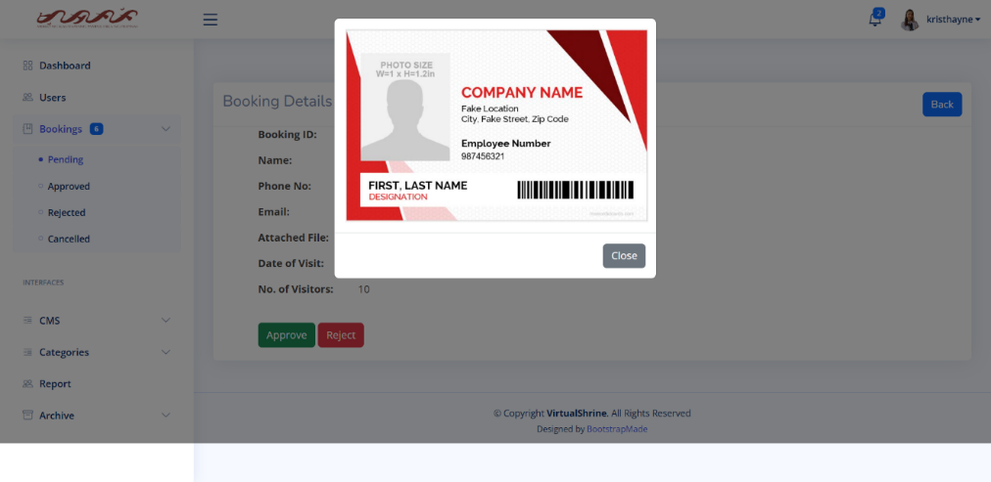

**Figure 75.** **View More booking details**

**2.3 Upload Website Content**

This module is the CMS of the Management System. This allows admins to upload and modify website contents.

**2.3.1 Collections**

**Content Management System – Collections**

In Figure 76, the Collection CMS is shown. It includes a table that provides information about the collection, such as its ID, title, the gallery it belongs to, a preview image, and its status. There are also action buttons for editing and archiving.

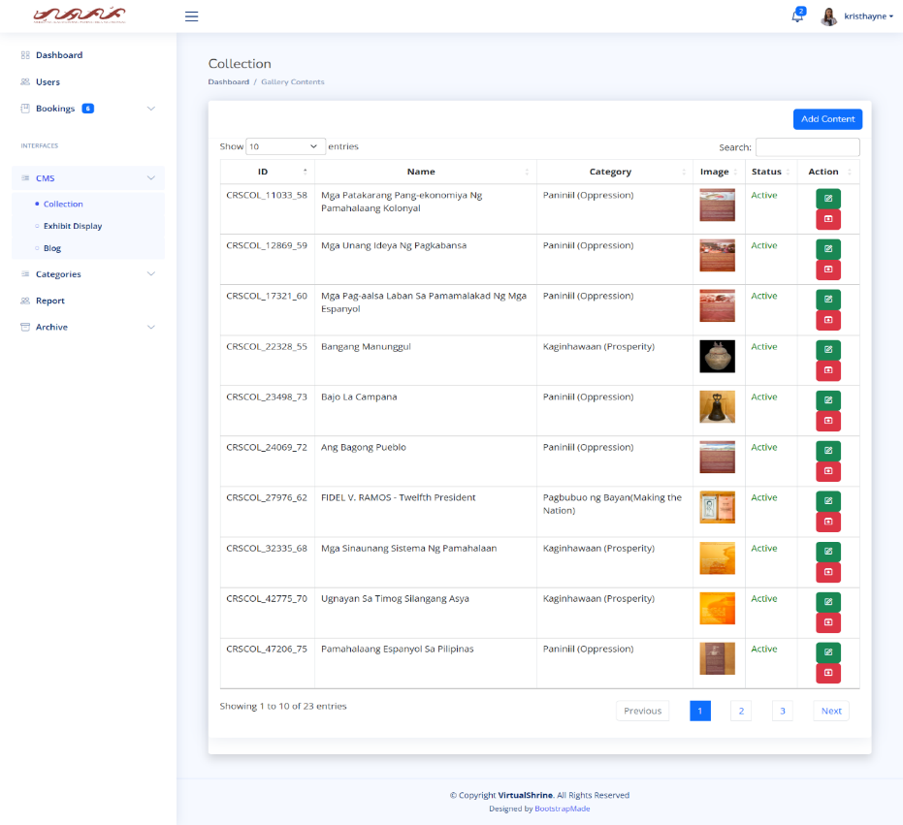

**Figure 76.** **Content Management System – Collections**

**Content Management System – Edit Collection Information**

As seen in Figure 77, the Edit Collection form gives admins the ability to edit the collection's information.

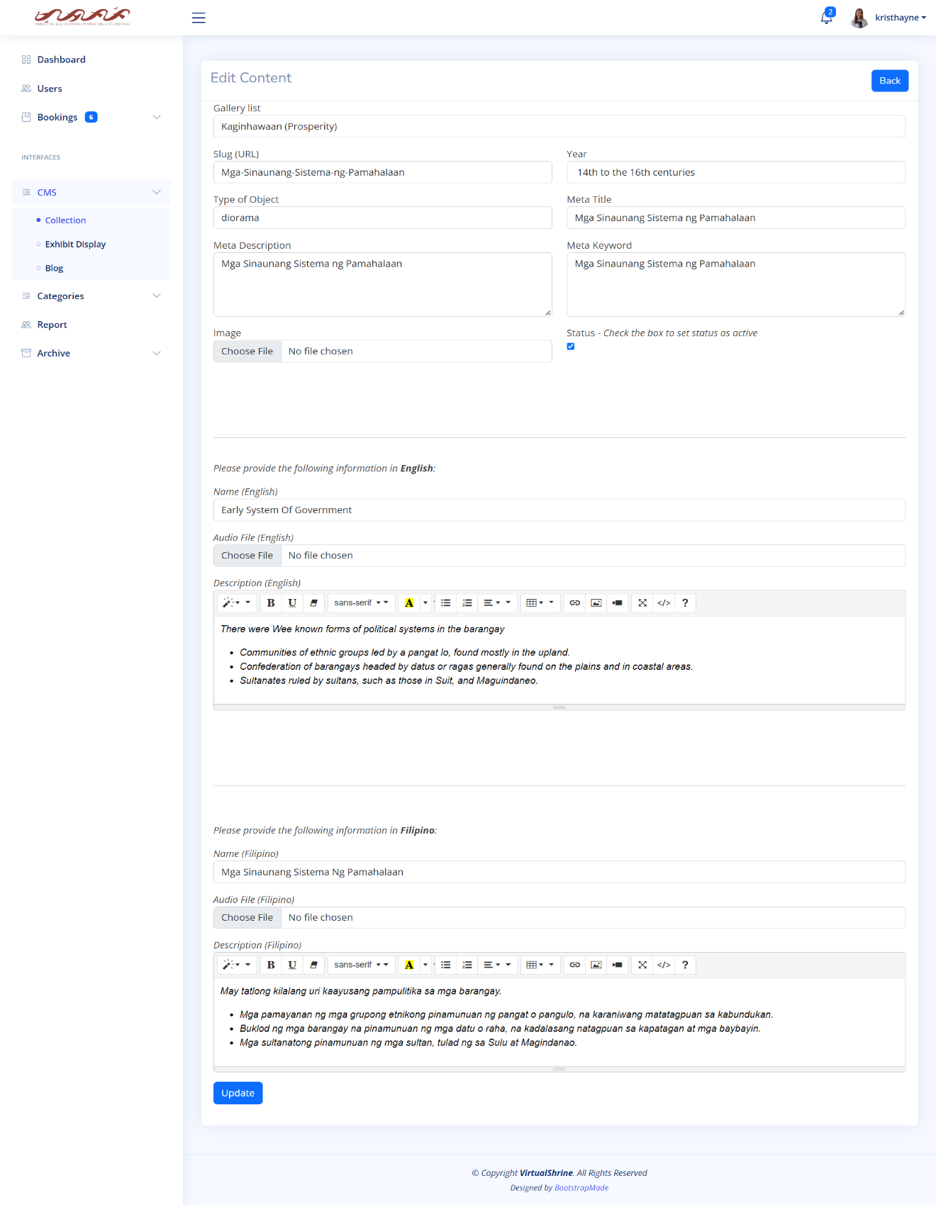

**Figure 77.** **Content Management System – Edit Collection Information**

**Content Management System – Add new Collection**

In Figure 78, the Add new Collection form is shown. This is where the admin can add new collection that can displayed on its respective gallery category on the website.

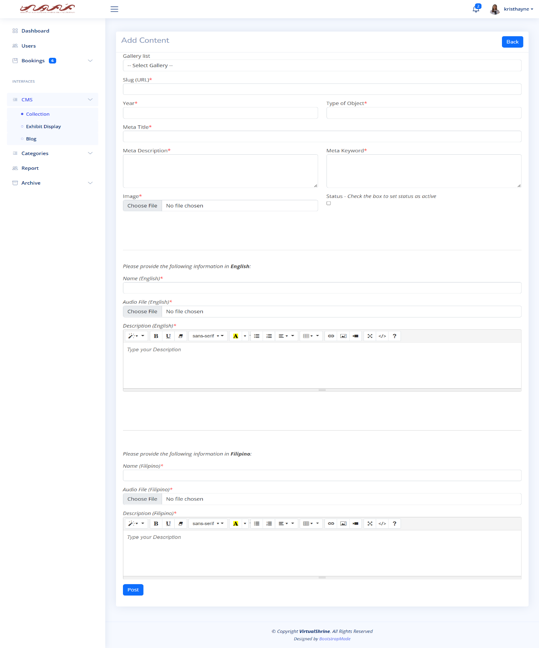

**Figure 78.** **Content Management System – Add new Collection**

**2.3.2 Exhibits**

**Content Management System – Exhibit Display**

In Figure 79, the Exhibit Display CMS is shown. It includes a table that provides information about the Exhibit Display, such as its ID, Title or Name, the Exhibit it belongs to, a preview image, and its status. There are also action buttons for editing and archiving.

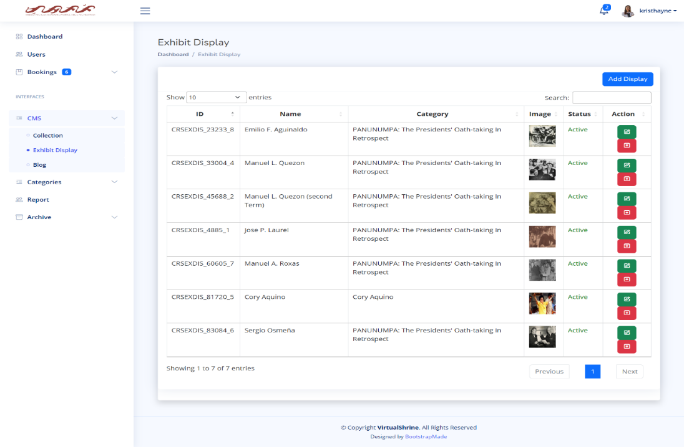

**Figure 79.** **Content Management System – Exhibit Display**

**Content Management System – Add new Exhibit Display**

In Figure 80, the Add new Exhibit Display form is shown. This is where the admin can add new Exhibit Display.

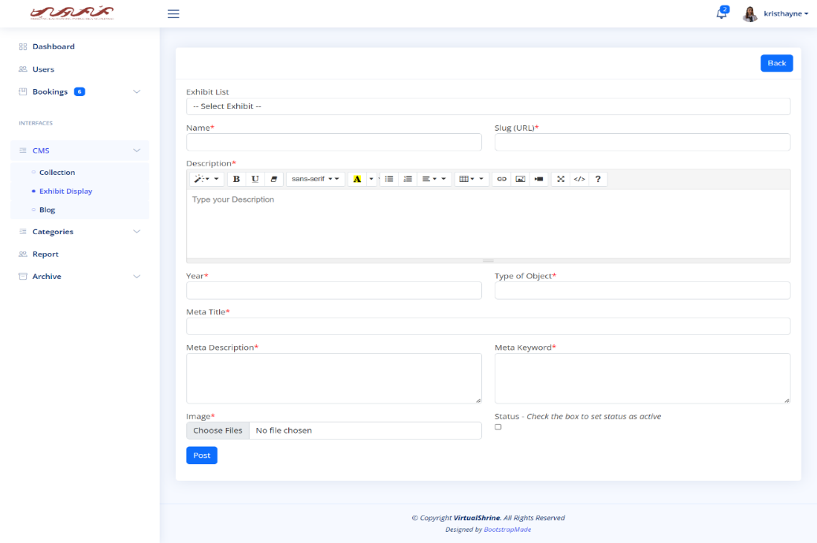

**Figure 80.** **Content Management System – Add new Exhibit Display**

**Content Management System – Edit Exhibit Display**

As seen in Figure 81, the Edit Exhibit display form gives admins the ability to edit the Exhibit display information.

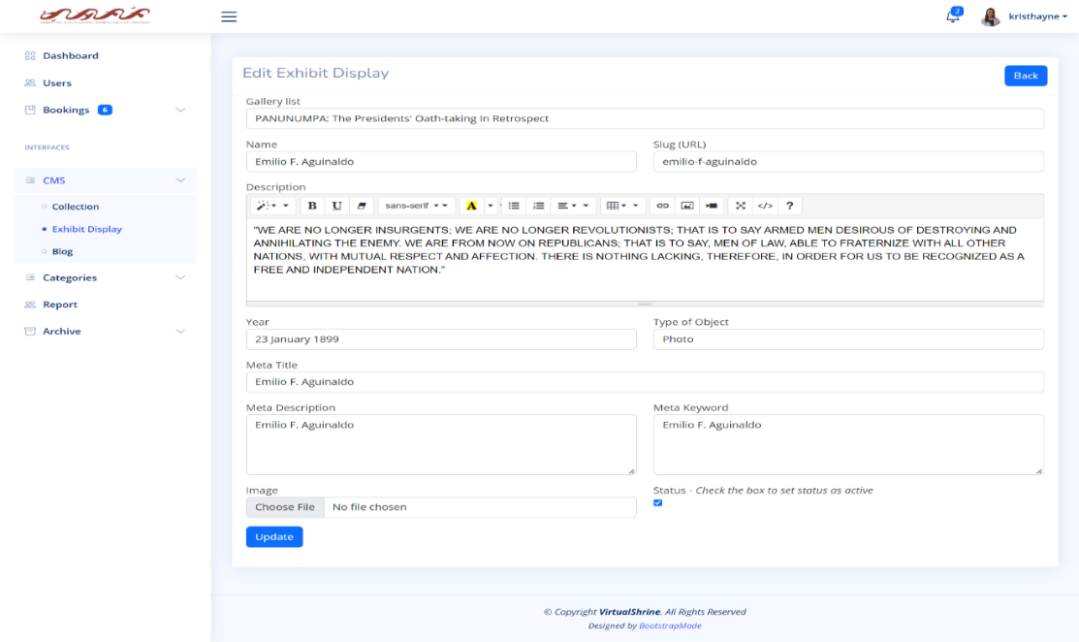

**Figure 81.** **Content Management System – Edit Exhibit Display**

**2.3.3 Blogs**

**Content Management System – Blog**

In Figure 82, the Blog CMS is shown. It includes a table that provides information about the Blog, such as its ID, Name, a preview image, and its status. There are also action buttons for editing and archiving.

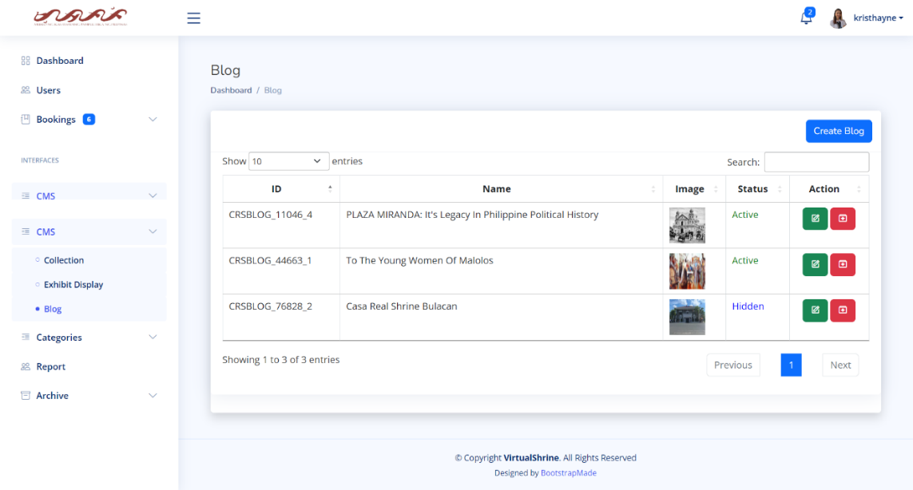

**Figure 82.** **Content Management System – Blog**

**Content Management System – Create a Blog Post**

In Figure 83, the Create a Blog form is shown. This is where the admin can add and upload new Blog posts.

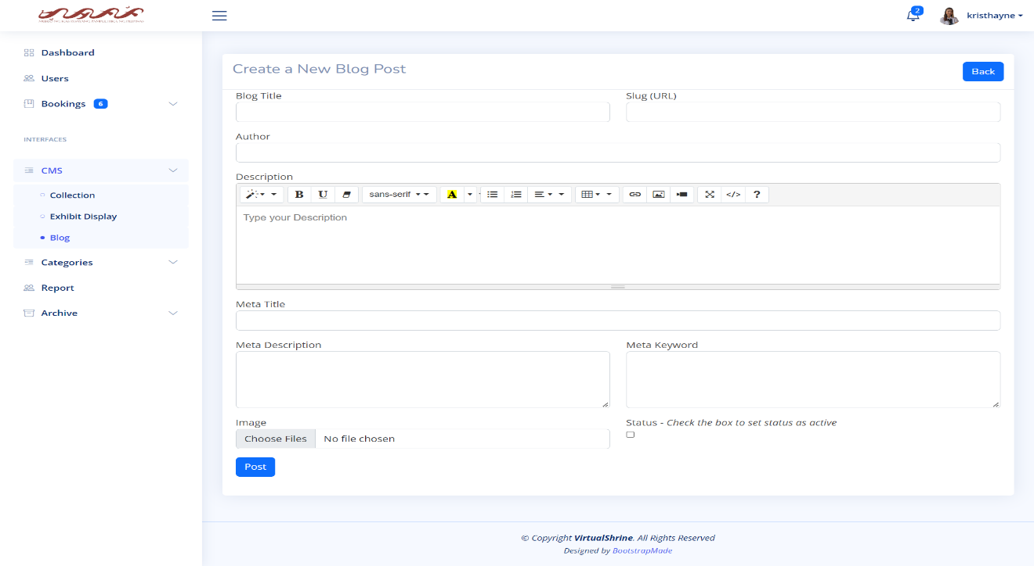

**Figure 83.** **Content Management System – Create a Blog Post**

**Content Management System – Edit**

As seen in Figure 84, the Edit Blog form gives admins the ability to edit the Blog information.

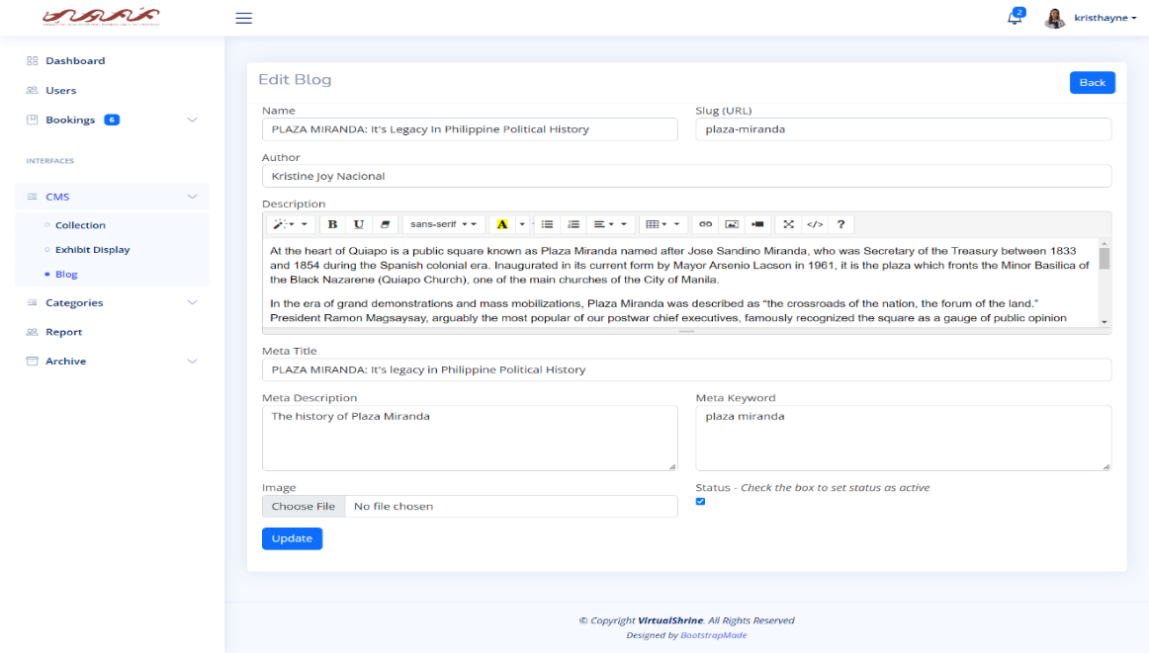

**Figure 84.** **Content Management System – Edit Blog**

**2.4 Generate and Print Admin Activity Record**

**Activity Report**

Figure 85 shows every activity like editing some of the website content or updating profile of the admin. It also includes the date when the data is changed.

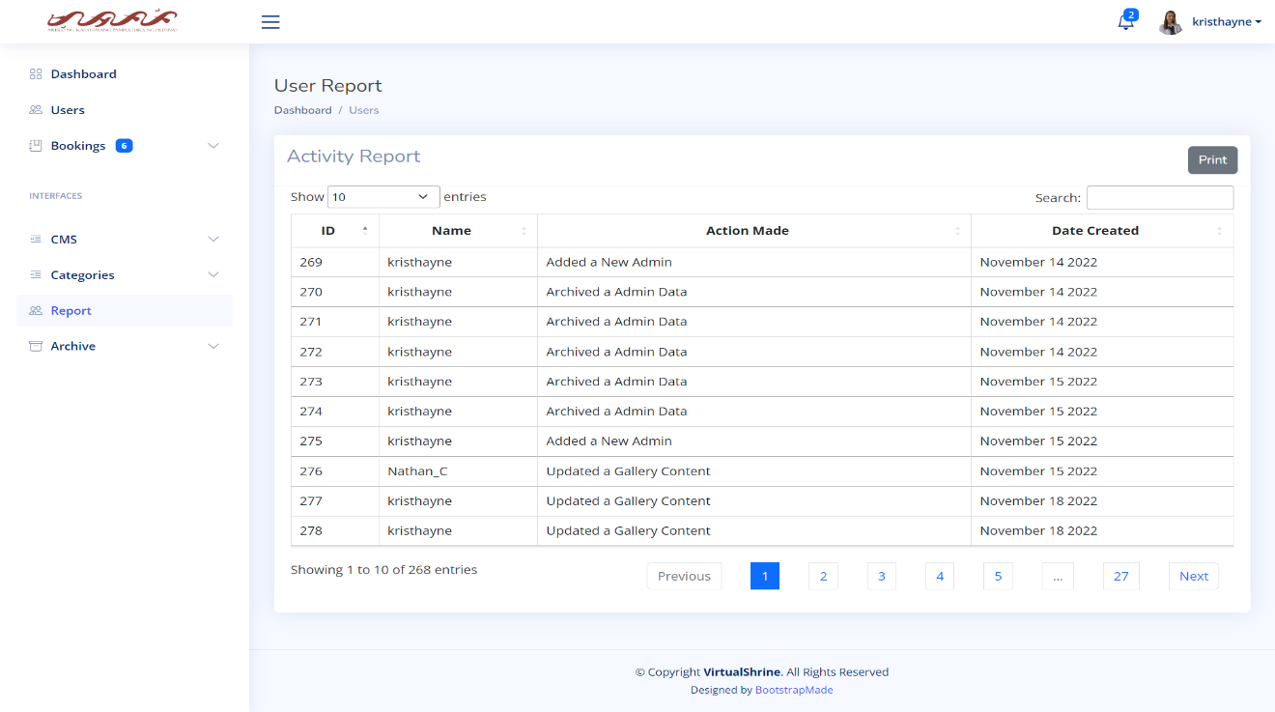

**Figure 85.** **Activity Report**

**Printing Report**

Figure 86 shows the printing report. This will help the admin to have a hard copy of the data when it needs to be submitted to the museum for the documentation.

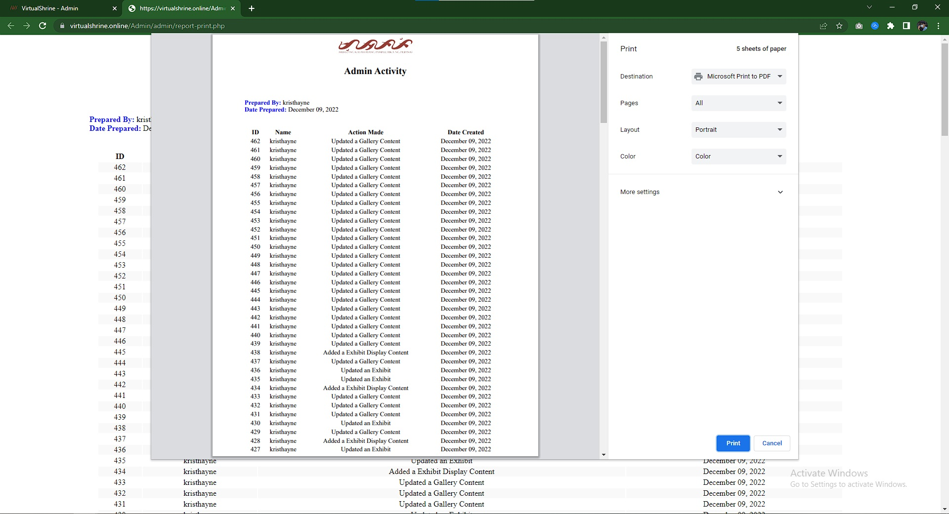

**Figure 86. Printing Report**

* 1. **Booking Confirmation through email after reservation**

**Email from the Administration**

Figure 87 displays the confirmation of booking reservation. This confirmation email will automatically be sent to the email provided by the visitor during the booking process if the administrator approves their booking. The email includes the booking information, reminders, and the link for cancellation and rescheduling of booking.



**Figure 87. Email from the Administration**

**Part III. Software Quality Evaluation of the VirtualShrine: An Interactive Museum Website for Casa Real Shrine**

It is comprised of several tables that illustrate how well the VirtualShrine: An Interactive Museum Website performs. Table 3 shows the *Functional Suitability* criterion; Table 4 shows the *Performance Efficiency* criterion; Table 5 shows the *Usability* criterion; Table 6 shows the *Reliability* criterion; and Table 7 shows the *Portability* criterion. In addition, a table that presents the total number of respondents and a five-score Likert scale are also included. The developed application was assessed in terms of functional suitability, performance efficiency, usability, reliability, and portability using the ISO/IEC 25010:2011 or the Square - System and Software Quality Models.

**Table 6. Total Number of Respondents**

Table 6 displays the total number of respondents. The respondents of this study are five (5) IT Professionals that have proven extensive knowledge or working in the field of Information Technology, five (5) Faculty Members from the College of Information and Communications Technology, twelve (12) students, ten (10) Local Tourist, ten (10) Foreign Tourist and three (3) Casa Real Shrine Museum Staff.

|  |  |  |
| --- | --- | --- |
| **Evaluators** | **Frequency** | **Percentage (%)** |
| IT Professionals | 5 | 11% |
| CICT Faculty | 5 | 11% |
| Casa Real Shrine Museum Staff | 3 | 7% |
| Student | 12 | 27% |
| Local Tourist | 10 | 22% |
| Foreign Tourist | 10 | 22% |
| **TOTAL** | **45** | **100%** |

**Table 7. 5-Score Likert Scale**

Table 7 displays the 5-Score Likert Scale. The evaluation procedure used a five-score scale which is 1 for Strongly Disagree, 2 for Disagree, 3 for Moderately Agree, 4 for Agree, and 5 for Strongly Agree. The fives-core rating with its frequencies was collected from 45 respondents and the computed mean.

|  |  |  |
| --- | --- | --- |
| **Scale** | **Range** | **Descriptive Interpretation** |
| 5 | 4.60-5.00 | Strongly Agree |
| 4 | 3.60-4.59 | Agree |
| 3 | 2.60-3.59 | Moderately Agree |
| 2 | 1.60-2.59 | Disagree |
| 1 | 0-1.59 | Strongly Disagree |

**Table 8. Frequency Distribution and Descriptive Measures in the Evaluation of the Developed Website in terms of Functional Suitability**

Table 8. Show Under the functional suitability sub characteristics, the functional completeness has a total mean of 4.64, interpreted as Strongly Agree, proved the developed website is capable to attain specified user objectives. Functional correctness has a total mean of 4.62, interpreted as Strongly Agree and still has a high acceptance rating from the respondents. And lastly, functional appropriateness has a total mean of 4.64, interpreted as Strongly Agree proved the developed website has an efficient and effective way of accomplishing all the specified tasks. Based on all the computed mean 4.64 is the final interpretation of the respondents it means that they are strongly agree that the website is with the functionality of the developed web portal.

|  |  |  |  |  |  |  |  |  |
| --- | --- | --- | --- | --- | --- | --- | --- | --- |
| ***No.*** | ***Characteristics*** | ***5*** | ***4*** | ***3*** | ***2*** | ***1*** | ***Mean*** | ***Descriptive Interpretation*** |
| 1 | ***Functional Completeness.*** The system functions according to its intended purpose. | **32** | **10** | **3** | **0** | **0** | **4.64** | Strongly Agree |
| 2 | ***Functional Correctness***. The system gives the exact output on each input per module. | **30** | **13** | **2** | **0** | **0** | **4.62** | Strongly Agree |
| 3 | ***Functional Appropriateness***. The system functions like any standard system entirely. | **32** | **10** | **3** | **0** | **0** | **4.64** | Strongly Agree |
|  | | **Weighted Mean** | | | | | **4.64** | **Strongly Agree** |

*4.60 - 5.00 Strongly Agree, 3.60 - 4.59 Agree, 2.60 - 3.59 Moderately Agree, 1.60 - 2.59 Disagree,0 - 1.59 Strongly Disagree*

**Table 9. Frequency Distribution and Descriptive Measures in the Evaluation of the Developed Website in terms of Performance Efficiency**

Table 9. Based on the information provided, it appears that the VirtualShrine website has performed well in terms of its time behavior, resource utilization, capacity, and system accuracy. The respondents strongly agreed with the performance efficiency of the website, as indicated by the weighted mean of 4.65. This suggests that the website was able to meet the expected results in a short amount of time and uses a small proportion of resources when in use. Overall, it seems that the VirtualShrine website is efficient in its performance.

|  |  |  |  |  |  |  |  |  |
| --- | --- | --- | --- | --- | --- | --- | --- | --- |
| ***No.*** | ***Characteristics*** | ***5*** | ***4*** | ***3*** | ***2*** | ***1*** | ***Mean*** | ***Descriptive Interpretation*** |
| 1 | ***Time-Behavior.*** The system's response and processing times, as well as its throughput rates, carry out its intended tasks and adhere to the specifications. | **34** | **7** | **3** | **1** | **0** | **4.64** | Strongly Agree |
| 2 | ***Resource Utilization.*** The amount and kind of resources used by the system meet the criteria. | **31** | **11** | **3** | **0** | **0** | **4.62** | Strongly Agree |
| 3 | ***Capacity.*** The system manages time efficiently and effectively. | **32** | **11** | **2** | **0** | **0** | **4.67** | Strongly Agree |
| 4 | ***System accuracy.*** The system accurately presents the output at the maximum level. | **33** | **9** | **3** | **0** | **0** | **4.67** | Strongly Agree |
|  | | **Weighted Mean** | | | | | **4.65** | **Strongly Agree** |

*4.60 - 5.00 Strongly Agree, 3.60 - 4.59 Agree, 2.60 - 3.59 Moderately Agree, 1.60 - 2.59 Disagree,0 - 1.59 Strongly Disagree*

**Table 10. Frequency Distribution and Descriptive Measures in the Evaluation of the Developed Website in terms of Compatibility**

Table 10 displays the Frequency Distribution and Descriptive Measures in the Evaluation of the Developed Website in terms of Compatibility. Shows the items used in determining the compatibility of the developed website. Which is categorized by Co-Existence, Interoperability and Flexibility. The Compatibility have a total means of 4.96 which interpreted as Strongly Agree. This shows that the website Virtual Shrine has complete features when it comes to compatibility.

|  |  |  |  |  |  |  |  |  |
| --- | --- | --- | --- | --- | --- | --- | --- | --- |
| Frequency Distribution and Descriptive Measures in the Evaluation of the Developed Website in terms of Compatibility | | | | | | | | |
| ***No.*** | ***Characteristics*** | ***5*** | ***4*** | ***3*** | ***2*** | ***1*** | ***Mean*** | ***Descriptive Interpretation*** |
| 1 | ***Co-Existence.*** The system can efficiently perform its required functions while sharing a familiar environment and resources with other systems, with no negative influence on any other method. | **34** | **9** | **1** | **1** | **0** | **4.69** | Strongly Agree |
| 2 | ***Interoperability.*** The system can exchange information and utilize data that has been exchanged between two or more platforms. | **30** | **12** | **3** | **0** | **0** | **4.6** | Agree |
| 3 | ***Flexibility.*** The system can be accessed on both phone and computer browsers. | **35** | **9** | **1** | **0** | **0** | **4.76** | Strongly Agree |
|  | | **Weighted Mean** | | | | | **4.69** | **Strongly Agree** |

*4.60 - 5.00 Strongly Agree, 3.60 - 4.59 Agree, 2.60 - 3.59 Moderately Agree, 1.60 - 2.59 Disagree,0 - 1.59 Strongly Disagree*

**Table 11. Frequency Distribution and Descriptive Measures in the Evaluation of the Developed Website in terms of Usability**

Table 11. Shows the items used in determining the usability of the developed website. Which is categorized by User-Friendly, Acceptability Recognizability, System Utility and Operability. The Usability have a total means of 4.71 which interpreted as Strongly Agree. This shows that the website Virtual Shrine has complete features when it comes to usability.

|  |  |  |  |  |  |  |  |  |
| --- | --- | --- | --- | --- | --- | --- | --- | --- |
| ***No.*** | ***Characteristics*** | ***5*** | ***4*** | ***3*** | ***2*** | ***1*** | ***Mean*** | ***Descriptive Interpretation*** |
| 1 | ***User friendly****. The design of the system is easy to understand and use.* | **32** | **10** | **3** | **0** | **0** | **4.64** | Strongly Agree |
| 2 | ***Acceptability Recognizability.*** *Users are able to determine whether the system is suitable for their requirements.* | **33** | **11** | **1** | **0** | **0** | **4.71** | Strongly Agree |
| 3 | ***System Utility.*** *The system can generate reports that can be viewed online (and can be download).* | **32** | **10** | **3** | **0** | **0** | **4.64** | Strongly Agree |
| 4 | ***Operability.*** *The system is simple to use, navigate.* | **38** | **7** | **0** | **0** | **0** | **4.84** | Strongly Agree |
|  | | **Weighted Mean** | | | | | **4.71** | **Strongly Agree** |

*4.60 - 5.00 Strongly Agree, 3.60 - 4.59 Agree, 2.60 - 3.59 Moderately Agree, 1.60 - 2.59 Disagree,0 - 1.59 Strongly Disagree*

**Table 12. Frequency Distribution and Descriptive Measures in the Evaluation of the Developed Website in terms of Reliability**

Table 12. Shows the items used to determining the reliability of the developed website by means of Maturity, Availability, Fault Tolerance, and Recoverability. The total mean of reliability that comes from the respondents is 4.68 which interpreted as Strongly Agree. This demonstrates that the created web portal is trustworthy when used normally and is accessible and fully functional when needed.

|  |  |  |  |  |  |  |  |  |
| --- | --- | --- | --- | --- | --- | --- | --- | --- |
| ***No.*** | ***Characteristics*** | ***5*** | ***4*** | ***3*** | ***2*** | ***1*** | ***Mean*** | ***Descriptive Interpretation*** |
| 1 | ***Maturity***. Under normal conditions, the system meets the requirements for reliability. | **33** | **10** | **2** | **0** | **0** | **4.69** | Strongly Agree |
| 2 | ***Availability.*** The system is operational and accessible when required for use. | **35** | **7** | **3** | **0** | **0** | **4.71** | Strongly Agree |
| 3 | ***Fault Tolerance.*** Despite the presence of hardware or software faults, the system or its components function as planned. | **30** | **14** | **1** | **0** | **0** | **4.64** | Strongly Agree |
| 4 | ***Recoverability.*** In an interruption or failure, the system can immediately recover the affected data and restore the system to its desired state. | **33** | **9** | **3** | **0** | **0** | **4.67** | Strongly Agree |
|  | | **Weighted Mean** | | | | | **4.68** | **Strongly Agree** |

*4.60 - 5.00 Strongly Agree, 3.60 - 4.59 Agree, 2.60 - 3.59 Moderately Agree, 1.60 - 2.59 Disagree,0 - 1.59 Strongly Disagree*

**Table 13. Frequency Distribution and Descriptive Measures in the Evaluation of the Developed Website in terms of Security**

Table 13. Shows the items used in determining the security of the developed website. Which is categorized by Confidentiality, Accountability, and Integrity. The Security have a total mean of 4.78 that comes from the respondents which interpreted as Strongly Agree. The system makes sure the data are secure, prohibits unauthorized users from accessing and changing the data, and saves auditable logs that demonstrate each activity was made.

|  |  |  |  |  |  |  |  |  |
| --- | --- | --- | --- | --- | --- | --- | --- | --- |
| ***No.*** | ***Characteristics*** | ***5*** | ***4*** | ***3*** | ***2*** | ***1*** | ***Mean*** | ***Descriptive Interpretation*** |
| **1** | ***Confidentiality.*** The system guarantees that the data is only available to those granted access. | **38** | **6** | **1** | **0** | **0** | **4.82** | Strongly Agree |
| **2** | ***Accountability.*** The actions of an entity can be traced uniquely by the system to the entity. | **37** | **7** | **1** | **0** | **0** | **4.8** | Strongly Agree |
| **3** | **Integrity**. The system prevents unauthorized access to, or modification of data. | **33** | **11** | **1** | **0** | **0** | **4.71** | Strongly Agree |
|  | | **Weighted Mean** | | | | | **4.78** | **Strongly Agree** |

*4.60 - 5.00 Strongly Agree, 3.60 - 4.59 Agree, 2.60 - 3.59 Moderately Agree, 1.60 - 2.59 Disagree,0 - 1.59 Strongly Disagree*

**Table 14. Frequency Distribution and Descriptive Measures in the Evaluation of the Developed Website in terms of Maintainability**

Table 14 shows the items used in determining the maintainability of the developed system, which is categorized by Modularity, Modifiability, Testability, and Analyzability. The total computed mean for the maintainability is 4.79 which interpreted as Strongly Agree. It demonstrates the system's adaptability to various hardware, software, and other operational or usage scenarios. Mobile devices like smartphones, tablets, and PCs can all access the designed system online.

|  |  |  |  |  |  |  |  |  |
| --- | --- | --- | --- | --- | --- | --- | --- | --- |
|  | | | | | | | | |
| ***No.*** | ***Characteristics*** | ***5*** | ***4*** | ***3*** | ***2*** | ***1*** | ***Mean*** | ***Descriptive Interpretation*** |
| **1** | ***Modularity.*** Because the system is made up of distinct parts, altering one has little to no impact on the others. | **39** | **6** | **0** | **0** | **0** | **4.87** | Strongly Agree |
| **2** | ***Modifiability***. The system allows updating different user records through level of security. | **35** | **9** | **1** | **0** | **0** | **4.76** | Strongly Agree |
| **3** | ***Testability***. It is clear that the application is effective and efficient. For the product, test criteria can be set, and tests can be run to see if the criteria have been met. | **35** | **9** | **1** | **0** | **0** | **4.76** | Strongly Agree |
| **4** | ***Analyzability.*** The system works well and efficiently. One can evaluate the effects of a planned modification to a system or product on one or more of its components. | **35** | **10** | **0** | **0** | **0** | **4.78** | Strongly Agree |
|  | | **Weighted Mean** | | | | | **4.79** | **Strongly Agree** |

*4.60 - 5.00 Strongly Agree, 3.60 - 4.59 Agree, 2.60 - 3.59 Moderately Agree, 1.60 - 2.59 Disagree,0 - 1.59 Strongly Disagree*

**Table 15. Frequency Distribution and Descriptive Measures in the Evaluation of the Developed Website in terms of Portability**

Table 15 shows the item used in determining the portability of the developed system, which is categorized by Adaptability. Out of 45 respondents 38 is strongly agree and 7 is agree for the adaptability of the website. The portability has a total mean of 4.84 which interpreted as Strongly Agree. This means that the respondents strongly agree with portability of the website Virtual Shrine.

|  |  |  |  |  |  |  |  |  |
| --- | --- | --- | --- | --- | --- | --- | --- | --- |
| ***No.*** | ***Characteristics*** | ***5*** | ***4*** | ***3*** | ***2*** | ***1*** | ***Mean*** | ***Descriptive Interpretation*** |
| **1** | ***Adaptability.*** The system can effectively and efficiently be adapted for different evolving hardware, software, or other operational or usage environments. | **38** | **7** | **0** | **0** | **0** | **4.84** | Strongly Agree |
|  | | **Weighted Mean** | | | | | **4.84** | **Strongly Agree** |

*4.60 - 5.00 Strongly Agree, 3.60 - 4.59 Agree, 2.60 - 3.59 Moderately Agree, 1.60 - 2.59 Disagree,0 - 1.59 Strongly Disagree*

**Table 16**

Table 16 displays the interpretation of the computed mean for every software criteria. The Functional Suitability registered a computed mean of 4.64 with a descriptive interpretation as “Strongly Agree”. Performance Efficiency on the other hand acquired 4.65 which is also interpreted as “Strongly Agree”. Compatibility registered a computed mean of 4.69 with a descriptive interpretation as “Strongly Agree”. Usability registered a computed mean 4.71 with a descriptive interpretation as “Strongly Agree”. Reliability registered a computed mean 4.68 with a descriptive interpretation as “Strongly Agree”. Security registered a computed mean 4.78 with a descriptive interpretation as “Strongly Agree”. Maintainability registered a computed mean 4.79 with a descriptive interpretation as “Strongly Agree”. Portability acquired 4.84 which garnered the highest mean among the other criteria.

|  |  |  |
| --- | --- | --- |
| **Software Criteria** | **Computed Mean** | **Descriptive Interpretation** |
| **1. Functional Suitability** | **4.64** | **Strongly Agree** |
| **2. Performance Efficiency** | **4.65** | **Strongly Agree** |
| **3. Compatibility** | **4.69** | **Strongly Agree** |
| **4. Usability** | **4.71** | **Strongly Agree** |
| **5. Reliability** | **4.68** | **Strongly Agree** |
| **6. Security** | **4.78** | **Strongly Agree** |
| **7. Maintainability** | **4.79** | **Strongly Agree** |
| **8. Portability** | **4.84** | **Strongly Agree** |
| **Overall Mean** | **4.72** | **Strongly Agree** |

**CHAPTER V**

**SUMMARY OF FINDINGS, CONCLUSION AND RECOMMENDATIONS**

This chapter presents the summary of findings that the researchers have analyzed, the conclusion based on the results obtained, interpreted data based on the previous chapter, and recommendations.

**Summary of Findings**

The world today lives in an era where Internet has become a vital part of everyone’s lives. Websites has become popular to organizations because it is effective in acting as a launchpad that would help them grow and expand their audience. Museum Organizations have also started to use websites to spread information to a greater audience online. However, some museums like the Casa Real Shrine still doesn’t have a website, so the proponents conceptualized a website for Casa Real Shrine. The purpose of this study is to develop an interactive museum website for Casa Real Shrine that will allow them to reach more audience and share information and knowledge regarding the Political history of the Philippines by providing interactive features like audio guide, collections, and virtual 360 tour of the museum galleries.

The researchers used the Agile development model for a more flexible workflow. This approach provides an opportunity for the researchers to make improvements and respond to changes constantly during production. The developed Website has (7) features: Homepage; Online Booking; Visitor Guide; Gallery; Audio Guide; Virtual Tour; and About Page. The Homepage will serve as the landing page whenever a visitor access the website. The Online Booking feature allows visitors to book a visit reservation online. Visitor Guide page displays information the visitor needs to know regarding the museum operations, and rules and regulations. The Gallery Page displays all the existing gallery inside the museum, and at the same time, gives visitors access to view the displays inside the gallery. The Audio Guide provides enhance visitor experience. The Virtual Tour has a 360 degree tour of the museum galleries. And lastly, the about page displays the information and the history of Casa Real Shrine.

The ISO/IEC 25010:2011 was used to evaluate the developed website in terms of functionality, performance, usability, reliability, and portability. In total, 36 individuals responded to the assessment survey, including 5 faculty members, 12 BulSu students, 5 IT professionals, 10 local visitors/tourists of Casa Real Shrine, 10 foreign visitors/tourists of Casa Real Shrine, and 4 Casa Real Shrine Museum staff. The results indicated that the developed mobile application had a weighted mean of 4.72, which was classified as "Highly Acceptable".

The primary goal of this study was to create a website that provides enhanced user experience, interactivity, and comprehensive knowledge to the online museum visitor. The following objectives were considered in the research:

1. **To develop a website that can perform functionalities such as:**
   1. **Online Booking reservation.** The developed website provides a booking feature which allows visitors to easily plan their visit in advance. They can select the date and time of their visit, as well as enter any other relevant information that may be needed. This feature makes it convenient for visitors to plan and book their visits without having to contact the organization directly.
   2. **Virtual Museum tour.** The developed website includes a feature that allows visitors to virtually tour a museum. Through the use of 360-degree technology, viewers can look around and explore the museum as if they were there in person. This feature provides an interactive and immersive experience that allows visitors to explore the museum in full detail.
   3. **Gallery Collections.** The developed website includes a Gallery Collection where it allows visitors to explore the library of images and provides definitions to help them understand the images. Additionally, the website provides the option for visitors to choose between English and Filipino as their language.
   4. **User assisting features.**
      1. **Plan Your Visit.** The developed website provides visitors with instructions and guidelines that they should follow while visiting the museum. This information helps visitors plan their museum trip and make sure they have a safe and enjoyable experience.
      2. **Audio Guide.** The developed website provides visitors with a way to listen to audio recordings that tell stories related to the exhibits they can view while visiting a museum. This Audio Guide feature allows visitors to learn more about the exhibits they are seeing, without having to read information or talk to museum staff.
2. **To design and develop a Management System that can perform functionalities such as:**
   1. **Manage User Admins.** The developed system gives the Head administrator the ability to keep track of and control the data related to assistant administrators. This could include creating, modifying, and deleting user accounts, tracking user activity, and managing user privileges.
   2. **Accept and Reject Visitor Booking.** The developed system allows both the head administrator and assistant administrator to approve or deny any requests for bookings from visitors. This system allows for two layers of approval and allows the head administrator and assistant administrator to both have a say in the decisions that are made regarding bookings.
   3. **Upload Website Content.**
      1. **Collections.** The developed system provides the ability for two types of administrators - a "super admin" and an "assistant admin" - to add images, videos, and other forms of media to a gallery collection.
      2. **Exhibits.** The developed website allows two different types of administrators - a super administrator and an assistant administrator - to create a new schedule for an exhibit and upload the content related to the exhibit into the website.
      3. **Blog.** The developed website allows both the main administrator (super admin) and the secondary administrator (assistant admin) to upload and publish blog posts on the website.
   4. **Generate and Print Admin Activity Report.** The system has been created to provide administrators with a way to create and print out a report that details their activities. This report can be used to track the activities of an administrator and make sure they are carrying out their duties in an efficient and effective manner.
   5. **Booking confirmation through email after reservation.** The system has been developed to send an email to the user once the admin has reviewed and approved the visitor’s reservation request. The email will confirm the booking and provide additional information needed.

The proponents developed VirtualShrine: An interactive museum website for casa real shrine to provide a useful and reliable website with a pleasant and appealing user interface. The website met the needs of the users in terms of enhancing user experience, interactivity, and comprehensive knowledge regarding the information associated with Casa Real Shrine Museum.

**Conclusion**

The research conducted in this study led to the creation of a website which fulfilled all the stated and intended features. The website proved to be advantageous to all users, who can use it to discover the history of Philippine politics. It is expected that more individuals will be interested and intrigued by the history of the Casa Real Shrine as a result of the website.

**Recomm endations**

The following suggestion were made given the study’s findings and conclusion and can be used by future information technology researchers who would conduct similar research:

1. An enhance VR control capabilities in virtual tours that could focus on improving the user experience and accessibility of VR technology. This could involve exploring new ways to interact with virtual environments, such as using voice commands or gesture recognition, as well as studying how to make VR technology more accessible to people with disabilities.
2. A Museum maps that could focus on exploring the use of augmented reality (AR) technology to enhance the visitor experience. This could involve developing AR museum maps that can be accessed through a smartphone or other device, allowing visitors to see virtual annotations and information about exhibits as they explore the museum.
3. QR codes for audio guides in museums could focus on studying the effectiveness of this technology as a tool for enhancing visitor engagement and understanding of museum exhibits. This could involve conducting user studies to evaluate the usefulness and ease of use of QR code-based audio guides, as well as examining how different design elements and features impact visitor behavior and engagement.
4. Calendar integration for museum closures could focus on studying the effectiveness of different notification systems and strategies for informing researchers and other stakeholders about unexpected closures. This could involve conducting user studies to evaluate the effectiveness of different notification methods, such as email, text message, or push notification, as well as examining the impact of different timing and frequency of notifications on researcher behavior and satisfaction.